

**ABOUT THE BOOK**



**PREFACE**

Part I - This book contains 250 very important .NET interview questions. Part II - Next part of this book contains 250 more interview questions.

**ABOUT THE AUTHOR**

Happy Rawat has around 15 years of experience in software development. He helps candidates in clearing technical interview in tech companies.

Chapters



2. .NET FRAMEWORK



3. SQL

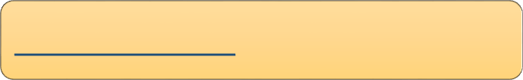

4. ASP.NET MVC



5. ASP.NET WEBFORMS

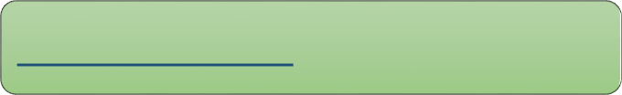

6. ADO.NET & EF



7. WEB API



8. .NET CORE

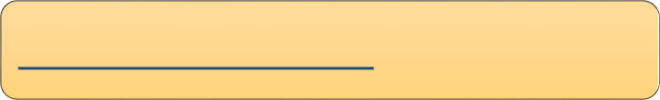

9. SOLID PRINCIPLES



10. DESIGN PATTERNS



11. CODING PROBLEMS

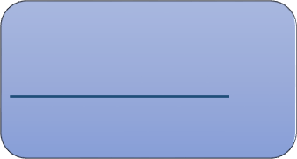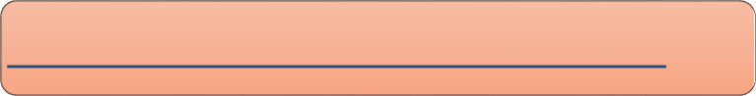

1. Basics

1. OOPS/ C#

2. Inheritance, Abstraction, Encap…

3. Abstract Class & Interface

4. Access Specifiers, Boxing, Unboxing...

5. Loops, Conditions, Exception Hand…

6. Generics & Collections

7. Constructors

8. Method, Parameters, Delegates…

9. Important Keywords

10. LINQ

## Chapter 1 : OOPS & C# - Basics

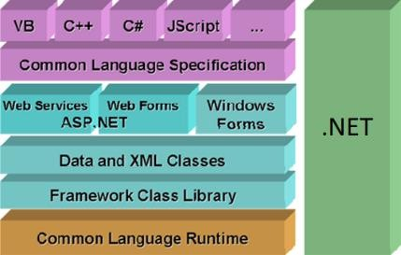Q1. What is C#? What Is the difference between C# and .NET? Q2. What is OOPS? What are the main concepts of OOPS?V Imp Q3. What are the advantages of OOPSV? Imp

Q4. What are the limitations of OOPS? Q5. What are Classes and Objects?

Q6. What are the types of classes in C#?

Q7. Is it possible to prevent object creation of a class in C#? Q8. What is Property?

Q9. What is the difference between Property and Function? Q10. What are Namespaces?

Back to main index

* 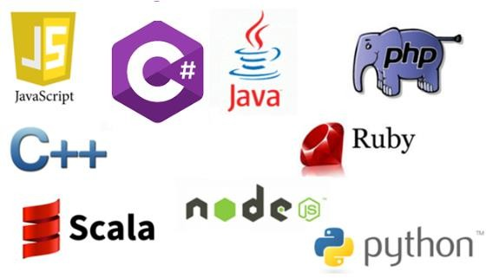C# is an object-oriented **programming language**



Q1

What is C#? What is the difference between C# and .NET?

which runs on the .NET framework.

* .NET is a **framework** for building and running software's and applications.

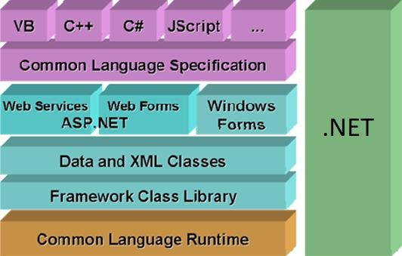

* 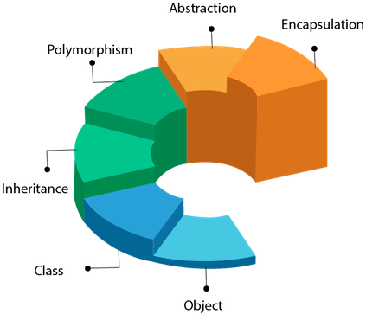OOP stands for **Object-Oriented Programming**, which means it is a way to create software around **objects**.



Q2

What is OOPS? What are the main concepts of OOPS?

* OOPs provide a clear structure for the software's and web applications.



Q3

What are the advantages of OOPS?

* + Advantages of OOPS:

1. **Reuse** of code using inheritance.
2. **Flexibility** of code using polymorphism.
3. **Secure** application by using Encapsulation.
4. **Easily scalable** from small to large applications.
5. **Easier troubleshooting** of code because of modularity**.**



Q4

What are the limitations of OOPS?

* + Disadvantage of OOPS:

1. It is not suitable for **small** applications.



Q5

What are Classes and Objects?

* A class is a **LOGICAL UNIT or BLUEPRINT.** It contains fields, methods and properties.

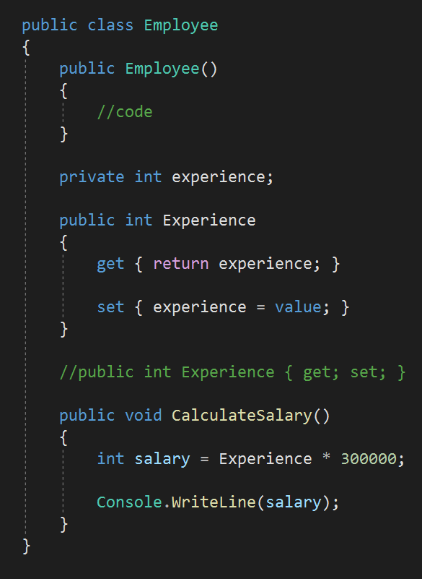

Method

Property

Field

Constructor

* + Class members are:

1. A **constructor** is a method in the class which gets executed when a class object is created.

2. A **field** is a variable of any type. It is basically the data.

3. A **property** is a member that provides helps in read and write of private field.

4. A **method** is a code block that contains a series of statements.



Q5

What are Classes and Objects?

* **Object** - An object is an **INSTANCE** of a class.

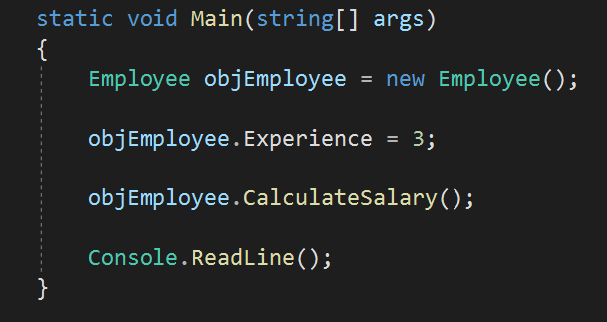

Object



Q6

What are the types of classes in C#?

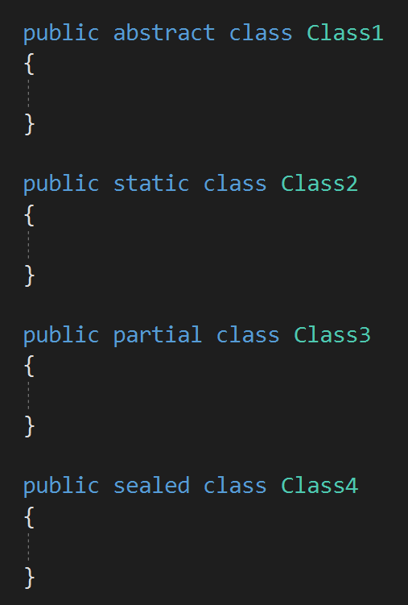



Types of Classes

Abstract

Class

Static Class

Partial Class

Sealed Class

* + 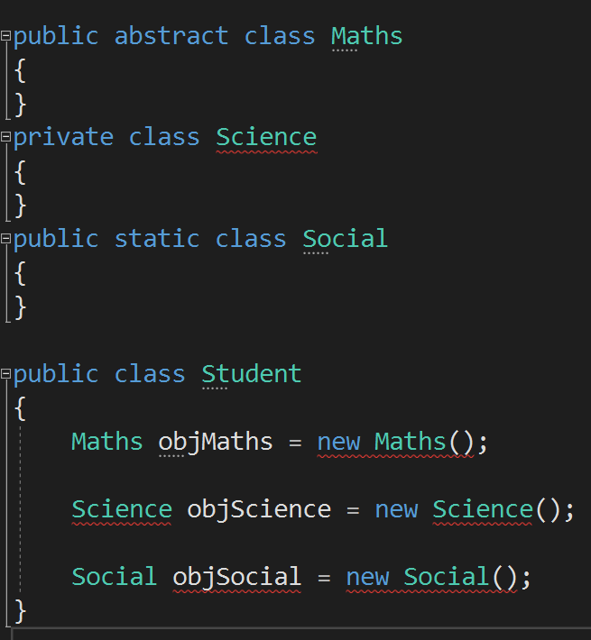Object creation of a class can be prevented by:



Q7

Is it possible to prevent object creation of a class in C#?

1. Abstract Class
2. Private Class
3. Static Class

* 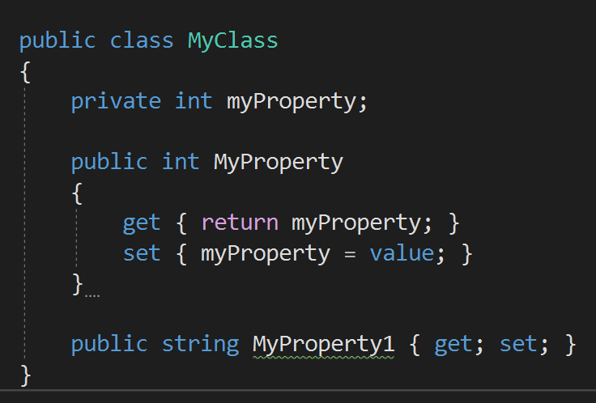A property is a class member that provides a flexible mechanism to **read** and **write** private field.



Q8

What is Property?

### Q9 What is the difference between Property and Function?



* + 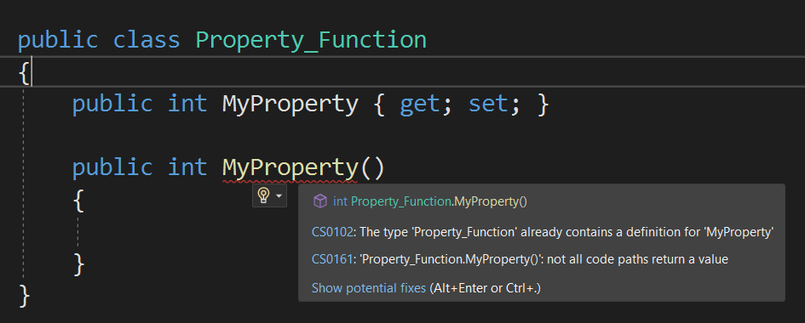Property is a **specialized function** only.
  + Specialized means properties are used

only to get and set field values.

* 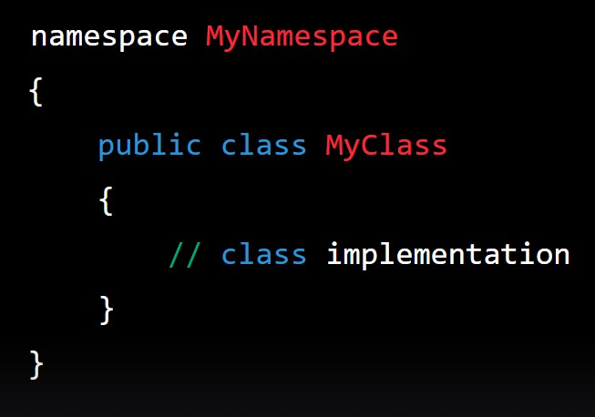A namespace is a container for a set of related classes and other types.



Q10

What are Namespaces?

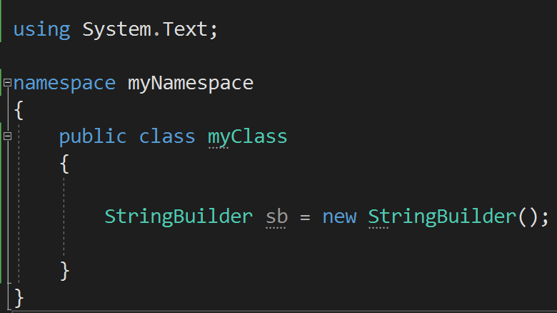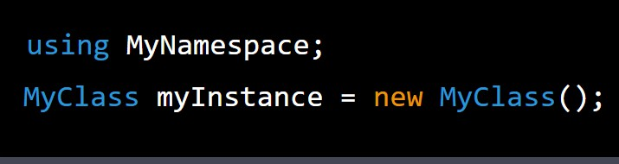

## Chapter 2 : OOPS & C# - Inheritance, Abstraction, Encapsulation & Polymorphism

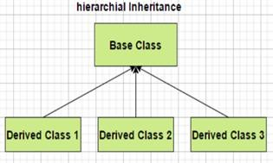Q11. What is Inheritance? When to use Inheritance?

Q12. What are the different types of Inheritance?

Q13. Does C# support Multiple Inheritance?

Q14. How to prevent a class from being Inherited?

V Imp

Q15. Are private class members inherited to the derived class?

Q16. What is Abstraction? How to implement abstraction? V Imp

Q17. What is Encapsulation? How to implement encapsulation? V Imp

Q18. What is the difference between Abstraction and Encapsulation?

Q19. What is Polymorphism and what are its types? When to use polymorphism? Q20. What is Method Overloading? In how many ways a method can be overloaded? Q21. When should you use method overloading in real applications?

Q22. If two methods are same except return type, then methods are overloaded or what willl happen?

Q23. What is the difference between Overloading and Overriding? Q24. What is the use of Overriding?

V Imp

Q25. If a method is marked as virtual, do we must have to "override" it from the child class? Q26. What is the difference between Method Overriding and Method Hiding?

Back to main index

Q11

### What is Inheritance? When to use Inheritance?

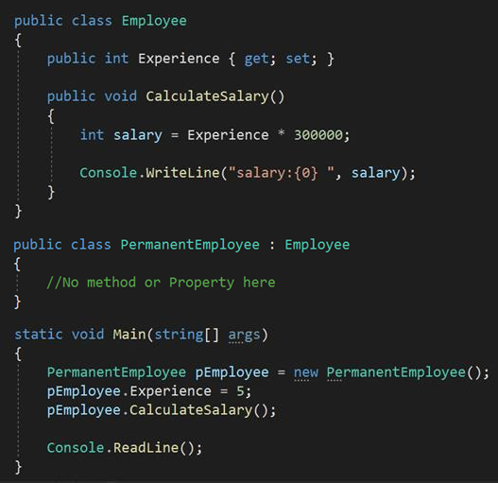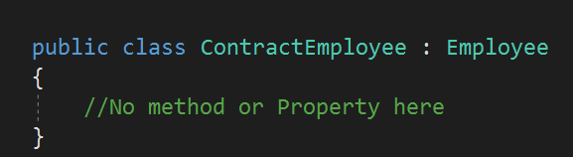

t When to use

* Inheritance is creating a **PARENT-CHILD**

Base/ Parent/ Super class

relationship between two classes, where child class will **automatically** get the properties and methods of the parent.

* Inheritance is good for: **REUSABILITY** and

Derived/ Child/ Sub class

**ABSTRACTION** of code

CalculateSalary() method is not present in PermanentEmployee class, but it will get it

automatically from it’s parent



Q12

What are the different types of Inheritance?

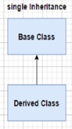 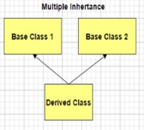 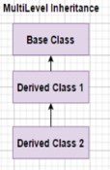 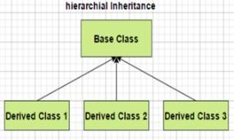

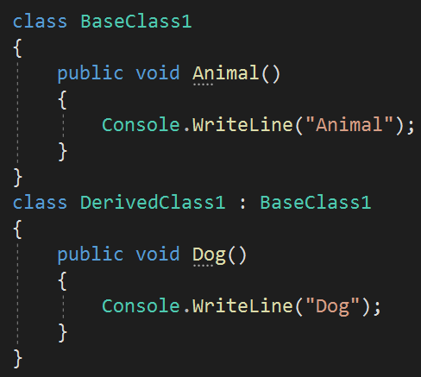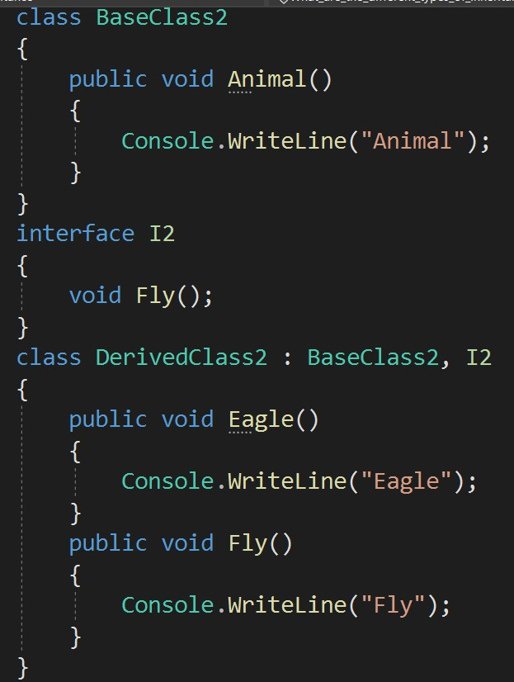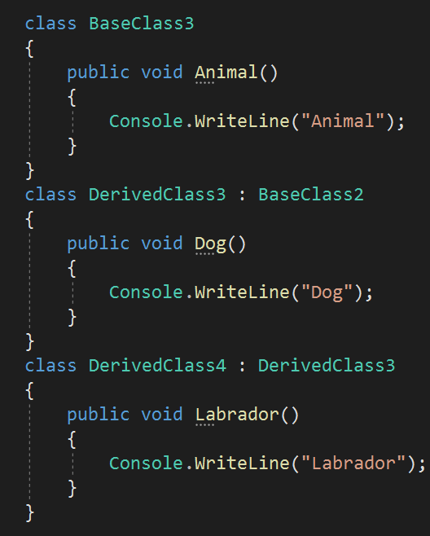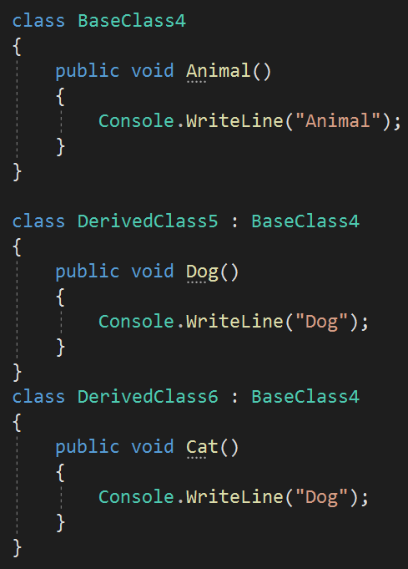

* + NO



Q13

Does C# support Multiple Inheritance? How can you implement multiple inheritance in C#?

* + C# support inheritance by using **multiple Interfaces.** This is an alternative way of multiple inheritance.



Q14

How to prevent a class from being Inherited?

* By using **SEALED** keyword in class

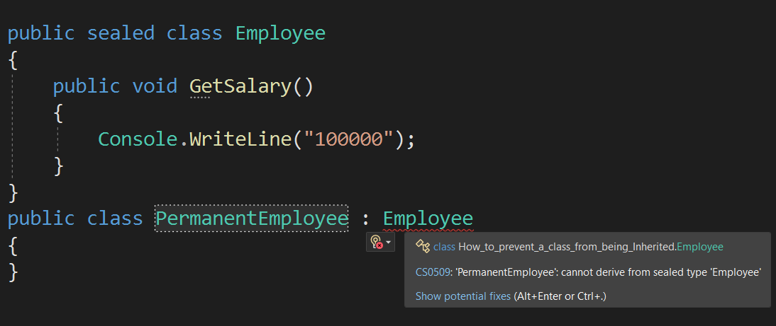

* By using **STATIC** keyword in base class

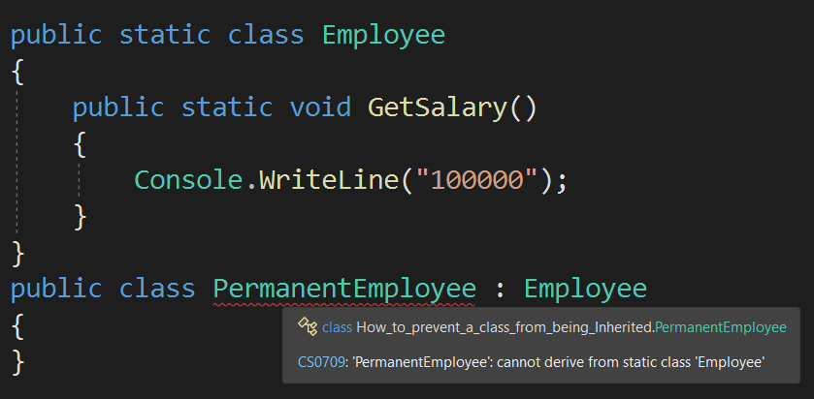

* Difference between sealed & static is, you can create the object of sealed class, but you cannot create the object of static class.
  + No, the private members cannot be inherited to derived class.



Q15

Are private class members inherited to the derived class?

* + Only public and protected class members can be inherited.
* 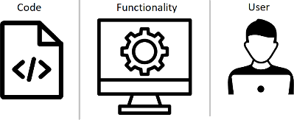Abstraction means showing only required things and hide the **BACKGROUND** details.

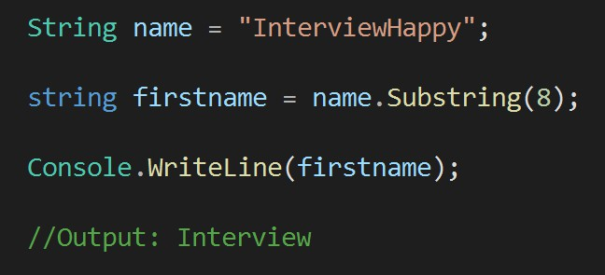

Background/Hidden method.



Q16

What is Abstraction? How to implement abstraction in real applications?

* 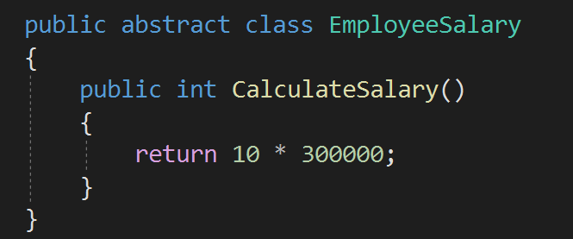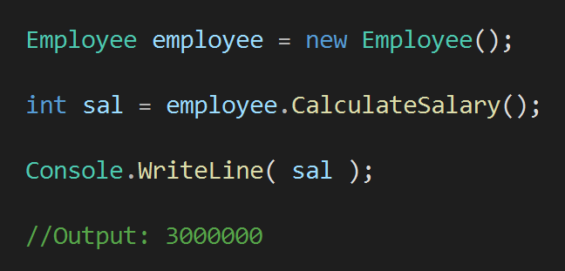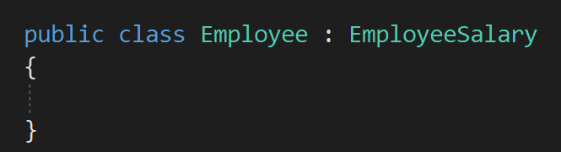Mostly we use **abstract classes** and **interfaces**

for implementing abstraction.

Q17



### What is Encapsulation? How to implement encapsulation in real applications?

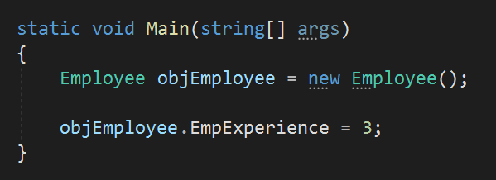

* + Encapsulation means **WRAPPING** of data

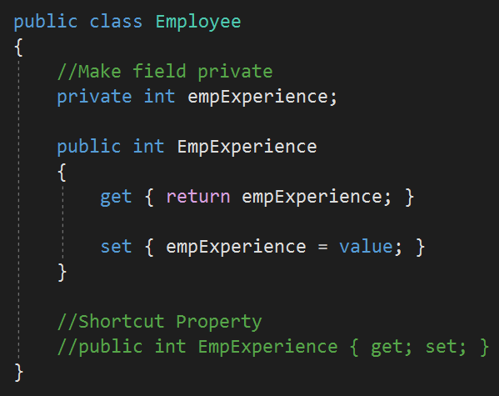

on?

This field cannot be accessed from outside without the property

and methods into a single unit.

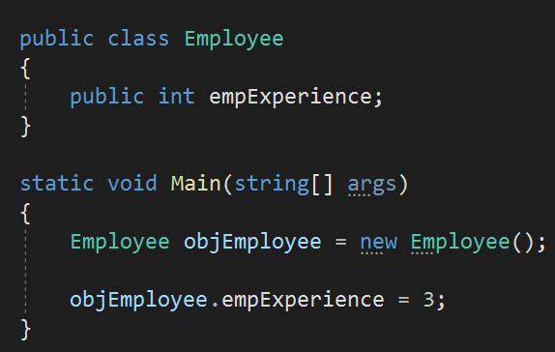

Field/Data is accessed without property or function. It will work but it violating encapsulation

* + Abstraction means showing only required things and hide the **BACKGROUND** details.



Q18

What is the difference between Abstraction and Encapsulation?

* + Encapsulation means **WRAPPING** of data and methods into a single unit.

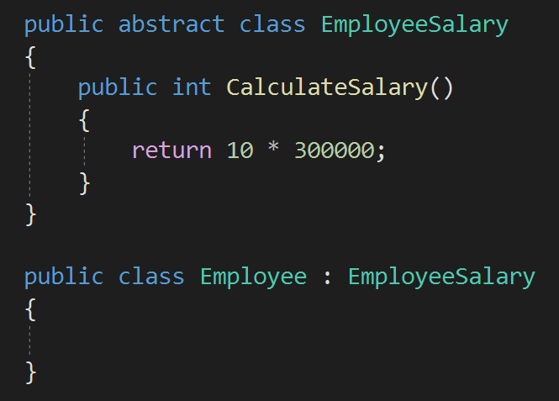



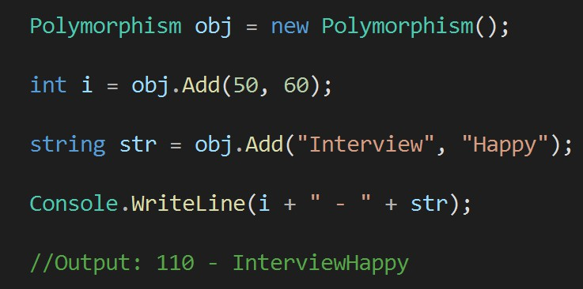

* Polymorphism is the ability of a variable, object, or function to take on **MULTIPLE FORMS**.

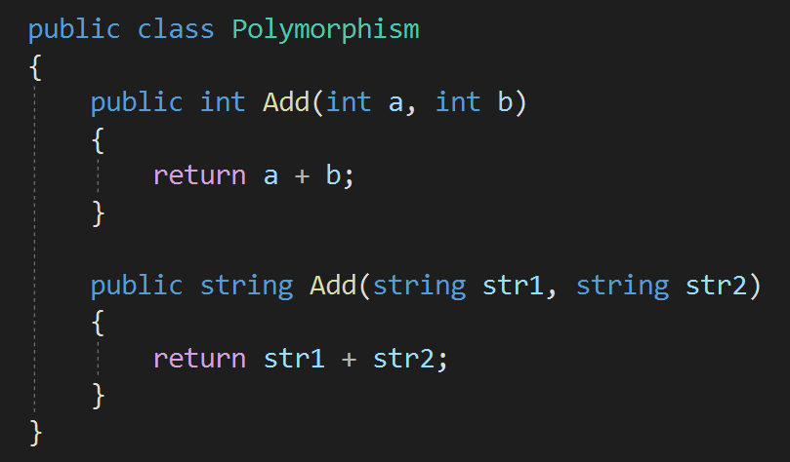

o use polymorphism?

Function with same name but have multiple forms



Q19

What is Polymorphism and what are its types? When to use polymorphism?

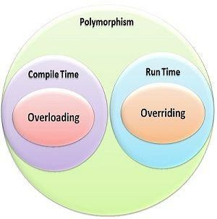

* Method overloading is a type of polymorphism in which we can create multiple methods of the **same name in the same class**, and all methods work in different ways.



Q20

What is Method Overloading? In how many ways a method can be overloaded?

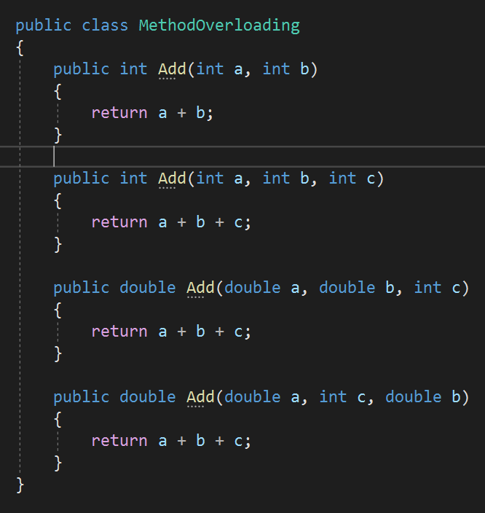

3. Order of parameters is different

2. Type of parameters

are different

1. Number of parameters are

different



Q21

When should you use method overloading in real applications?

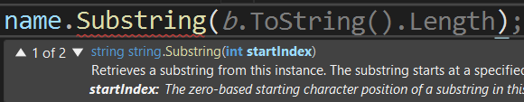 

* + No, this will show compile time error.



Q22

If two methods are same except return type, then methods are overloaded or what will happen?

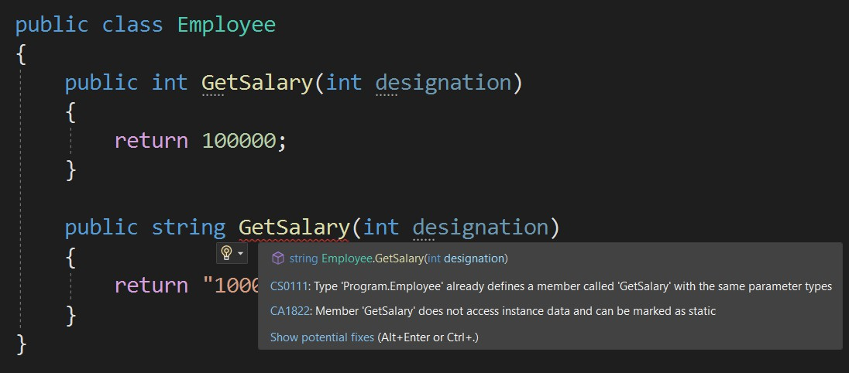

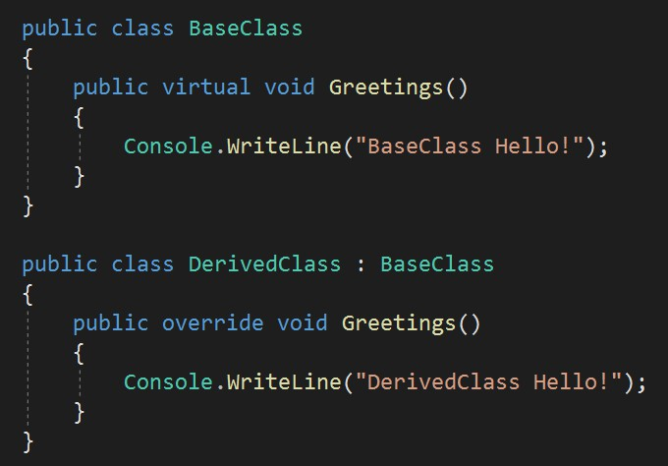ing?



Q23

What is the difference between Overloading and Overriding?

* Method Overriding

1. Multiple methods of same name are in **different class**.
2. I**nheritance is used**, as it is in different class.
3. Both methods have **same signature.**
4. It’s a **run time** polymorphism.
5. **Virtual** & **override** keywords.

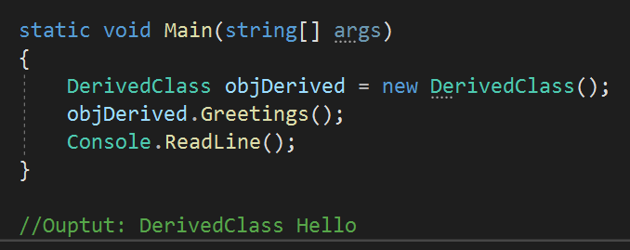



Q23

What is the difference between Overloading and Overriding?

#### Method Overloading

1. Multiple methods of same name in **single class**.
2. No need of **inheritance**, as it is in single class.
3. All methods have **different signature.**
4. It’s a **compile time** polymorphism.
5. No special keyword used.

#### Method Overriding

1. Multiple methods of same name in **different class**.
2. I**nheritance is used**, as it is in different class.
3. All methods have **same signature.**
4. It’s a **run time** polymorphism.
5. **Virtual** & **override** keywords.

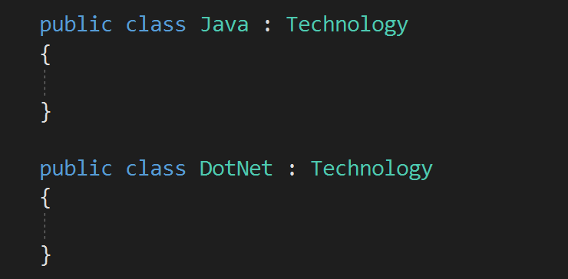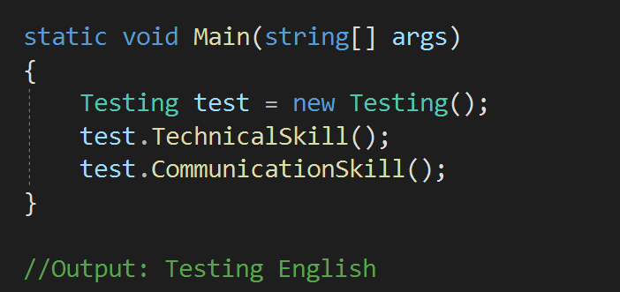

* + 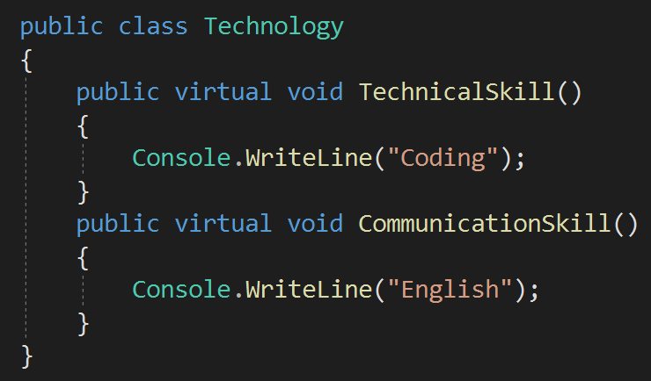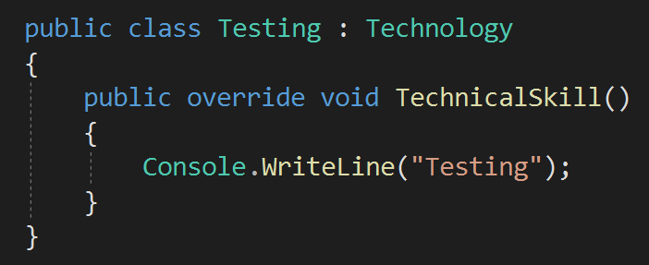Overriding is used to modify and provide a new implementation of the method inherited from a base class.



Q24

What is the use of Overriding? When should I override the method in real applications?

* + NO. Overriding virtual method is optional.



Q25

If a method is marked as virtual, do we must have to "override" it from the child class?

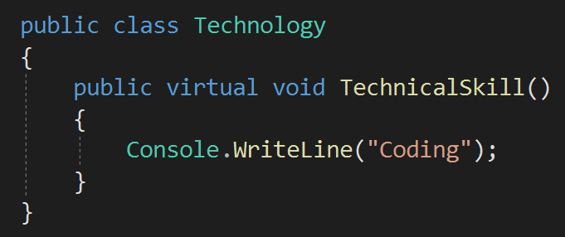

it from the child class?

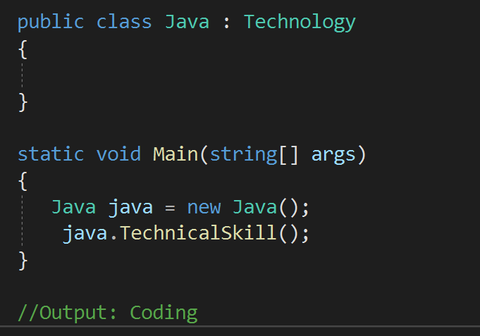

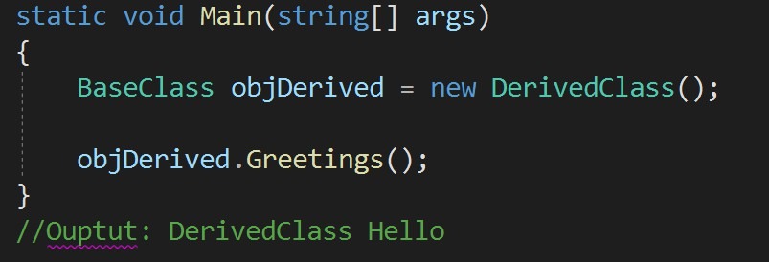

* QI2n6M. Wethhaot ids Hhiedingfe, ryeonucecabne completehlyodhide the



Q26

What is the difference between Method Overriding and Method Hiding?

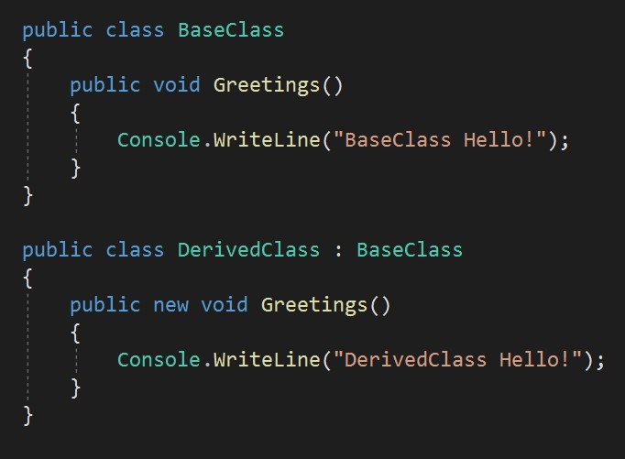implementation of the methods of a base class

from the derived class using the **new keyword**.

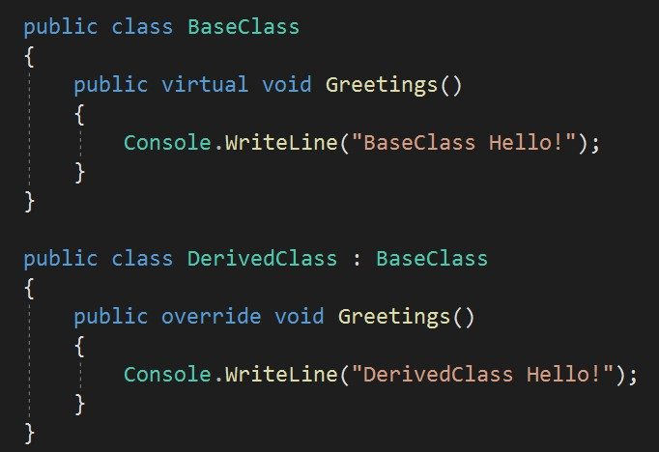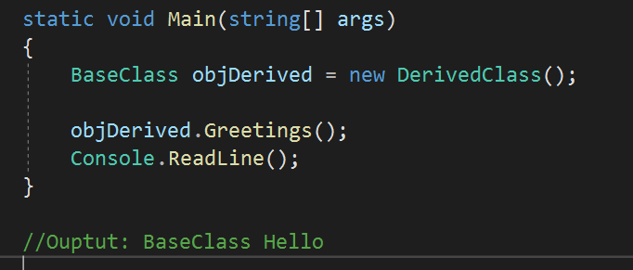

## Chapter 3 : OOPS & C# - Abstract Class & Interface

Q27. What is the difference between Abstract class and an Interface? V Imp

Q28. When to use Interface and when Abstract class in real applications? Q29. Why to create Interfaces in real applications?

V Imp

Q30. Can we define body of Interfaces methods? When to define methods in Interfaces? Q31. Can you create an instance of an Abstract class or an Interface?

Q32. Do Interface can have a Constructor? Q33. Do abstract class have Constructors in C#?

Q34. What is the difference between abstraction and abstract class? Q35. Can Abstract class be Sealed or Static in C#?

Q36. Can you declare abstract methods as private in C#? Q37. Does Abstract class support multiple Inheritance?

V Imp

Back to main index

1. Abstract class contains both **DECLARATION & DEFINITION** of methods.



Q27

What is the difference between an Abstract class and an Interface (atleast 4)?

* 1. Interface should contain **DECLARATION** of methods.
* *With C# 8.0, you can now have default implementations/ definition of methods in an interface. But that is recommended in special case*.*

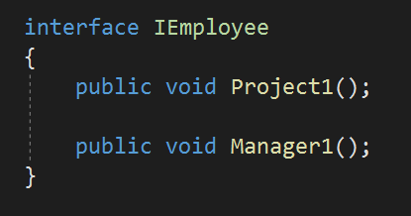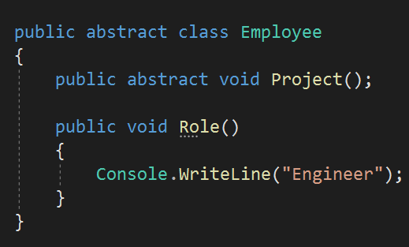

Method Declared

Only method Declaration is allowed

Method Defined

1. Abstract class keyword: **ABSTRACT** 2. Interface keyword: **INTERFACE**

Q27



### What is the difference between an Abstract class and an Interface (atleast 4)?

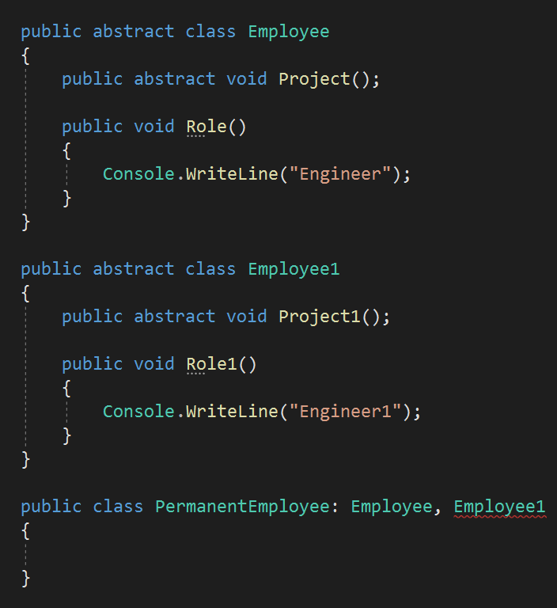

1. Abstract class does not support **multiple inheritance** 3. Interface supports **multiple inheritance.**

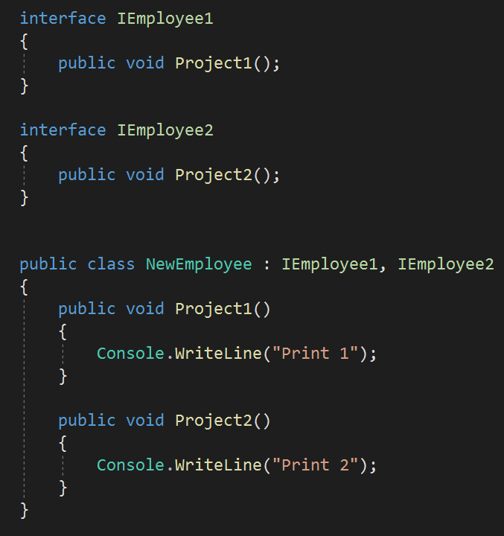

1. Abstract class can have **constructors**. 4. Interface do not have constructors.



Q27

What is the difference between an Abstract class and an Interface (atleast 4)?

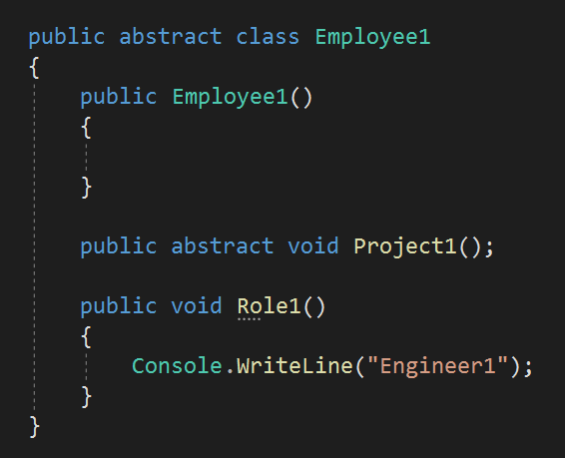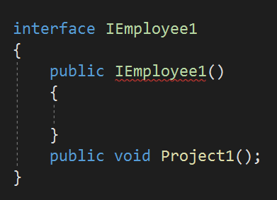



Q27

What is the difference between an Abstract class and an Interface (atleast 4)?

|  |  |
| --- | --- |
| **Abstract Class** | **Interface** |
| 1. Abstract class contains both  **DECLARATION & DEFINITION** of methods. | Mostly Interfaces contain **DECLARATION** of methods. From C# 8.0 definition is also possible. |
| 2. Abstract class keyword: **ABSTRACT** | 2. Interface keyword: **INTERFACE** |
| 3. Abstract class does not support  **multiple inheritance** | 3. Interface supports **multiple inheritance.** |
| 4. Abstract class can have **constructors**. | 4. Interface do not have constructors. |

* When to use Interface?



Q28

When to use Interface and when Abstract class in real applications?

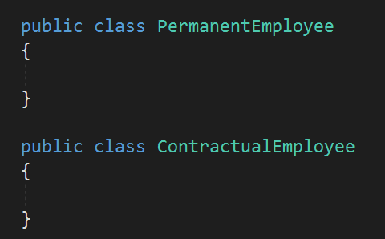

ons?

An interface is a good choice when you know a method has to be there, but it can be implemented **DIFFERENTLY** by independent derived classes.

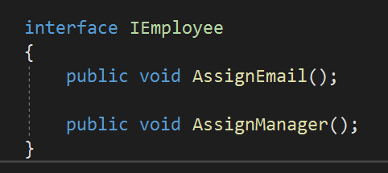

* When to use Abstract class?



Q28

When to use Interface and when Abstract class in real applications?

Abstract class is a good choice when you are sure some methods are concrete/defined and must be implemented in the **SAME WAY** in all derived classes.

* 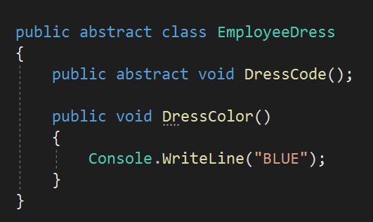Normally we prefer Interface because it gives us the flexibility to modify the behavior at later stage.



Q29

Why to create Interfaces in real applications?

 

* 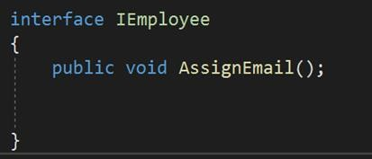Benefits of Interfaces:

1. Help in defining the **contract** of the system.
2. **Unit testing** is easy in application having interfaces.
3. Used for implementing **dependency injection**.
   * 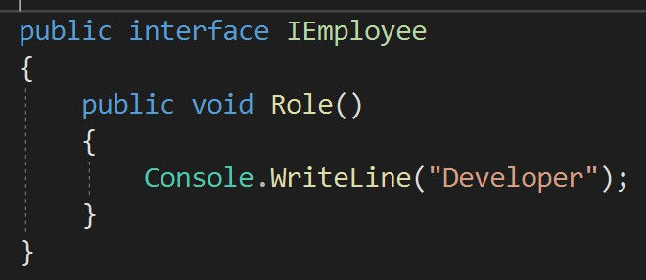Yes. From C# 8.0 it is possible to put method bodies in Interfaces.



Q30

Can we define body of Interfaces methods? When to define methods in Interfaces?

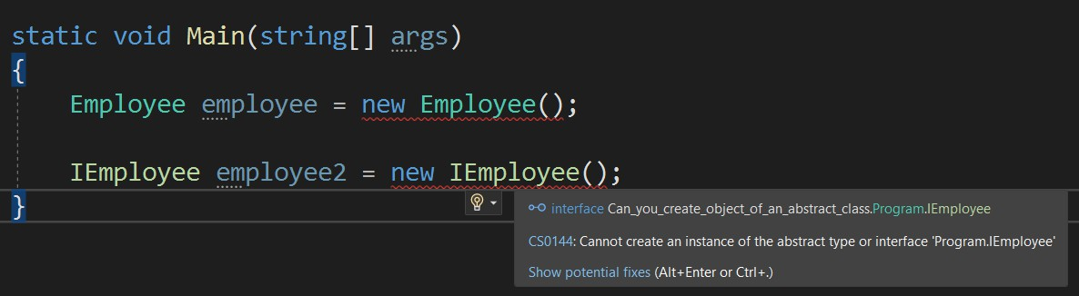

* + 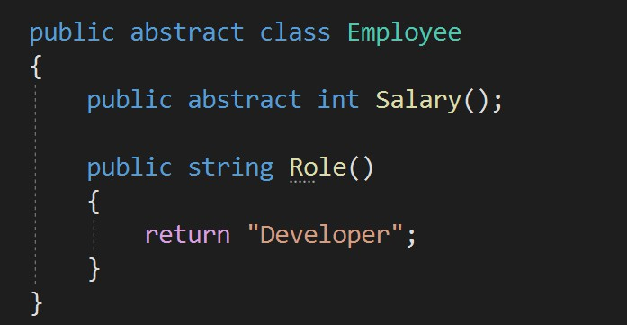No. Abstract class and interface purpose is to act as base class via inheritance. There object creation is not possible.



Q31

Can you create an instance of an Abstract class or an Interface?

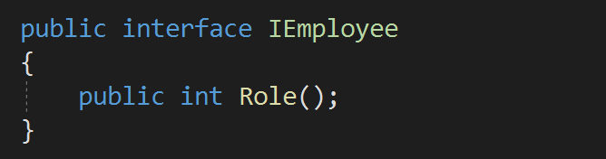

Q32



### Do Interface can have a constructor?

* 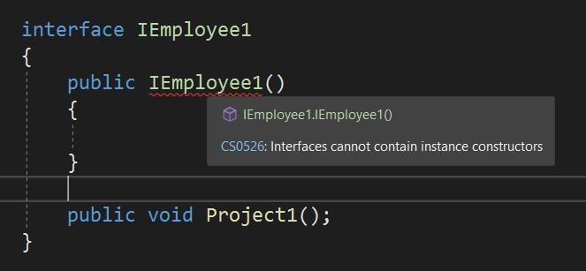**NO**. Interface can only be used for inheritance, so constructor is not required.
* 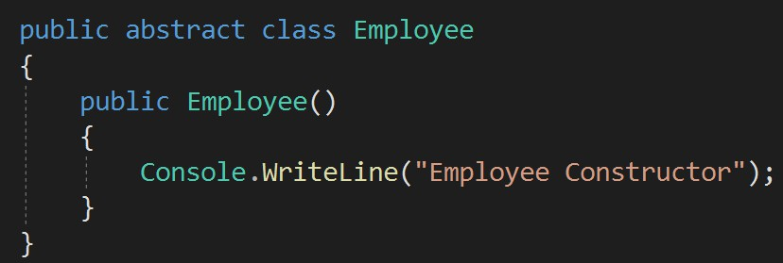YES, Abstract class can have constructors.



Q35

Do abstract class have Constructors in C#?

* 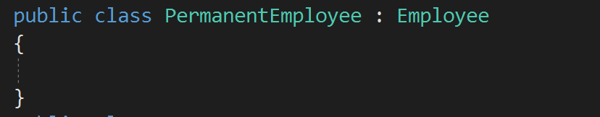The reason is, when the abstract class is inherited in the derived class, and whenever the object of the derived class is created then FIRST the constructor of the abstract/ base class will be called and then only the constructor of derived class will be called.

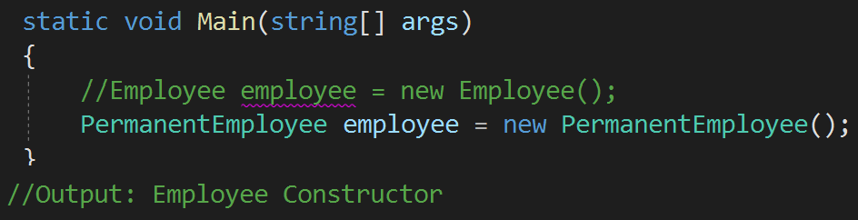

* + Abstraction means showing only required things and hide the **BACKGROUND** details.



Q33

What is the difference between abstraction and abstract class?

* + Abstract class is one of the ways to implement abstraction.
  + NO. Abstract class are used for inheritance, but sealed and static both will not allow the class to be inherited.



Q34

Can Abstract class be Sealed or Static in C#?

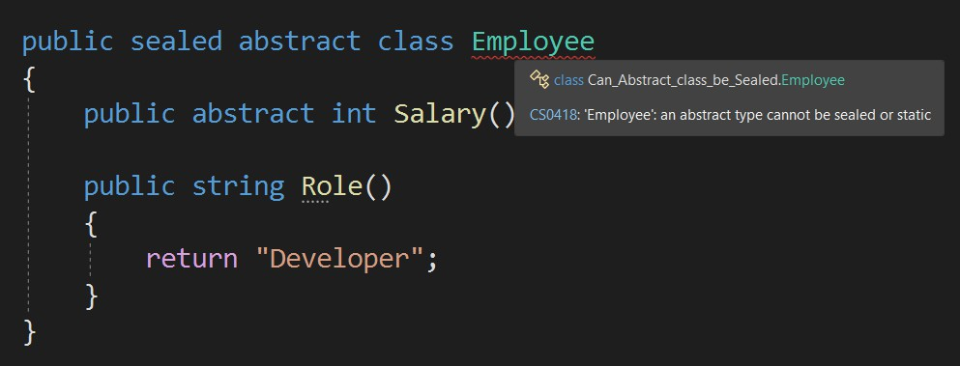

* + - NO. Abstract methods are only declaration, and they must be implemented in the derive class, therefore they can not be private.



Q36

Can you declare abstract methods as private in C#?

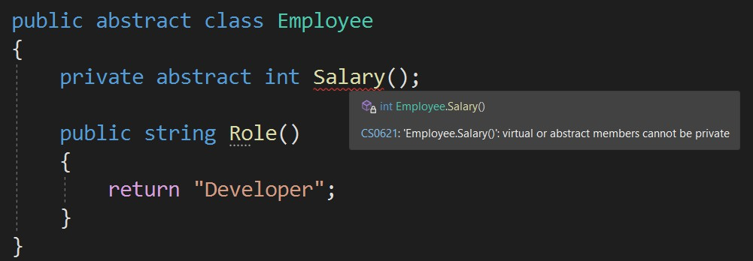

* + - NO. Only at maximum one abstract class can be used for inheritance.



Q37

Does Abstract class support multiple Inheritance?

* + - But multiple interfaces can be used.

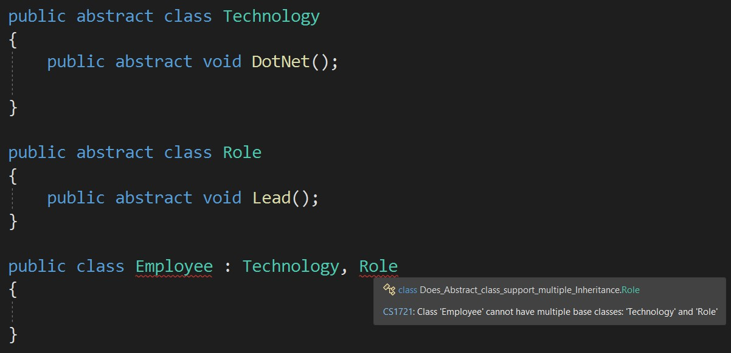

## Tech talks !!!: Access Specifier Example, C#Chapter 4 : OOPS & C# - Access Specifiers, Boxing, Unboxing, String & StringBuilder

Q38. What are Access Specifiers?

V Imp

Q39. What is internal access modifier? Show example? Q40. What is the default access modifier in a class?

Q41. What is Boxing and Unboxing?

V Imp

Q42. Which one is explicit Boxing or Unboxing? Q43. Is Boxing and Unboxing good for performance? Q44. What are the basic string operations in C#?

Q45. What is the difference between “String” and “StringBuilder”?

V Imp

Q46. When to use String and when StringBuilder in real applications?

Q47. What is String Interpolation in C#?

Back to main index

* Access specifiers are keywords to specify the



Q38

What are Access Specifiers?

**accessibility** of a class, method, property, field.

* The keywords are – Public, Private, Protected, Internal, Protected Internal.

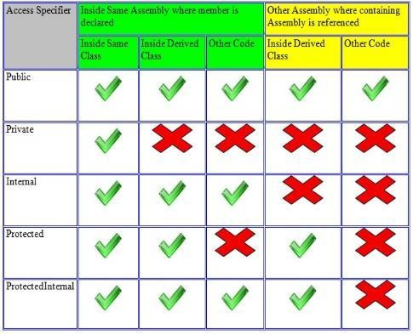

Q39



### What is internal access modifier? Show example.

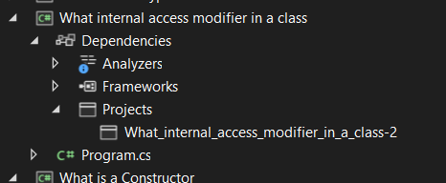

* 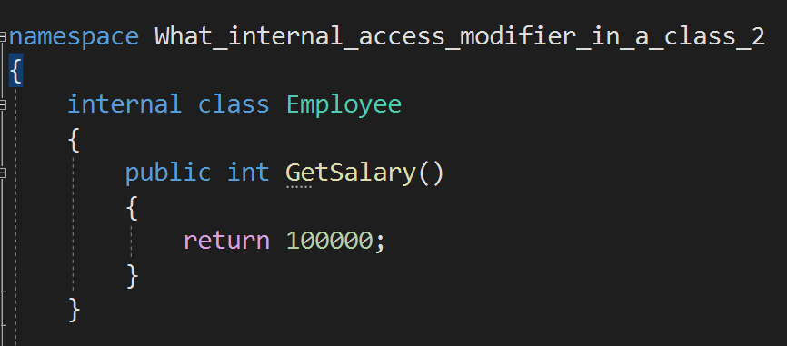Internal modifier is used to tell that access is limited to the current assembly.

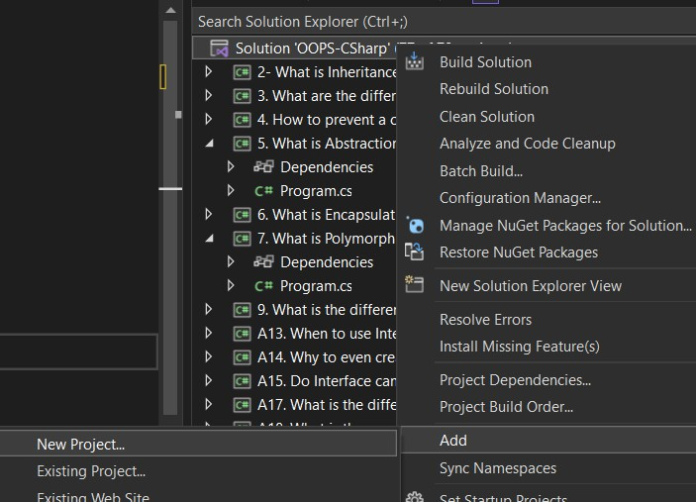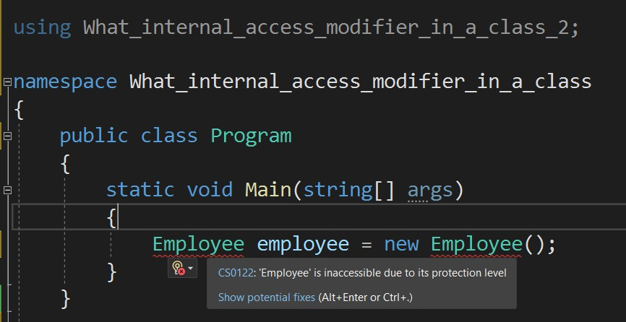



Q40

What is the default access modifier in a class?

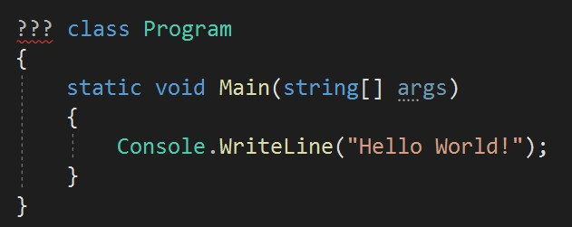

Internal is the default access

modifier of a class.

* + 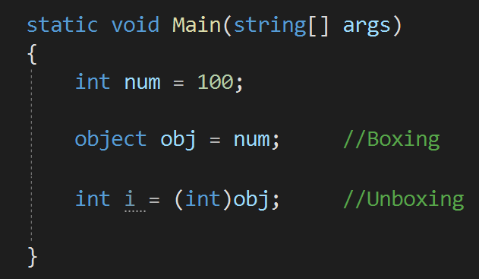**Boxing -** Boxing is the process of converting from value type to reference type.



Q41

What is Boxing and Unboxing? Where to use Boxing and Unboxing in real applications?

* + **Unboxing -** Unboxing is the process of

converting reference type to value type.

* + We internally use boxing when item is added to Arraylist. And we use unboxing when item is extracted from Arraylist.



Q41

What is Boxing and Unboxing? Where to use Boxing and Unboxing in real applications?

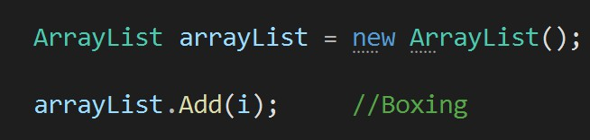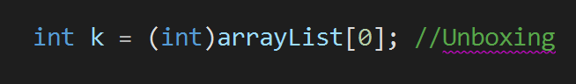

* + - 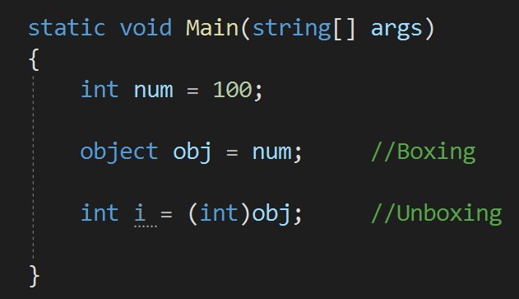Unboxing is explicit conversion process.



Q42

Which one is explicit Boxing or Unboxing?

* + 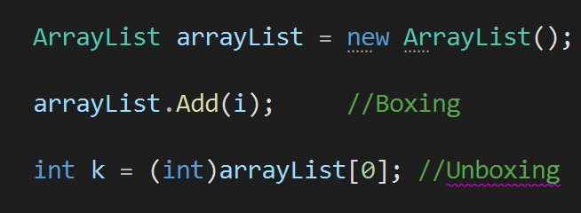No, it is recommended to use boxing and unboxing when it is necessary only.



Q43

Is Boxing and Unboxing good for performance?

* + Converting from one type to another type is not good from performance point of view.

What are



Q44

What are the basic string operations in C#?

* + - **Concatenate:**

Two strings can be concatenated either by using a System.String.Concat or by using + operator.

*string str1 = "This is one"; string str2 = "This is two"; string str2 = str1 + str2;*

*//Output: This is one This is two*

* + - **Replace:**

Replace(a,b) is used to replace a string with

another string.

*string str1 = "This is one";*

*string str2 = str1.Replace(“one”, “two”);*

*//Output: This is two*

* + - **Trim:**

Trim() is used to trim the white spaces in a string at the end.

*string str1 = "This is one "; str1.Trim();*

*//Output: "This is one“*

* + - **Contains:**

Check if a string contains a pattern of substring or not.

*string str = "This is test";*

*bool result = str.Contains("test");*

*//Output: true*

45 What is the difference be



Q45

What is the difference between “String” and “StringBuilder”?

* String is **IMMUTABLE** in C#.  StringBuilder is **MUTABLE** in C#.

*It means if you defined one string then you couldn’t modify it. Every time you will assign some value to it, it will create a new string.*

*This means if any manipulation will be done on string, then it will not create a new instance every time.*

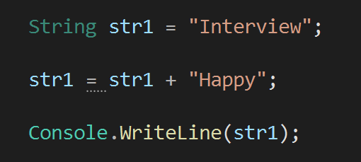

Both these strings are different and occupy different memory in process

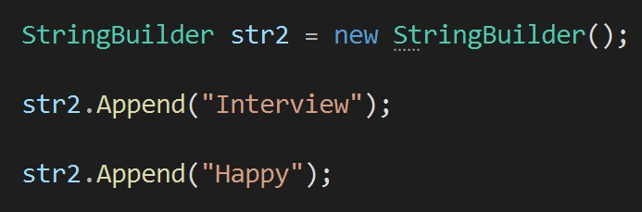

Only one string in memory.

* + If you want to change a string **multiple times**, then StringBuilder is a better option from **performance** point of view because it will not require new memory every time.



Q46

When to use String and when StringBuilder in real applications?



* + - String interpolation is a technique that enables you to insert expression values into strings.



Q47

What is String Interpolation in C#?

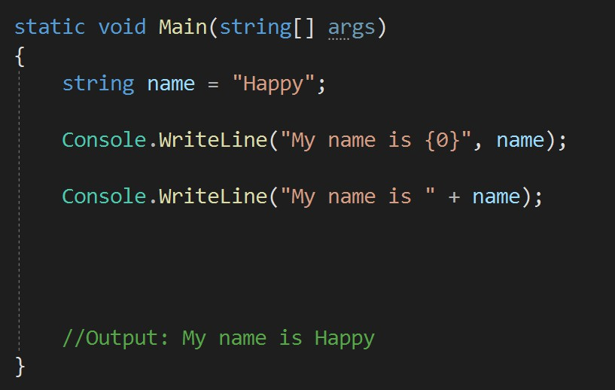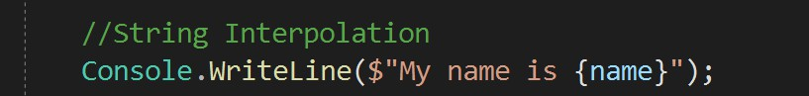

## Chapter 5 : OOPS & C# - Loops, Conditions, Exception Handling

Q48. What are the Loop types in C#? When to use what in real applications?

Q49. What is the difference between “continue” and “break” statement? V Imp

Q50. What are the alternative ways of writing if-else conditions? When to use what?

Q51. How to implement Exception Handling in C#? Q52. Can we execute multiple Catch blocks?

Q53. When to use Finally in real applications?

V Imp

Q54. Can we have only “Try” block without “Catch” block in real applications? Q55. What is the difference between Finally and Finalize?

Q56. What is the difference between “throw ex” and “throw”? Which one to use in real applications?

V Imp

Back to main index

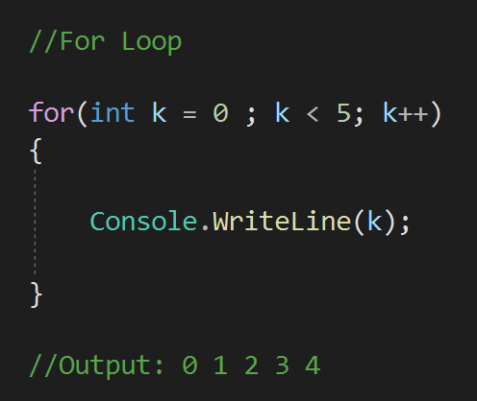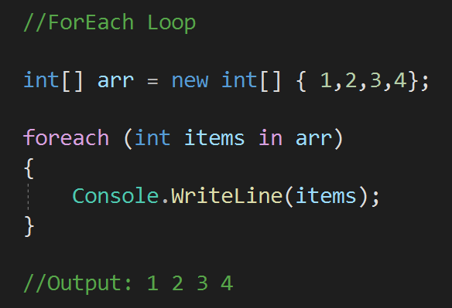



Q48

What are the Loop types in C#? When to use what in real applications?

Whether condition true or false, this statement will run at least first time.

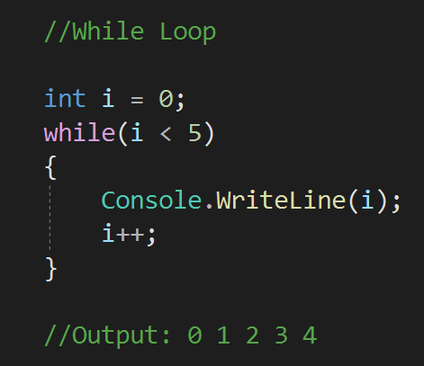

Increment

Condition

Initialize

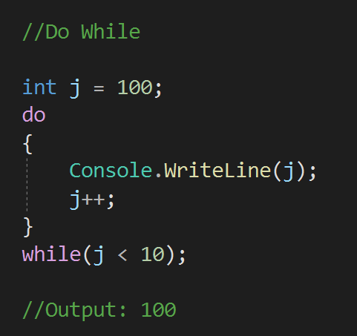

Q49



### What is the difference between “continue” and “break” statement?

* **Continue** statement end the loop iteration and transfer the control to the beginning of the loop.
* **Break** statement end the loop iteration and exit the loop.

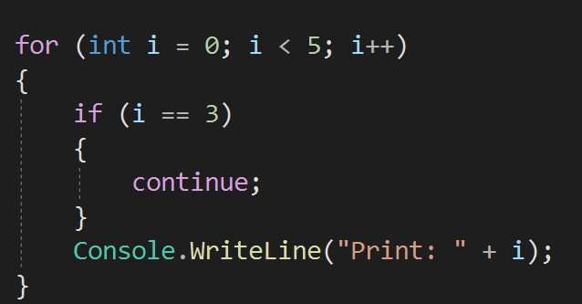 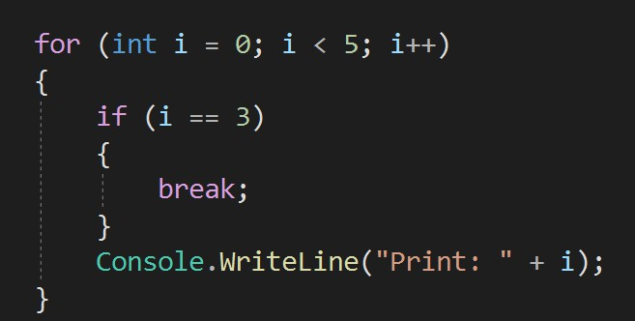

//Output:

Print: 0

Print: 1

Print: 2

Print: 4

//Output:

Print: 0

Print: 1

Print: 2

* 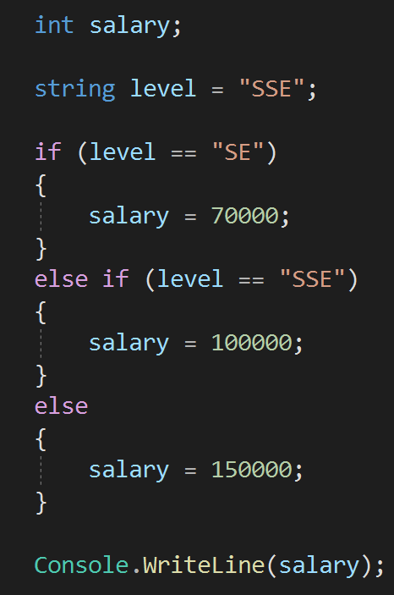**Switch** statement  **If-else if-else** statement



Q50

What are the alternative ways of writing if-else conditions? When to use what?

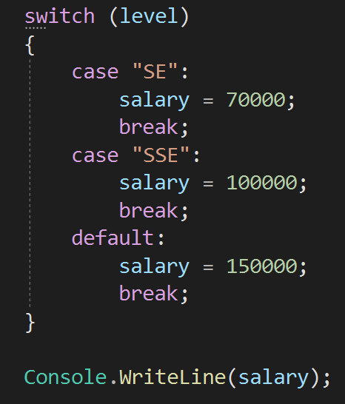

* **Ternary** Operator ?:

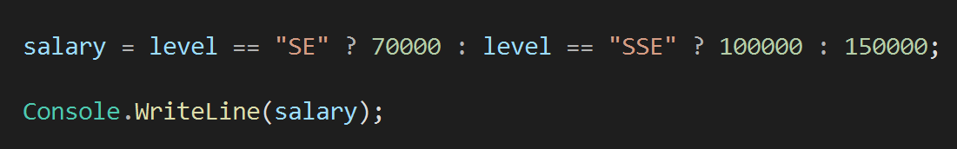

Q51

### How to implement Exception Handling in C#?

* + 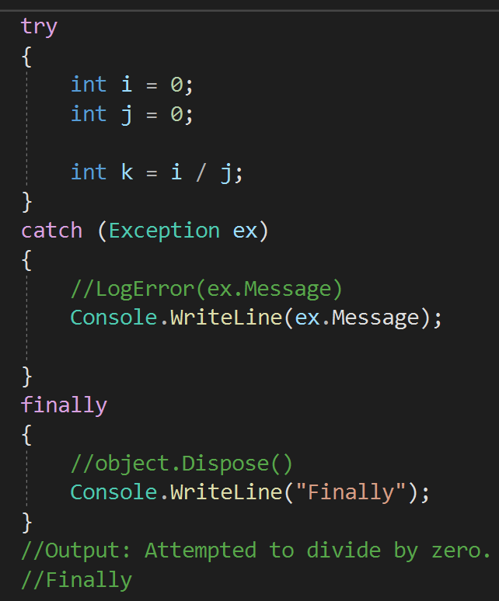Exception handling in Object-Oriented Programming is used to **MANAGE ERRORS.**



1. **TRY** − A try block is a block of code inside which any error can occur.
2. **CATCH** − When any error occur in TRY block then it is passed to catch block to handle it.
3. **FINALLY** − The finally block is used to execute a given set of statements, whether an exception occur or not.

#### NO



Q52

Can we execute multiple Catch blocks?

*We can write multiple catch blocks but when we will run the application and if any error occur,* ***only one*** *out of them will execute based on the type of error****.***

* 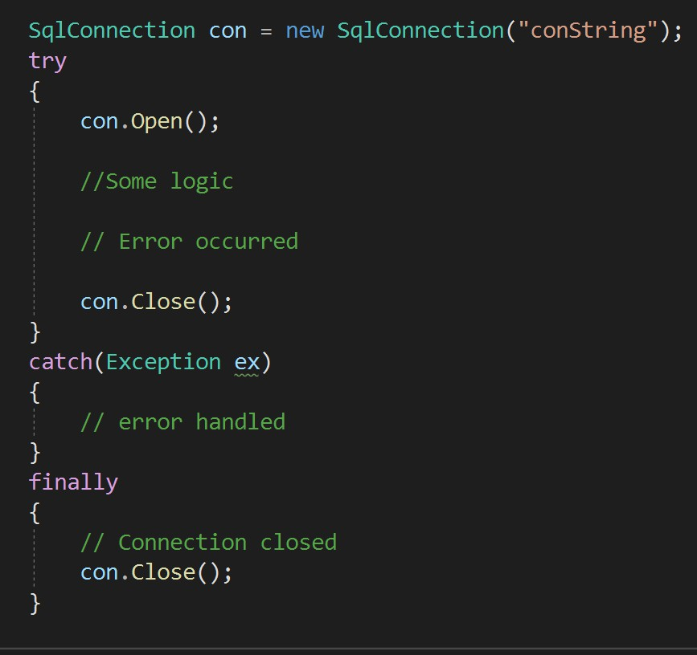Finally block is mostly used to dispose the unwanted objects when they are no more required. This is good for performance, otherwise you have to wait for garbage collector to dispose them.



Q53

When to use Finally in real applications?

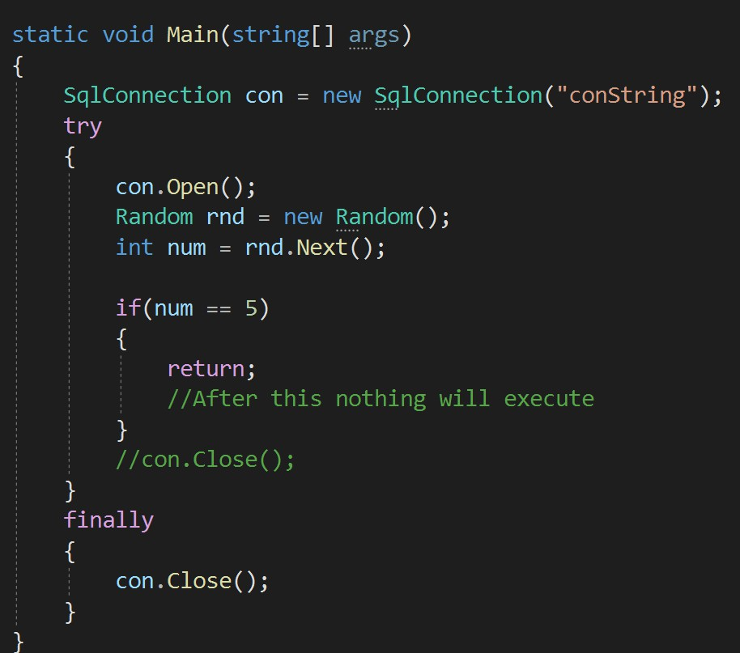in real applications?



Q54

Can we have only “Try” block without “Catch” block in real applications?

* + YES - We can have only try block without catch block, but then we must have **finally** block with try block.
    - Finally, is used in exception handling.



Q55

What is the difference between Finally and Finalize?

* + - Finalize is a method which is automatically called by the

**garbage collector** to dispose the no longer needed objects.

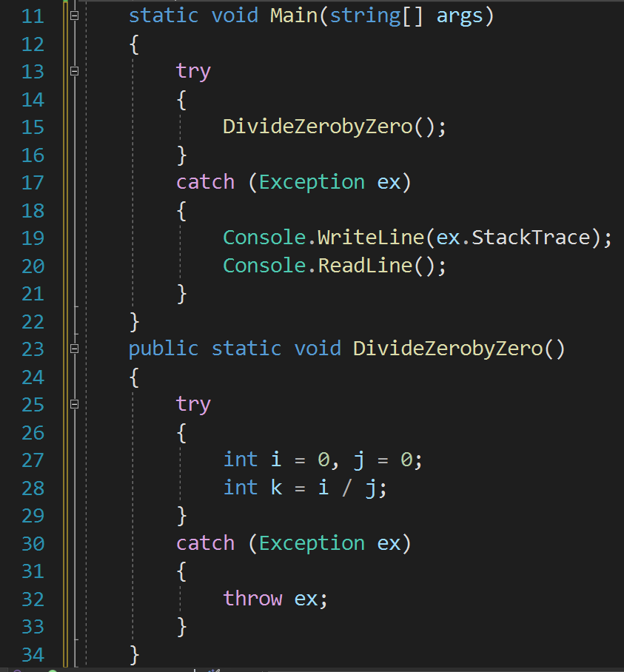one to use in real applications?



Q56

What is the difference between “throw ex” and “throw”? Which one to use in real applications?

* Throw ex will change the stack trace, where as

throw will preserve the whole **stack trace**.

**Error:**

at Throw_ex and throw.Program.DivideZerobyZero() in D:\InterviewHappy\_InterviewHappy-Hindi\31-Oct- 2022\OOP_CSharp_Code\Throw_ex_Throw\Program.cs:line 32

at Throw_ex and throw.Program.Main(String[] args) in D:\InterviewHappy\_InterviewHappy-Hindi\31-Oct- 2022\OOP_CSharp_Code\Throw_ex_Throw\Program.cs:line 15

* 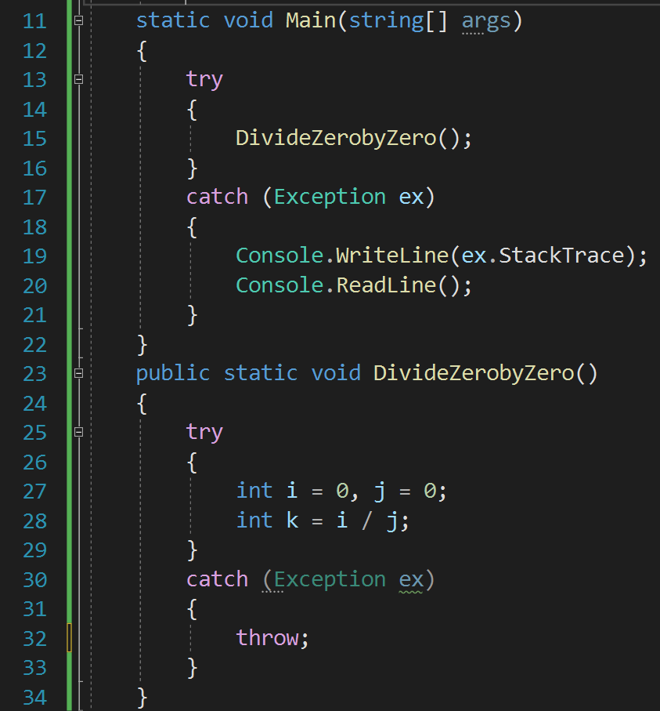Throw ex will change the stack trace, where as



Q56

What is the difference between “throw ex” and “throw”? Which one to use in real applications?

throw will preserve the whole stack trace.

**Error:**

at Throw_ex and throw.Program.DivideZerobyZero() in D:\InterviewHappy\_InterviewHappy-Hindi\31-Oct- 2022\OOP_CSharp_Code\Throw_ex_Throw\Program.cs:line 28

at Throw_ex and throw.Program.Main(String[] args) in D:\InterviewHappy\_InterviewHappy-Hindi\31-Oct- 2022\OOP_CSharp_Code\Throw_ex_Throw\Program.cs:line 15

* Its a best practice to use *throw* as it preserve the whole **stack trace.**

## Chapter 6 : OOPS & C# - Generics & Collections

Q57. Explain Generics in C#? When and why to use?

V Imp

Q58. What are Collections in C# and what are their types?

Q59. What is the difference between Array and ArrayList (atleast 2)? Q60. What is the difference between Arraylist and Hashtable?

Q61. What is the difference between List and Dictionary Collections? Q62. What is IEnumerable in C#?

V Imp V Imp

Q63. What is the difference between IEnumerable and IEnumerator in C#?

Q64. What is the difference between IEnumerable and IQueryable in C#?

V Imp

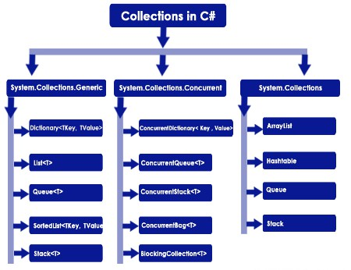Back to main index

* 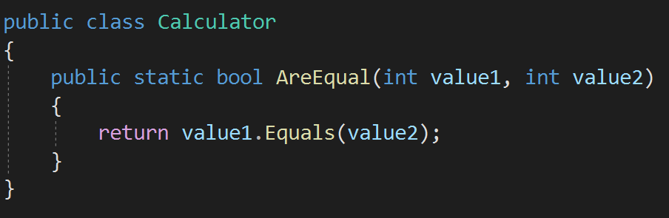Generics allows us to make classes and methods - **type independent or type safe**.



Q57

Explain Generics in C#? When and why to use them in real applications?

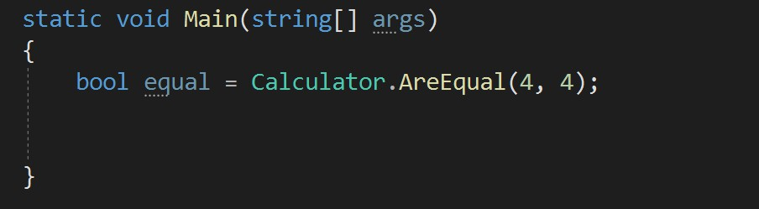

* + 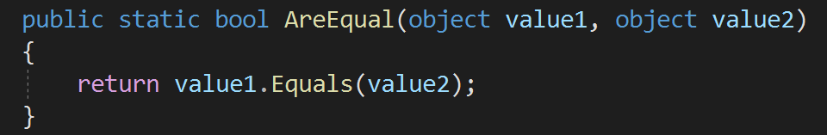The problem is, it involves Boxing from converting string (value) to object (reference) type. This will impact the performance.
* 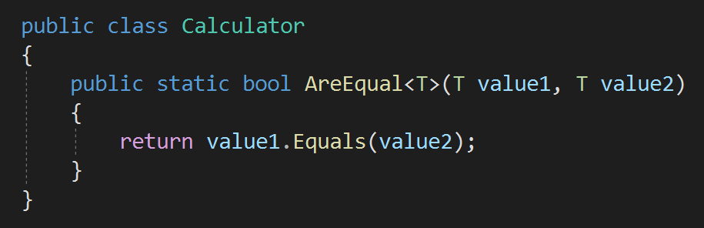Generics allows us to make classes and methods - **type independent or type safe**.
  + Generic Method



Q57

Explain Generics in C#? When and why to use them in real applications?

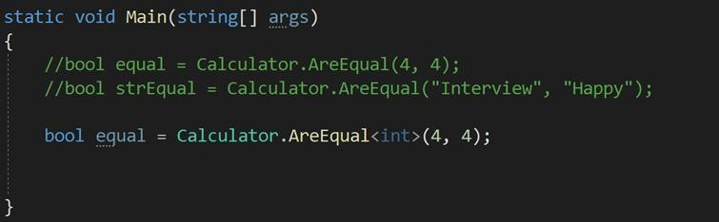

* 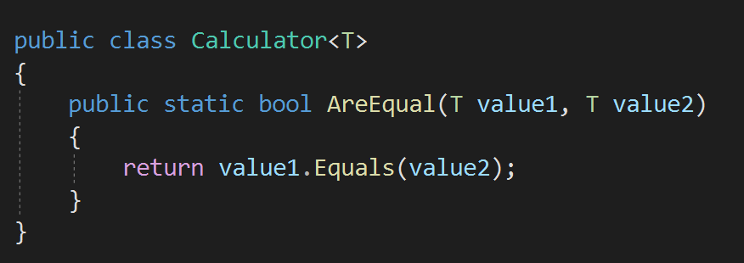Generics allows us to make classes and methods - **type independent or type safe**.
  + Generic Class



Q57

Explain Generics in C#? When and why to use them in real applications?

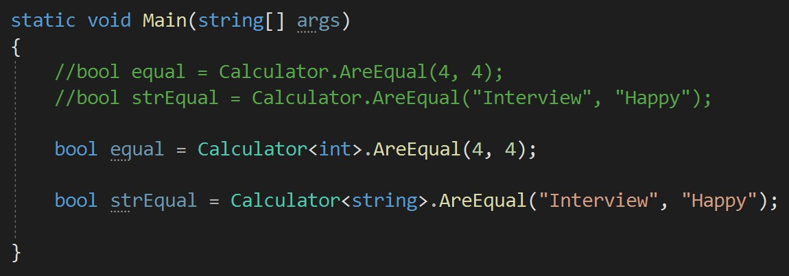

* 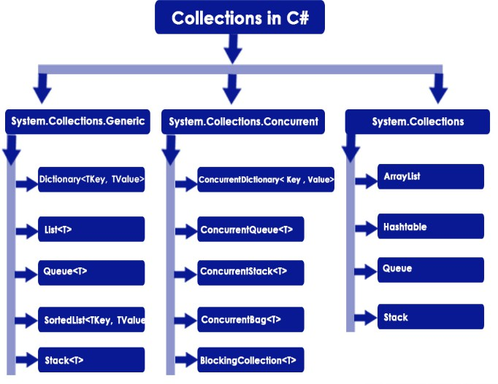C# collection are used to **store, manage and manipulate** data.



Q58

What are Collections in C# and what are their types?

* *For example ArrayList, Dictionary, List, Hashtable etc.*
  + Array  ArrayList



Q59

What is the difference between Array and ArrayList (atleast 2)?

1. Array is STRONGLY typed.

This means that an array can store only specific type of items/ elements.

1. ArrayList can store ANY type of items\elements.

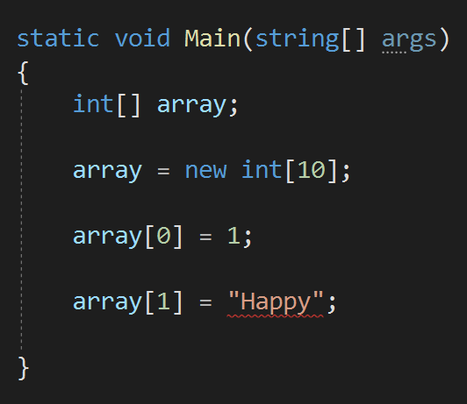

2. Array can contain FIXED number of items.

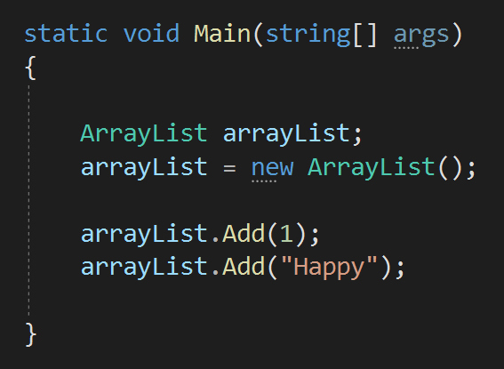

2. ArrayList can store ANY

number of

items.

* + In Arraylist we can only add Items/ Values to the list.



Q60

What is the difference between Arraylist and Hashtable?

* + In Hashtable we can add Items/Values with the Keys.

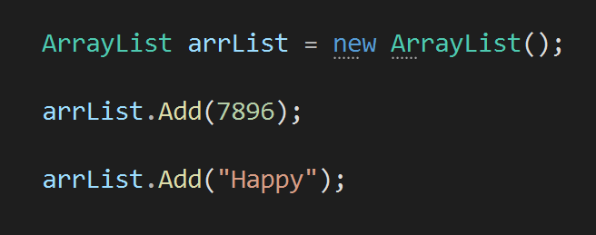

Value

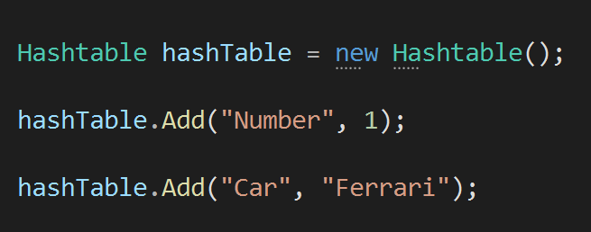

Value

Key

* + 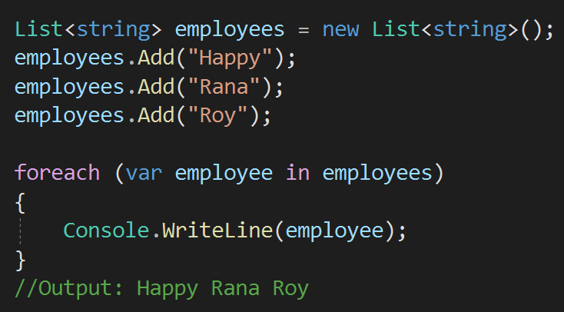List is a collection of items.



Q61

What is the difference between List and Dictionary Collections?

* + It is the generic version of Arraylist.
  + 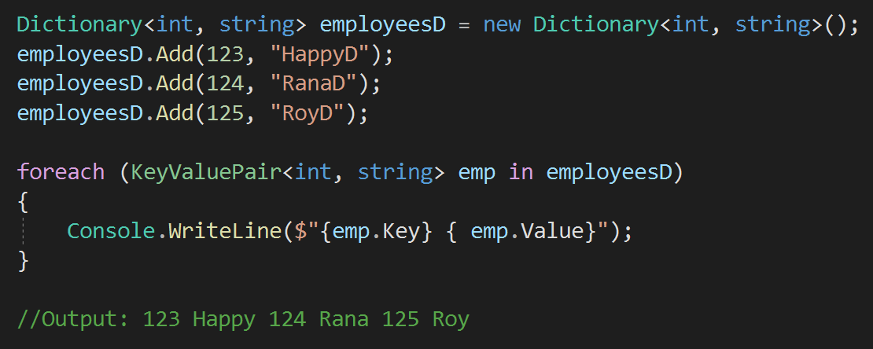Dictionary is a collection of key value pair.
  + It is the generic version of Hashtable.
  + IEnumerable interface is used when we want to ITERATE among our collection classes using a **FOREACH** loop.



Q62

What is IEnumerable in C#?

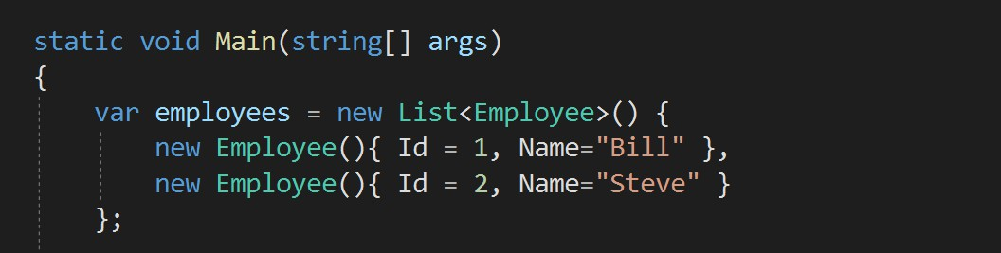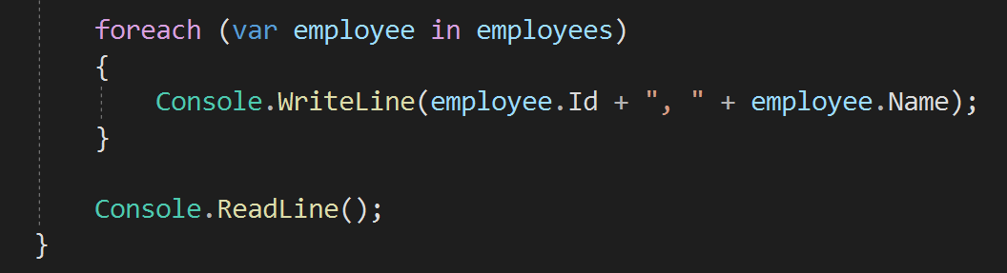

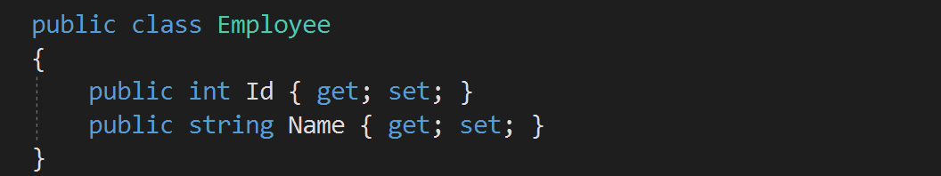



Q62

What is IEnumerable in C#?

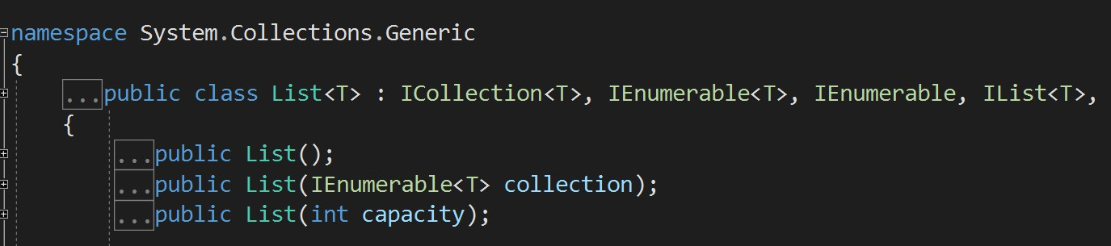

* + - 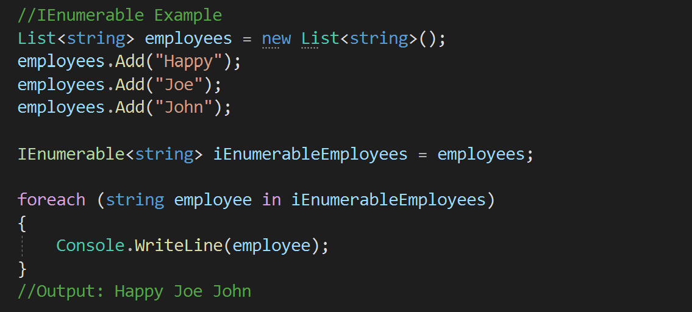IEnumerable internally uses IEnumerator only to iterate the collection via forach loop.



Q63

What is the difference between IEnumerable and IEnumerator in C#?

* + - IEnumerable simplifies the use of IEnumerator.

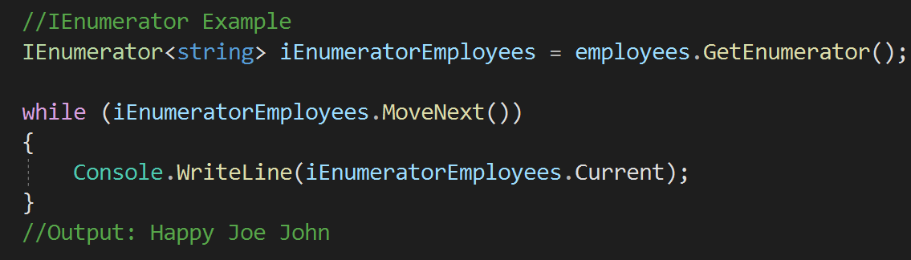



Q63

What is the difference between IEnumerable and IEnumerator in C#?

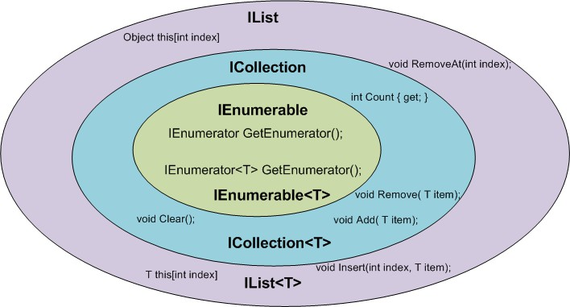 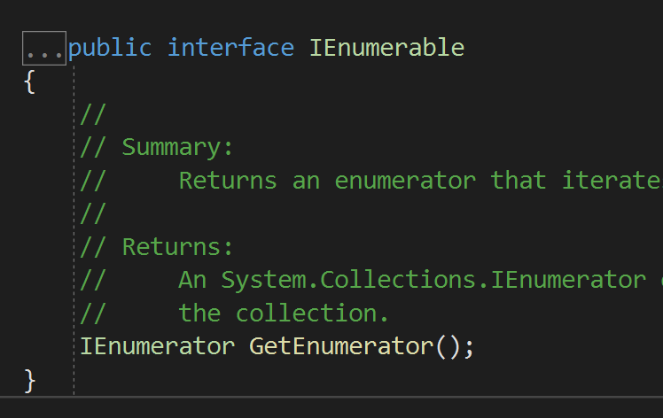

* + - * IQueryable inherited from IEnumerable interface only, so anything you can do with a IEnumerable, you can also do with an IQueryable also.



Q64

What is the difference between IEnumerable and IQueryable in C#?

Why to use IQueryable for sql queries?

* + - * For example, iterating the collection can be done

by both IEnumerable and IQueryable.

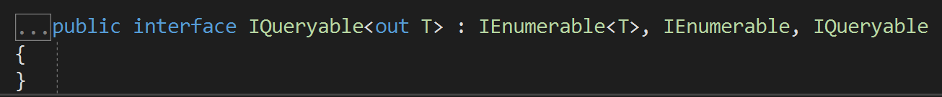

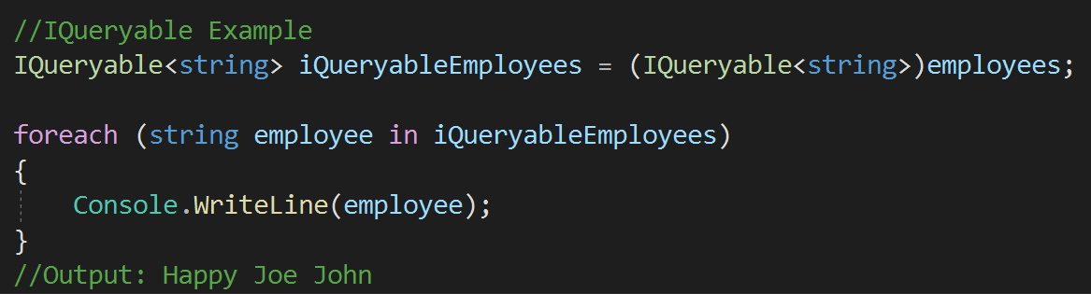



Q64

What is the difference between IEnumerable and IQueryable in C#?

Why to use IQueryable for sql queries?

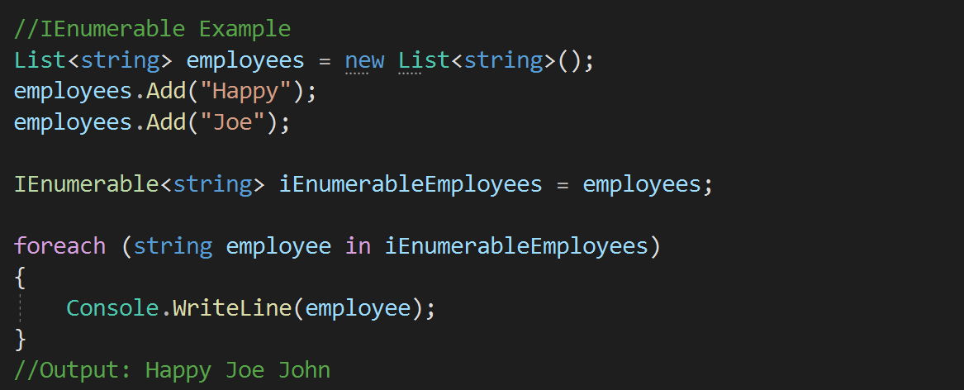

Q64

### What is the difference between IEnumerable and IQueryable in C#? Why to use IQueryable for sql queries?

* + - * IEnumerable is used with in-memory collection.



* + - * IQueryable is better in getting result from database.

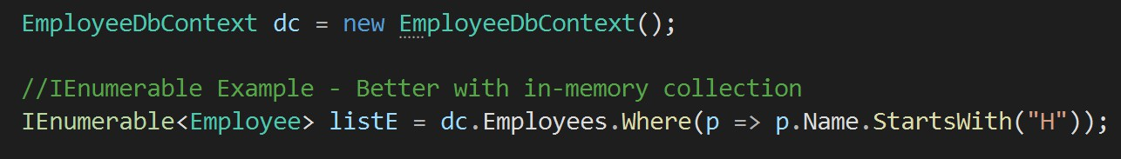

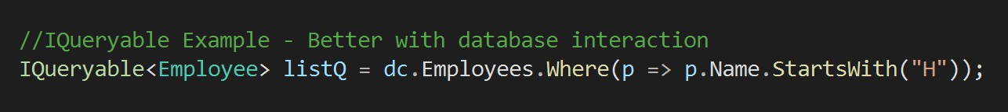

Q64

### What is the difference between IEnumerable and IQueryable in C#? Why to use IQueryable for sql queries?

* 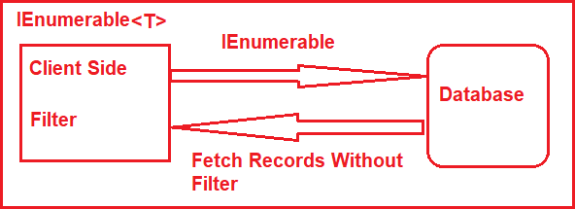IQueryable inherited from IEnumerable interface only, so anything you can do with a IEnumerable, you can also do with an IQueryable also.



* 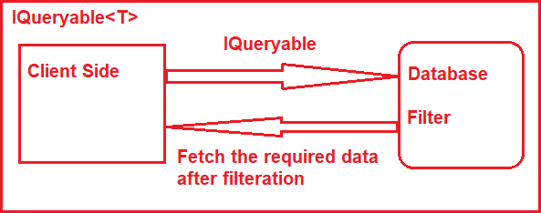IEnumerable bring all result from database and then filter it at code side, which is a network load and performance issue.
* IQueryable filter the result at database only and then get only filtered result, therefore less network load and better performance.
* IQueryable is under SYSTEM.LINQ namespace. IEnuberable is under System.Collections namespace.

## Chapter 7 : OOPS & C# - Constructors

Q65. What is a Constructor? When to use constructor in real applications?



Default Constructor

Parameterized

Constructor

Copy Constructor

Static Constructor

Private Constructor

Q66. What are the types of constructor? Q67. What is Default constructor?

Q68. What is Parameterized constructor?

V Imp

Q69. What is Static constructor? What is the use in real applications? Q70. Can we have parameters or access modifier in static constructor? Q71. What is Copy constructor?

Types of Constructors

Q72. What is Private constructor? What is the use?

Q73. What is Constructor overloading?

Q74. What is Destructor?

Q75. Can you create object of class with private constructor in C#?

Q76. If base class and child class both have constructor which one will be called first, when derived class object is created?

Back to main index

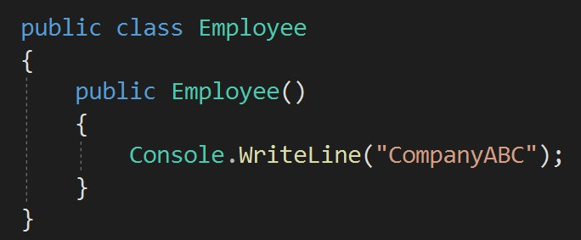lications?



Q65

What is a Constructor? When to use constructor in real applications?

* A constructor is a **specialized method** in the class which gets executed when a class object is created.
* Constructor name will same as of Class name.
* A constructor is used **to set default values** for the class.

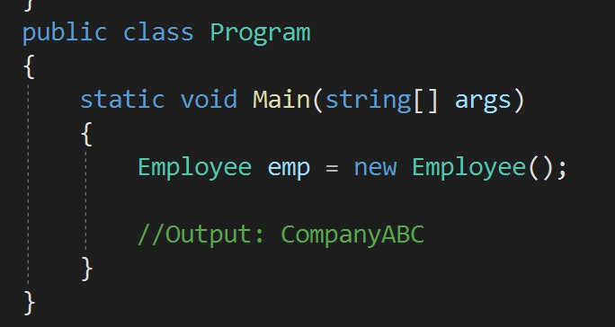



Q66

What are the types of constructor?



Types of Constructors

Default

Constructor

Parameterized

Constructor

Copy

Constructor

Static

Constructor

Private

Constructor

* + 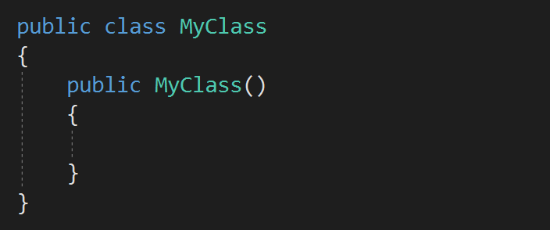A default constructor is a constructor that is automatically created by the compiler, if no other constructors are defined in the class.



Q67

What is Default constructor?

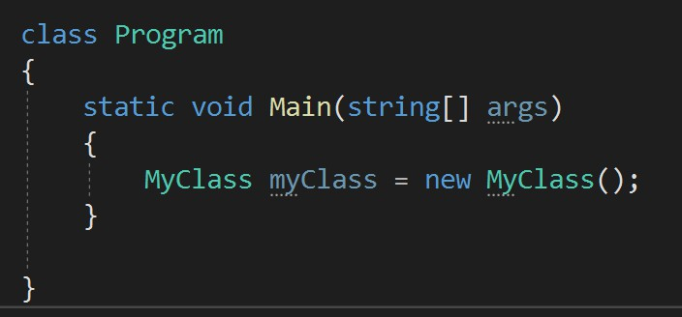

* + - 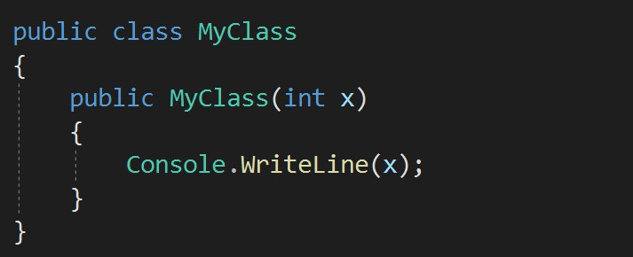A constructor with at least one parameter is a parameterized constructor.



Q68

What is Parameterized constructor?

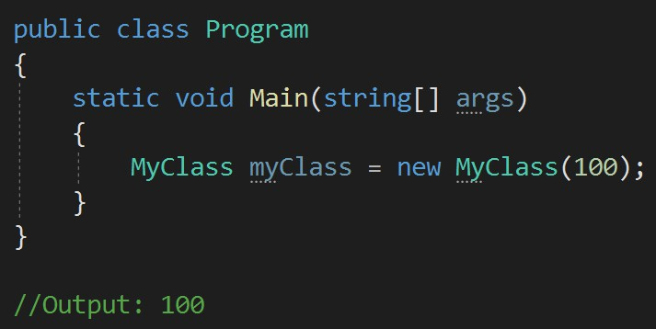

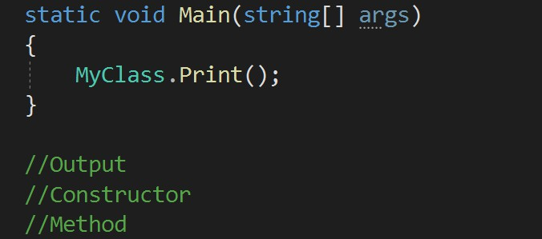

* 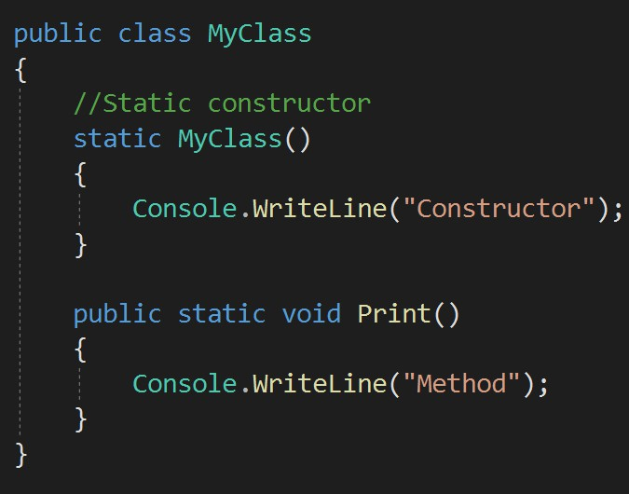Static constructor is used to be called before any static member of a class is called.



Q69

What is Static constructor? What is the use of it in real applications?

tructor?



Q70

Can we have parameters or access modifier in static constructor?

* + No, static constructor can not have parameters or access modifier.

Q71

### What is Copy constructor?

* + - 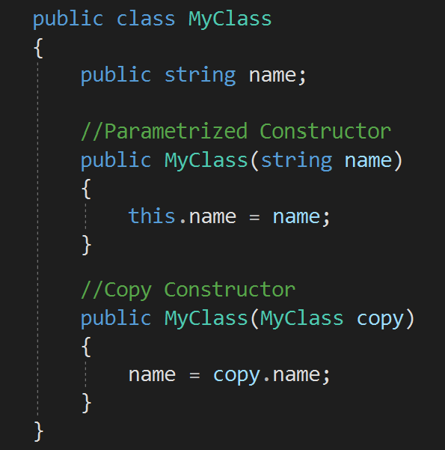The constructor which creates an object by copying variables from another object is called a copy constructor.



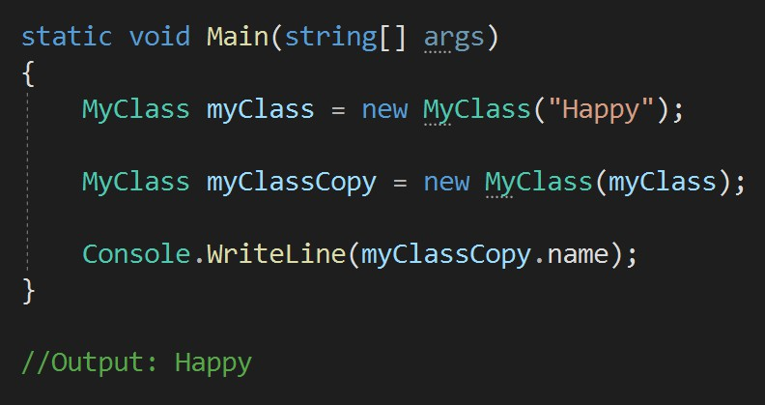

Q72



### What is Private constructor? What is the use?

* + 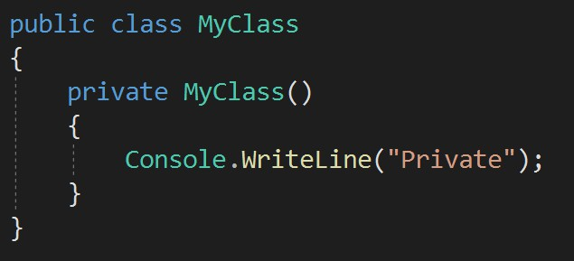When a constructor is created with a private specifier, it is not possible for other classes to derive from this class, neither is it possible to create an instance of this class.

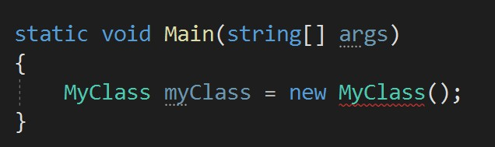

* Constructor Overloading is a technique to define multiple constructors within a class with different sets of parameters.



Q73

What is Constructor overloading?

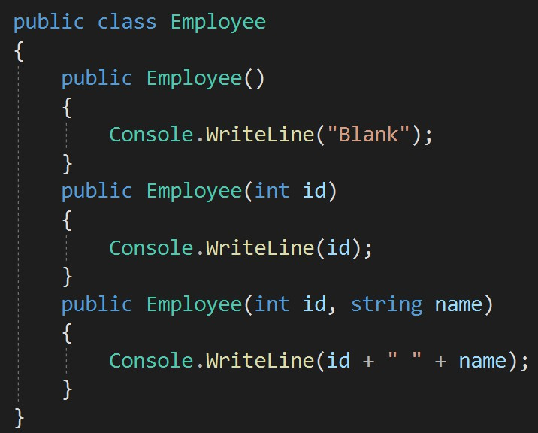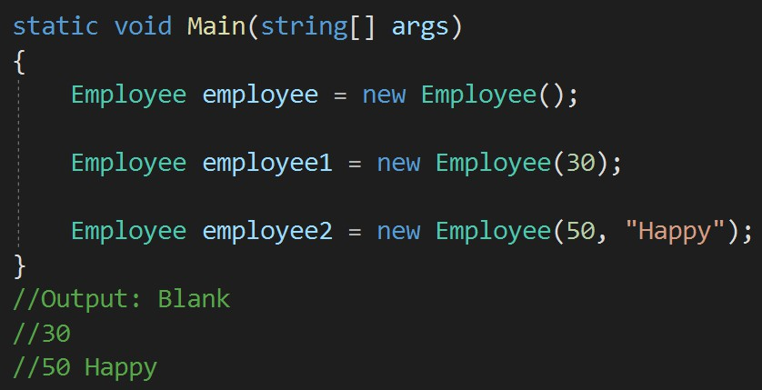

* 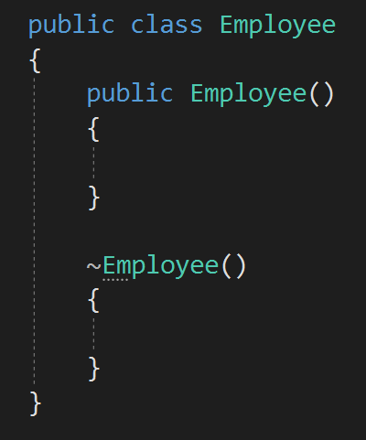Destructors in C# are methods inside the class used to destroy instances of that class when they are no longer needed.



Q74

What is Destructor?

* The Destructor is called implicitly by the .NET Framework’s Garbage collector
  + No



Q75

Can you create object of class with private constructor in C#?

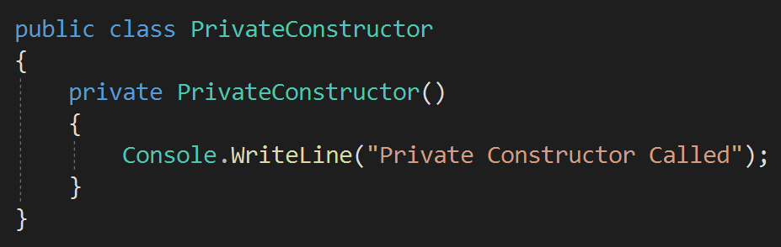

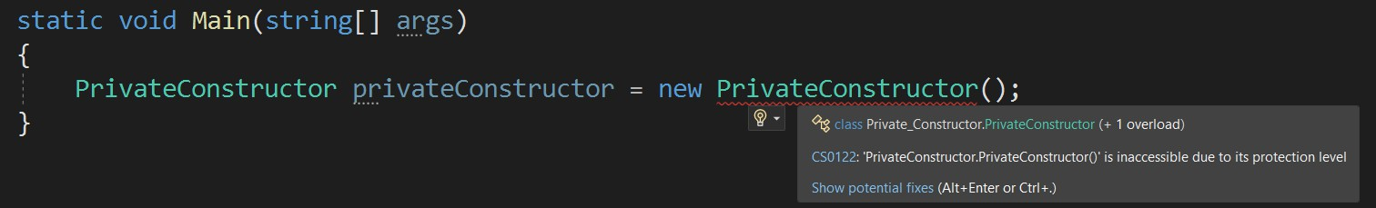

* 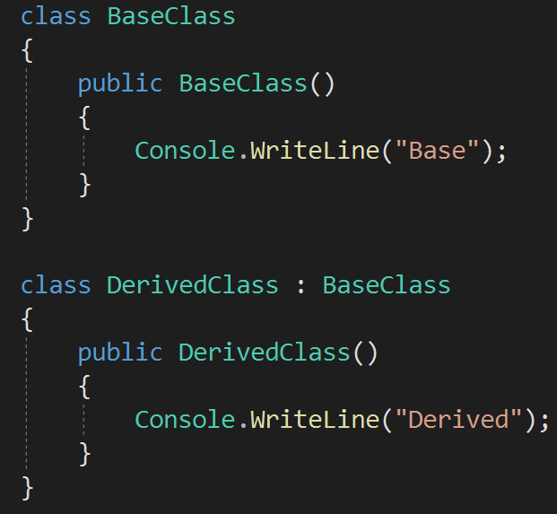Base class



Q76

If base class and child class both have constructor which one will be called first,

when derived class object is created?

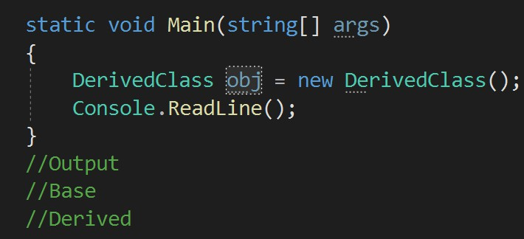

## Chapter 8 : OOPS & C# - Method Parameters, Delegates & Events

Q77. What is a Method in C#?

Q78. What is the difference between Pass by Value and Pass by Reference Parameters?

Q79. How to return more than one value from a method in C#? V Imp

Q80. What is the difference between “out” and “ref” parameters? V Imp

Q81. What is “params” keyword? When to use params keyword in real applications? Q82. What are optional parameters in a method?

Functions

Delegate

Event

Q83. What are named parameters in a method?

Q84. What are Extension Methods in C#? When to use extension methods? Q85. What are Delegates in C#? When to use delegates in real applications? Q86. What are Multicast Delegates?

Q87. What are Anonymous Delegates in C#?

V Imp V Imp

Q88. What are the differences between Events and Delegates? V Imp

Back to main index

* A **method** is a code block that contains a series of statements.



Q77

What is a Method in C#?



Method

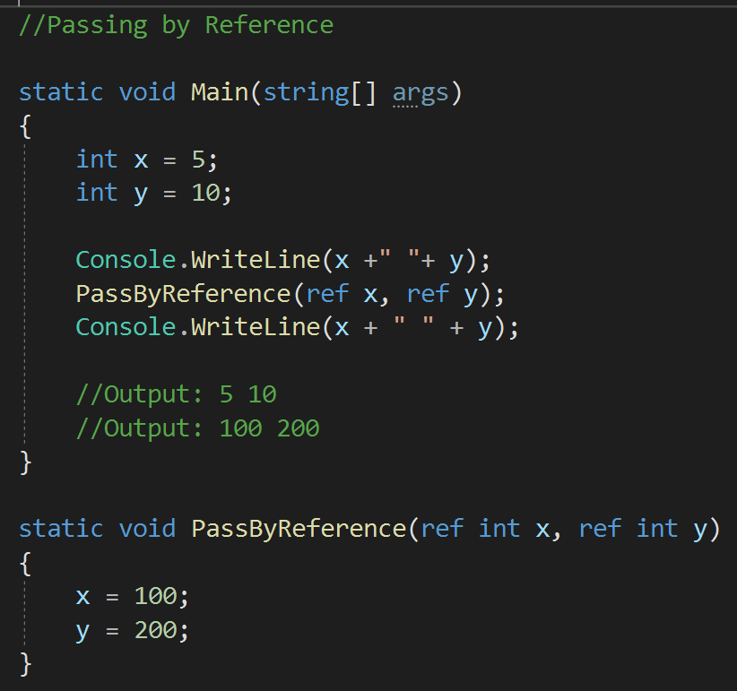Q78. What is the difference between Pass by Value an by Reference Parameters?



Q78

What is the difference between Pass by Value and Pass by Reference Parameters?

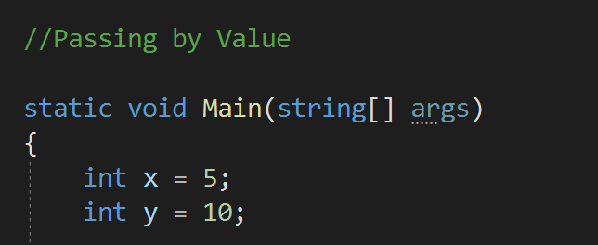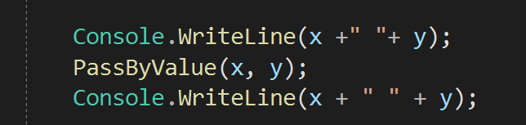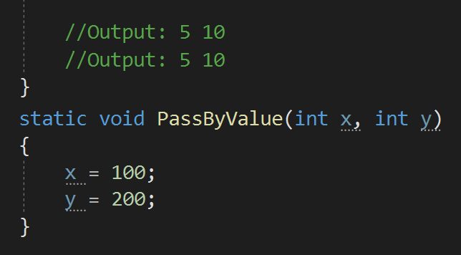

C#?



Q79

How to return more than one value from a method in C#?

* + By using ref and out keywords.
  + By using a List, Arraylist(any collection) in the return type.
  + When to use out and when to use ref?

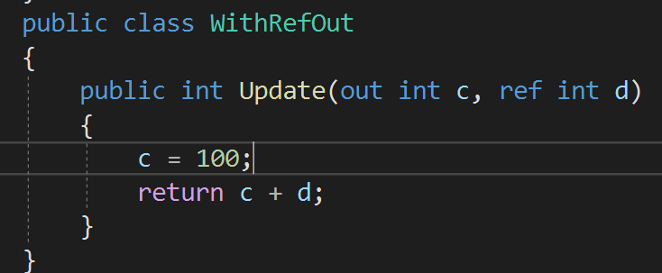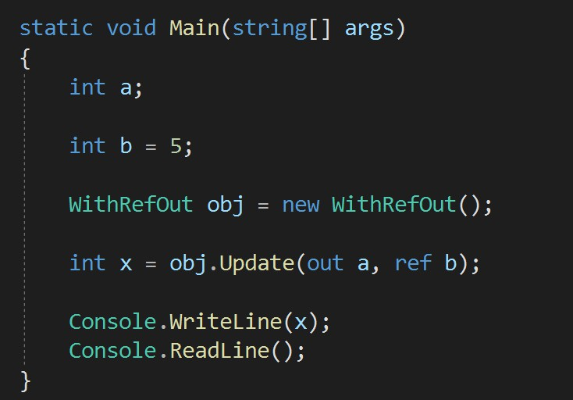

2. For Ref parameter, Initialization is not necessary before returning.

2. Out parameter must be initialized before returning.

1. Must initialize ref

parameter else error.

1. No need to initialize out parameter before passing it.



Q80

What is the difference between “out” and “ref” parameters?

Use out parameter to return a new and fresh value and use ref to modify an existing value.

* + Params keyword is used as a parameter which can take the **VARIABLE** number of parameters**.**

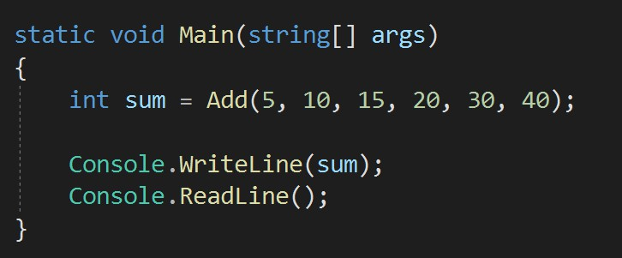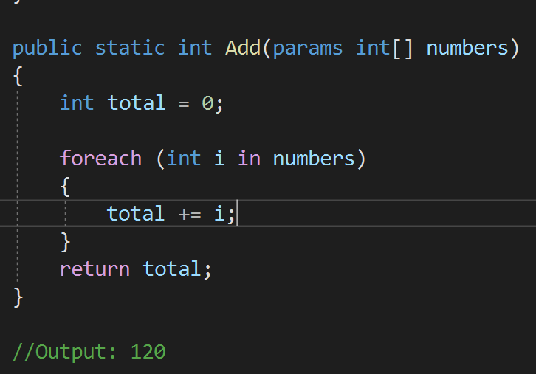

Q81

What is “params” keyword? When to use params keyword in real applications?

You can pass any number of parameters here.

* + It is useful when programmer don’t have any prior knowledge about the number of parameters to be used.
    - 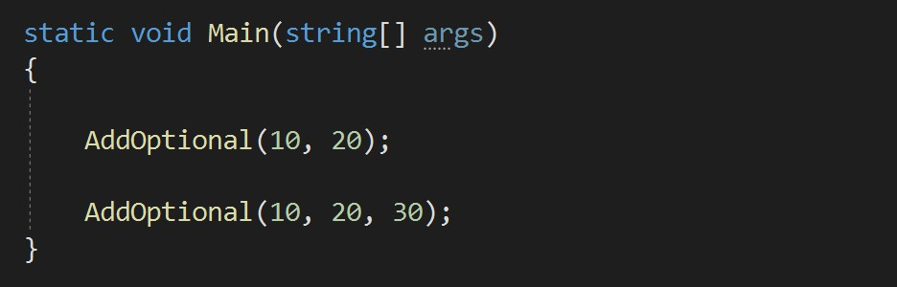Optional parameters allow some arguments which are not mandatory to pass, and their default value is set.



Q82

What are optional parameters in a method?

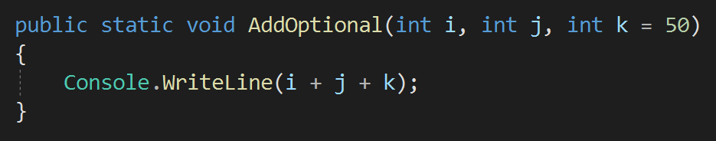

* + - * 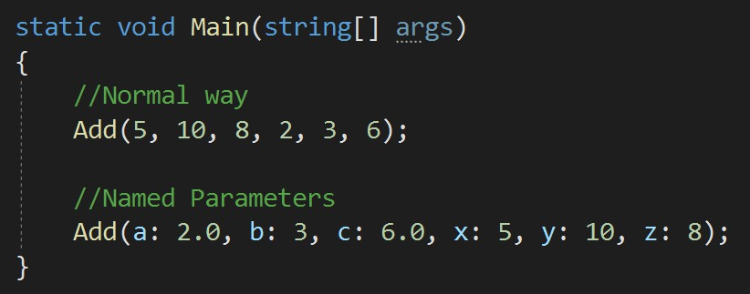Named parameters are used to specify an argument based on the name of the argument and not the position



Q83

What are named parameters in a method?

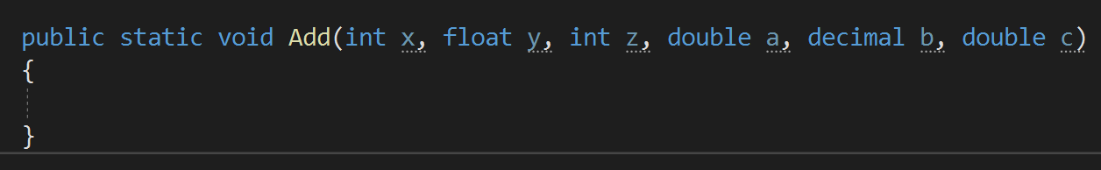

* + - * Extension method allows you to add new methods in the **existing class without modifying** the source code of the original class.

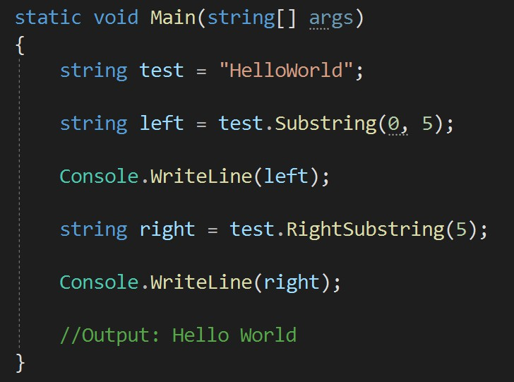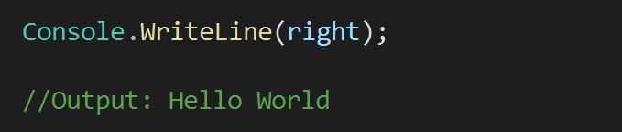

Q84

What are Extension Methods in C#? When to use extension methods in real applications?

* + - * Extension method must be static because this will be directly called from the class name, not by the object creation.
      * 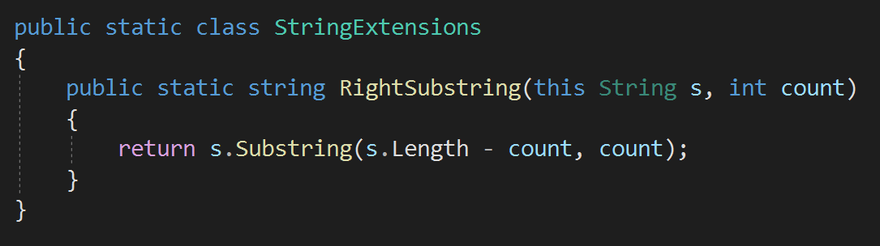**this** keyword is used for binding this method with the main class.
      * USE - Use them when you want to add a method in a class which code you don’t have.
      * A Delegate is a variable that holds the



Q85

What are Delegates in C#? When to use delegates in real applications?

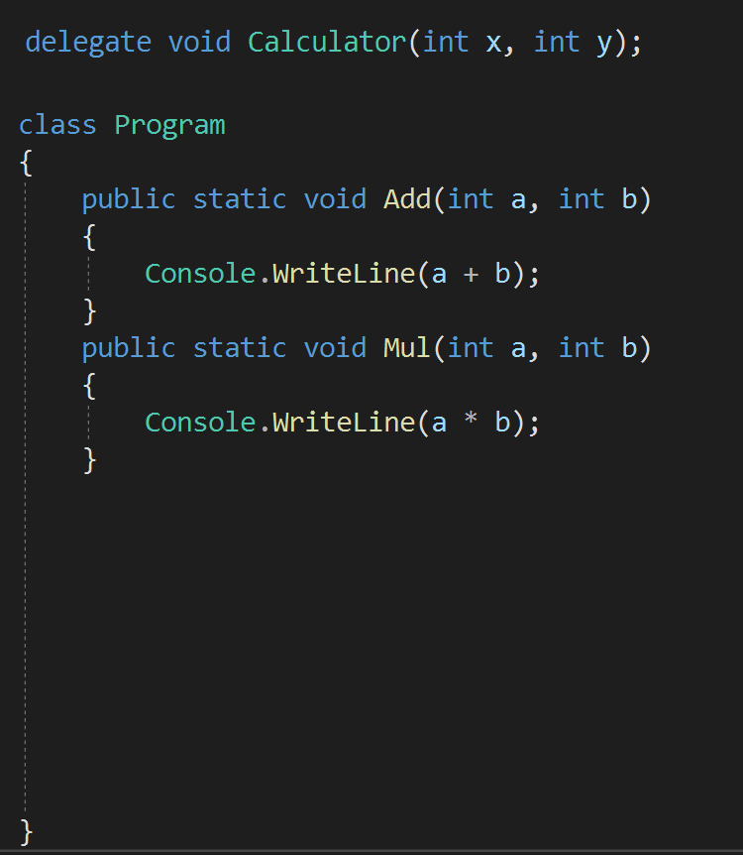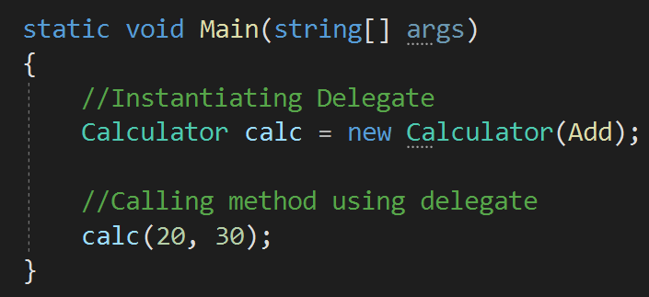

reference to a method or Pointer to a method.

* + - * A delegate can refer to more than one methods of same return type and parameters.
      * When to use delegate?

When we need to pass a method as a parameter.

Q86



### What are Multicast Delegates?

* + - * A Multicast Delegate in C# is a delegate that holds the references of more than one function.

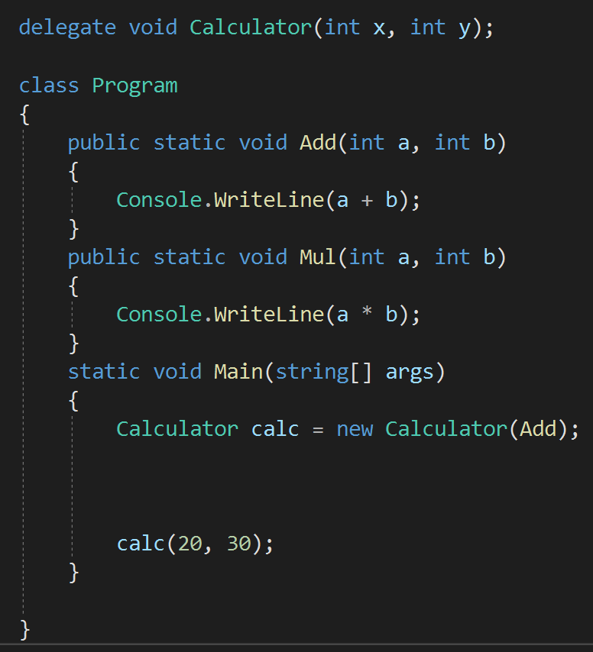

* + - * + 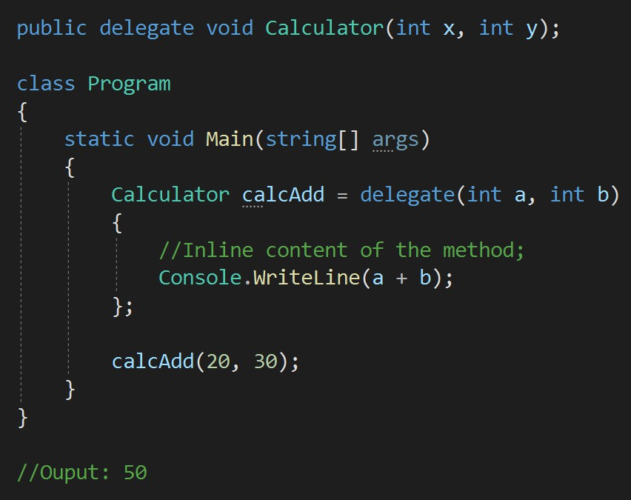Delegates pointing methods without name are called anonymous delegates.



Q87

What are Anonymous Delegates in C#?

Q88



### What are the differences between Events and Delegates?

* + - * + 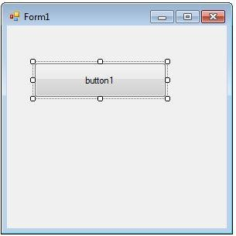The event is a notification mechanism that depends on delegates

Functions

Delegate

Event

* + - * + An event is dependent on a delegate and cannot be

created without delegates.

* + - * + Event is like a wrapper over the delegate to improve its security.

## Chapter 9: OOPS & C# - Important Keywords

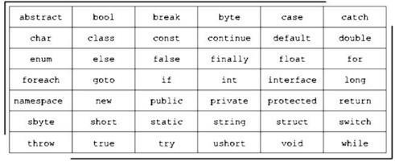Q89. What is ‘this’ keyword in C#? When to use it in real applications?

Q90. What is the purpose of “using” keyword in C#? V Imp

Q91. Can we use Using keyword with other classes apart from DBConnection? Q92. What is the difference between “is” and “as” operators?

Q93. What is the difference between “Readonly” and “Constant” variables? Q94. What is “Static" class? When to use static class in real application?

Q95. What is the difference between “var” and “dynamic” in C#? Q96. What is Enum keyword used for?

Q97. Is it possible to inherit Enum in C#? Q98. What is the use of Yield keyword in C#?

V Imp

Back to main index



Q89

What is “this” keyword in C#? When to use it in real applications?

* 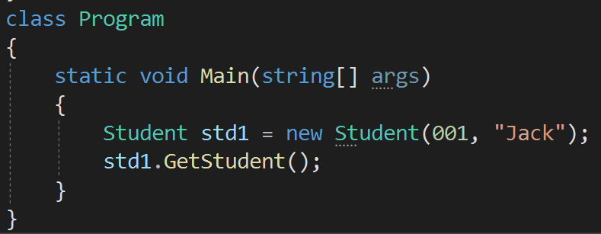*this* keyword is used to refer to the CURRENT INSTANCE of the class.
* *this* keyword avoids the name confusion between class fields and constructor parameters.

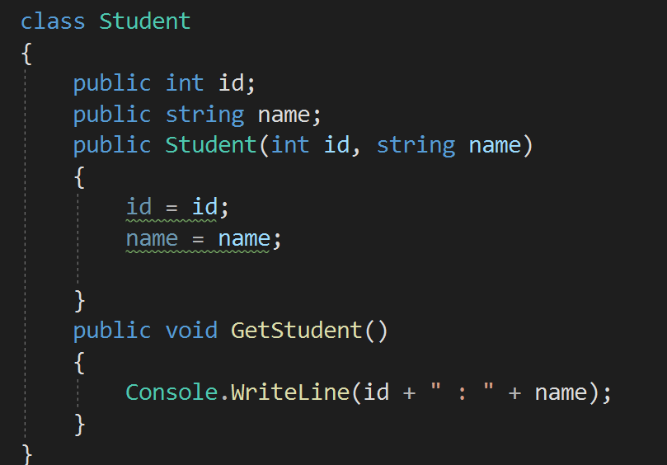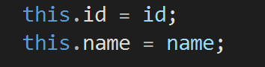



* 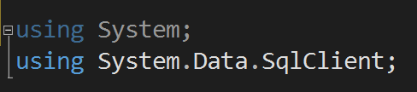There are two purpose of using keyword in C#:



Q90

What is the purpose of “using” keyword in C#?

* 1. 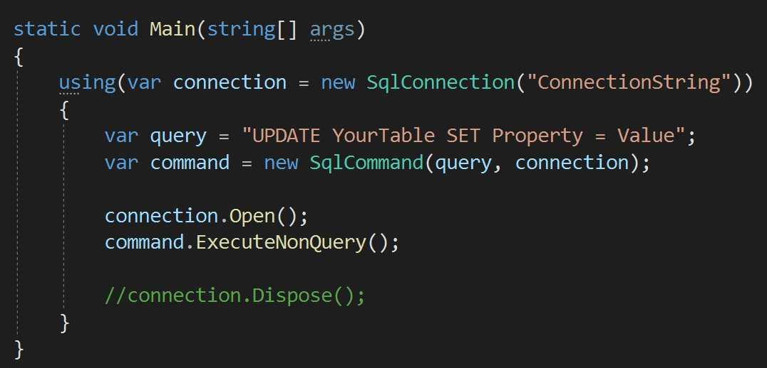USING DIRECTIVE
  2. **USING STATEMENT** - The using statement ensures that DISPOSE() method of the class object is called even if an exception occurs.



* + - Yes, using keyword can be used with any class which is inherited from **IDisposable** class. For example, with **StreamReader** class.



Q91

Can we use Using keyword with other classes apart from DBConnection?

Q92



### What is the difference between “is” and “as” operators?

* + - The **IS** operator is **USED TO CHECK** the

type of an object.

* + - **AS** operator is used to PERFORM CONVERSION

between compatible reference type.

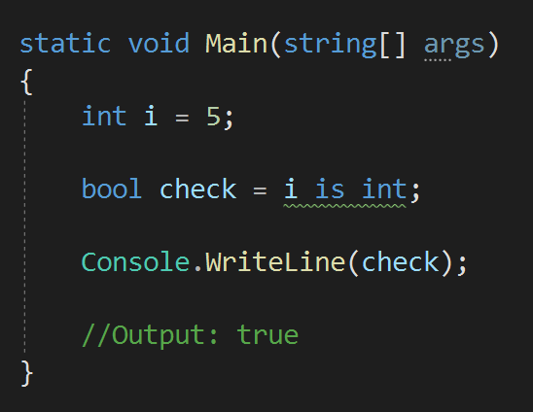 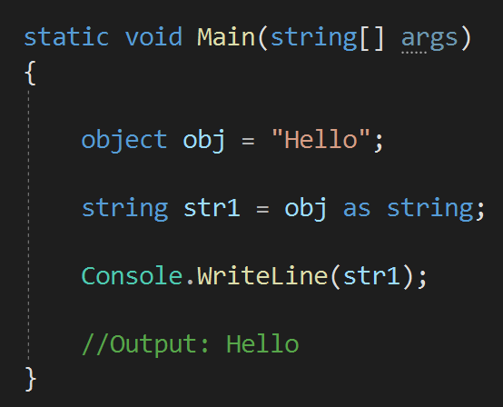

* + - The **IS** operator will return boolean type.  The **AS** operator is not of boolean type.
    - Constant  Readonly



Q93

What is the difference between “Readonly” and “Constant” variables (atleast 3)?

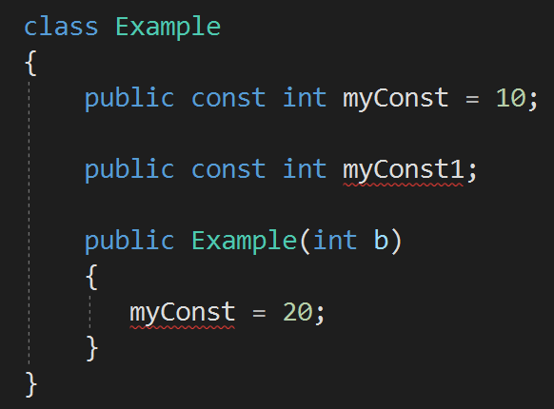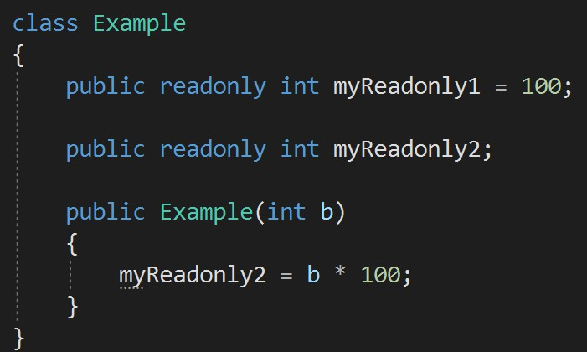

* + - 1. Using constant, we must assign values with declaration itself. But readonly fields can be assigned in declaration as well as in the constructor part.
      2. Constant field value cannot be changed, but Readonly field value can be changed.
      3. “const” keyword for Constant and “readonly” keyword is used for Readonly.
      4. Constant is a COMPILE time constant, and ReadOnly is a RUNTIME constant.
         * 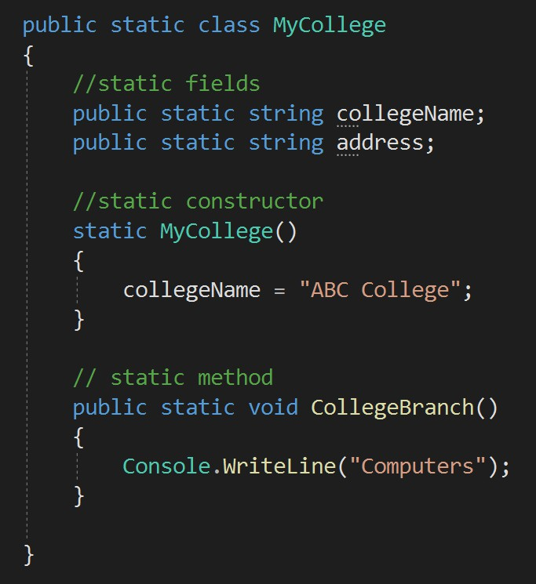A static class is a class which object can not be created, and which can not be inherited.



Q94

What is “Static" class? When to use static class in real application?

Use of static class:

Static classes are used as **containers** for static members like methods, constructors and others.

Q95



### What is the difference between “var” and “dynamic” in C#?

* VAR - The type of the variable is decided by the compiler at **compile time**.
* DYNAMIC - The type of the variable is decided at **run time**.

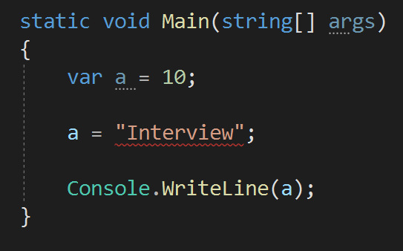

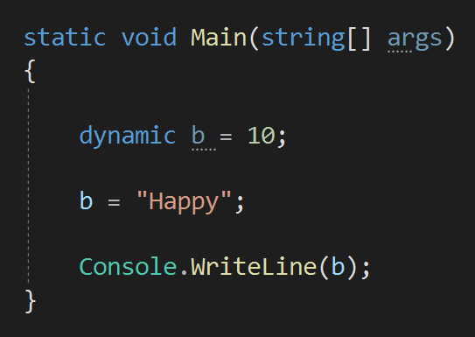

Q96



### What is Enum keyword used for?

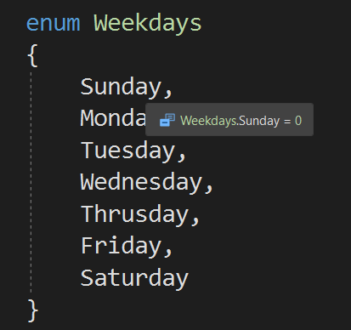

num for?

* + An **enum** is a special "class" that represents a

group of constants.

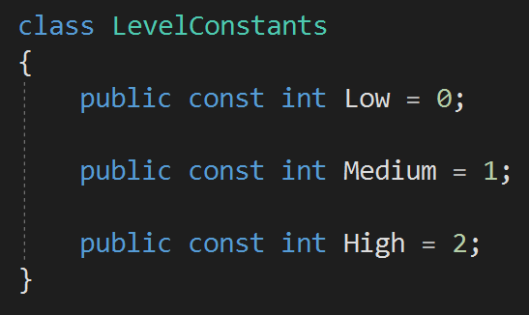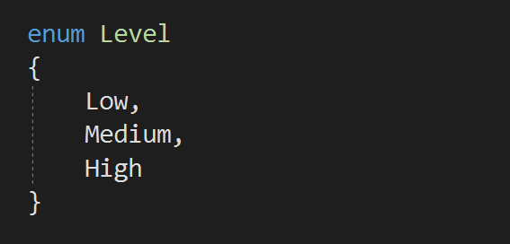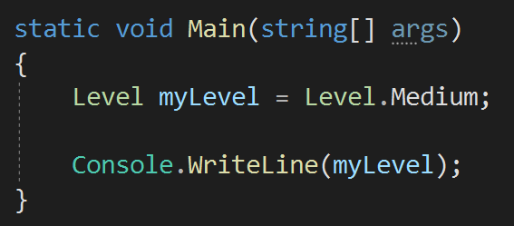

* + Enum is a **sealed** class type, so it cannot be inherited.



Q97

Is it possible to inherit Enum in C#?

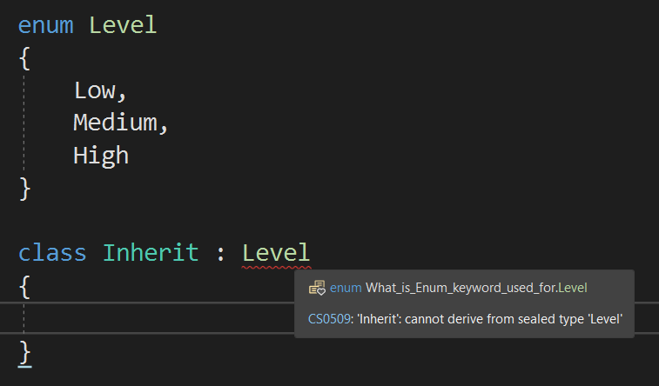

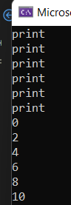



Q98

What is the use of Yield keyword in C#?

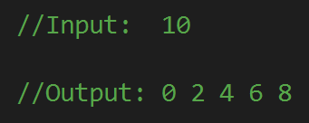 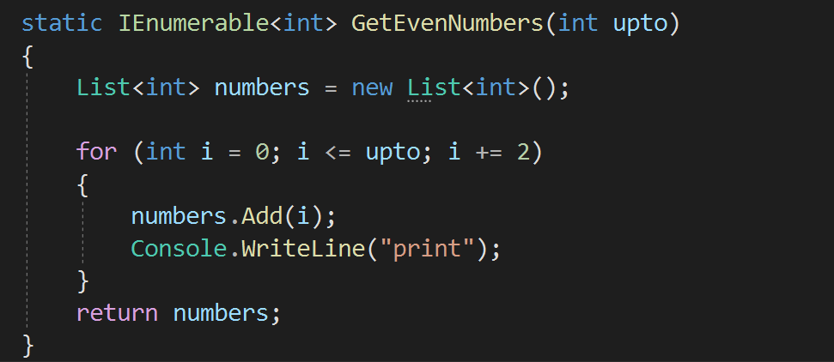

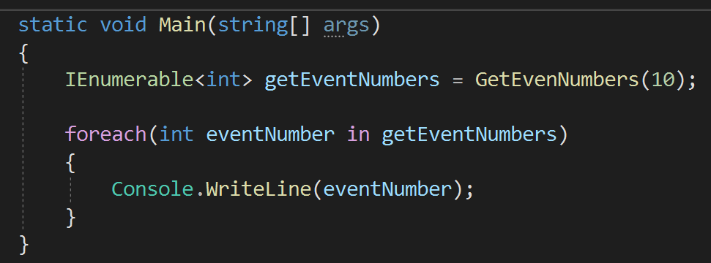

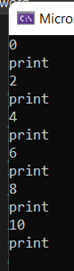

* + 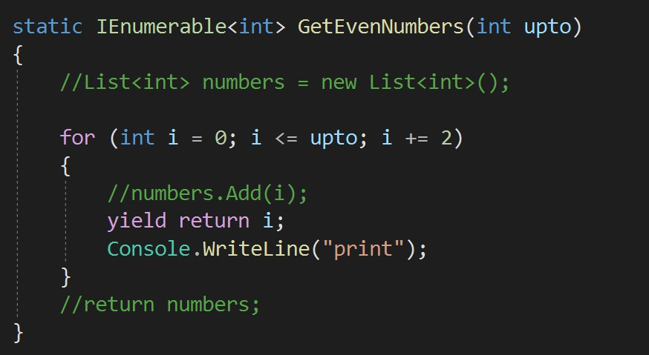The yield keyword will act as an iterator blocker and generate or return values.



Q98

What is the use of Yield keyword in C#?





## Chapter 10 : OOPS & C# - LINQ

Q99. What is LINQ? When to use LINQ in real applications? Q100. What are the advantages & disadvantages of LINQ?

Q101. What is Lambda Expressions? What is the use in real applications?

Q102. What is the difference between First and FirstOrDefault methods in LINQ? V Imp

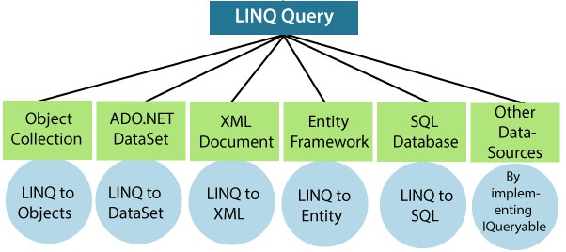

Back to main index

* LINQ (Language Integrated Query) is uniform query syntax in C# to retrieve data from different sources.



Q99

What is LINQ? When to use LINQ in real applications?

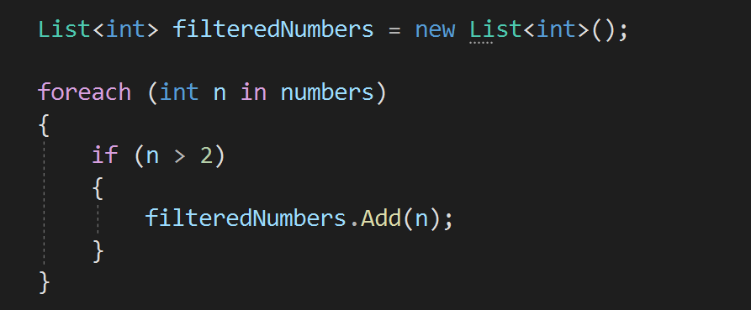

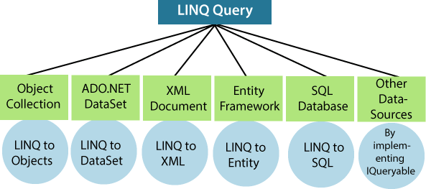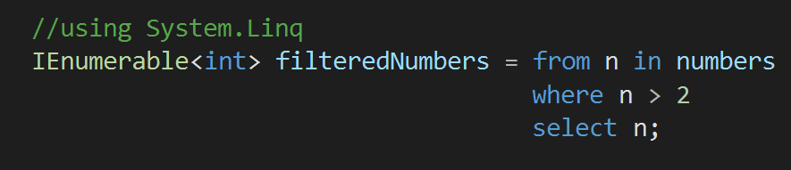

Advantages of LINQ



Q100

What are the advantages & disadvantages of LINQ?

* 1. Easy and simple syntax to Learn
  2. Improved code readability
  3. 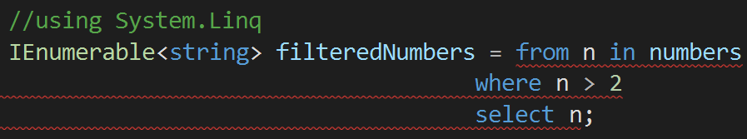Improved performance
  4. Type safety

Disadvantages of LINQ

1. Limited support for some data sources
2. Difficult to maintain and debug

Q101

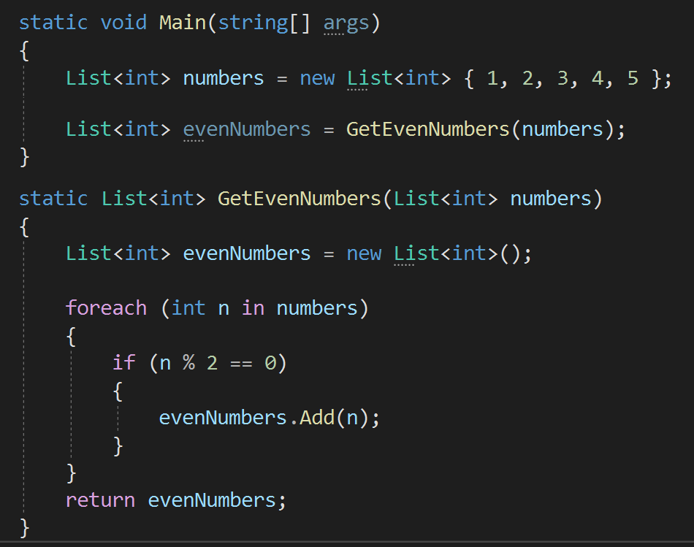

### What is Lambda Expressions? What is the use in real applications?

* A lambda expression is used to **simplify** the syntax of anonymous methods.

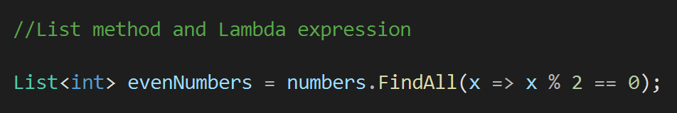

* 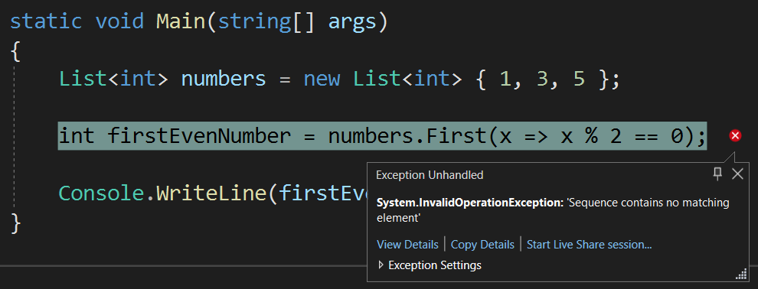First method will return the first value, but it is not able to handle null values.



Q102

What is the difference between First and FirstOrDefault methods in LINQ?

* FirstOrDefault will return the first value, and it is able to handle null values also.

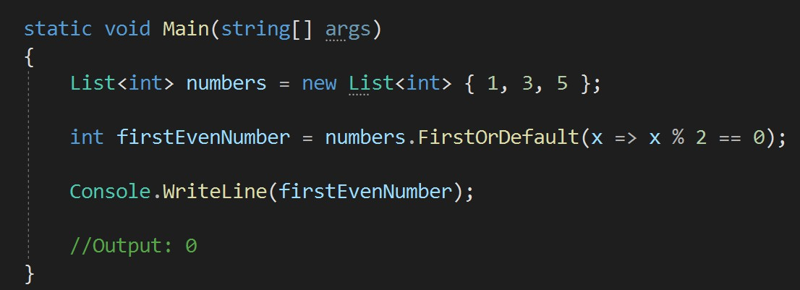

## Chapter 11 : .NET Framework - Basics

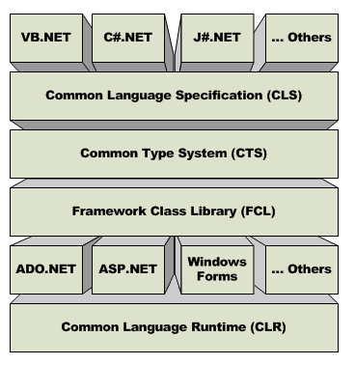Q103. What are the important components of .NET framework? V Imp

Q104. What is an Assembly? What are the different types of assembly? Q105. What is GAC?

Q106. What is Reflection?

Q107. What are Serialization and Deserialization? Q108. What is meant by Globalization and Localization? Q109. What are Window Services?

V Imp

Back to main index

* CLR (Common Language Runtime)



Q103

What are the important components of .NET framework?

* + CLR **manages** the execution of programs for example operations like memory management, security checks etc.
  + CLR provides execution of **managed code** only (Code written in any

.NET-supported language such as C#, Visual Basic .NET, or F#).

* CTS(Common Type System)
  + CTS is a set of rules that define how **types** are declared, used, and managed in the .NET Framework. Types like int, string, double.
* CLS(Common Language Specification)
  + CLS is a **subset** of CTS. It defines a set of **rules** that every language must follow which runs under .NET framework.
  + The benefit is, if you create same program logic in different languages of .NET, then the compiler will generate same dll.
* FCL(Framework Class Library)
  + FCL is the collection of classes, namespaces, interfaces and value types that are used for .NET applications.
  + For example, String, Arraylist, List classes are provided by FCL only.

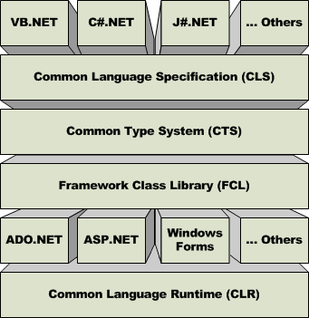

back to chapter index

* **Assembly** is unit of deployment like EXE or a DLL.



Q104

What is an Assembly? What are the different types of assembly in .NET?

*When you create a code and build the solution, then the .NET Framework convert your code into Intermediate Language and that is placed inside the assembly(dll), which you can find inside bin folder.*

* There are 3 types of assemblies:

1. **Private assembly** - A private assembly can be used by a single application only. It is not accessible outside. So, all the projects you create will by default create private assembly only.
2. **Public/ shared assembly** - Shared assemblies are usually libraries of code, which **multiple** applications can use. It is registered in the **global assembly cache(GAC)**.
3. **Satellite assembly -** A satellite Assembly is defined as an assembly with resources only, no executable code.

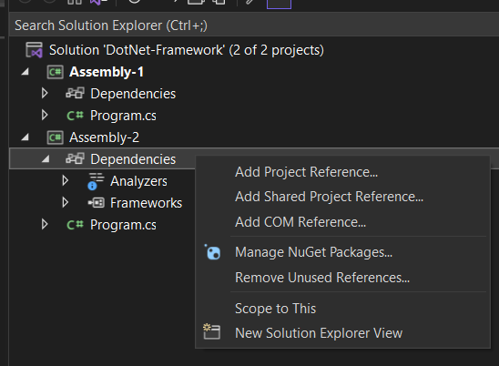

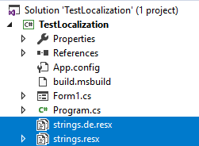back to chapter index

* + GAC stands for **Global Assembly Cache**.



Q105

What is GAC?

* + GAC is the place where **public assemblies** are stored.
  + Private assembly can be converted into public assembly by adding them in GAC using **gacutil** tool.

Q106



### What is Reflection?

* 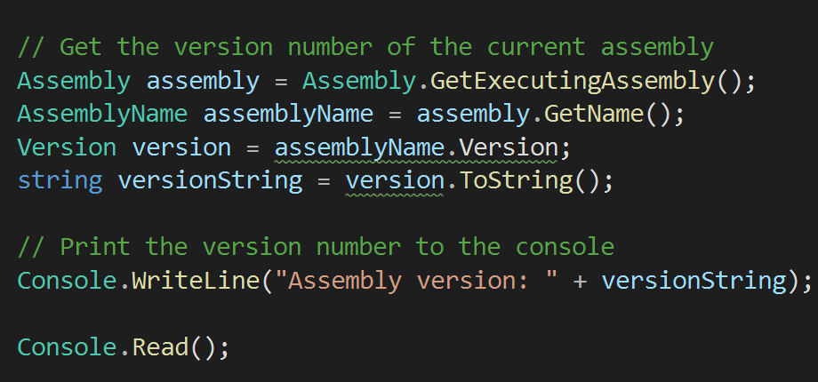Reflection is the ability of a code to access the metadata of the assembly during runtime.
* Metadata is information about data.
* *Suppose you have to check the version of the assembly at runtime, then you can use reflection.*



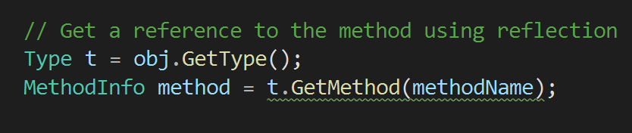

Q107



### What are Serialization and Deserialization? What are the types of serialization?

* Serialization is the process of **converting an object** into a format that can be stored, transmitted, or reconstructed later.

JSON

Serialization

XML

Serialization

Binary Serialization

Types of Serialization

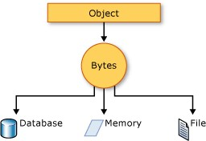

* Deserialization is the process of converting serialized data, such as binary/ XML/ json data,

Serialization

Deserialization

Object

json

json

Object

Application 1

Application 2

back into an object.

Q107



### What are Serialization and Deserialization? What are the types of serialization?

* Serialization is the process of converting an object into a format that can be stored, transmitted, or reconstructed later.



* Deserialization is the process of converting serialized data, such as binary/ XML/ json data, back into an object.
* When to use serialization??

It is mostly used in Web API to convert class objects into JSON string.

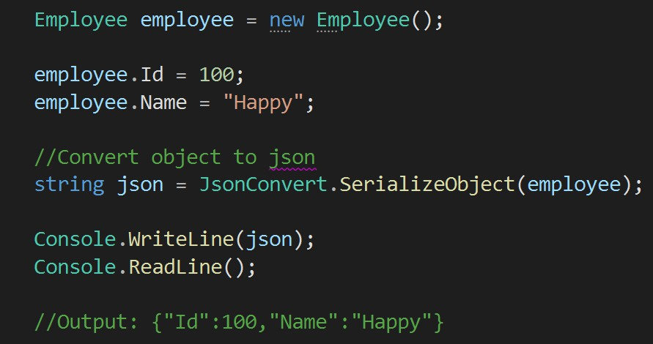

Q108



### What is meant by Globalization and Localization?

* + Globalization is the process of designing and developing a software product that can support different cultures and regions of the world.
  + 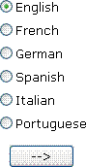Localization is the process of adapting a globalized application, to a particular culture/locale.

Q109



### What are Window Services?

* + 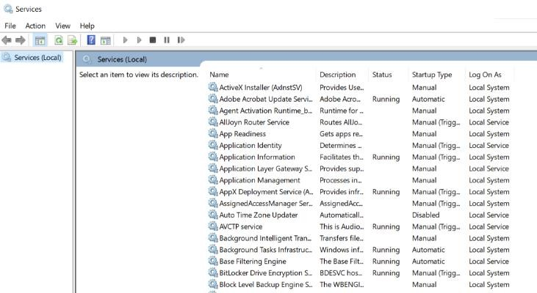Windows service is a computer program that runs in the **BACKGROUND** to execute some tasks.

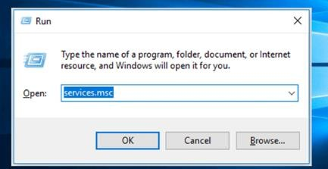

* + Windows services can be started

**AUTOMATICALLY** or manually.

* + You can also manually pause, stop and restart Windows services.

## Chapter 12 : .NET Framework - Garbage Collection

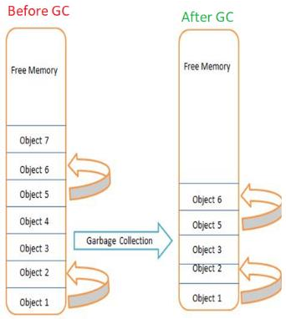Q110. What is Garbage Collection(GC)? V Imp

Q111. What are Generations in garbage collection?

Q112. What is the difference between “Dispose” and “Finalize”?

V Imp

Q113. What is the difference between “Finalize” and “Finally” methods? Q114. Can we force Garbage Collector to run?

Back to main index

* The garbage collector (GC) **manages** the allocation and release of memory in .NET framework.



Q110

What is Garbage Collection(GC)?

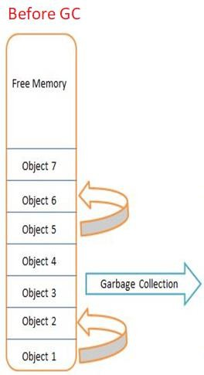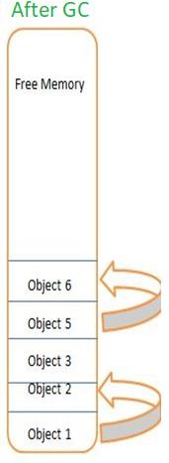

* Garbage collection is one of the responsibilities of CLR only.

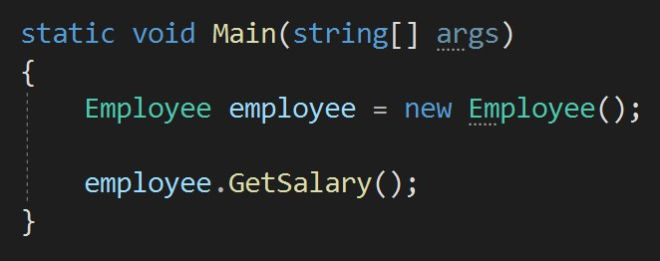

* + *Garbage collector will dispose this employee object automatically when it is no longer needed.*
  + Garbage collection release the objects which are no longer needed.



Q111

What are Generations in garbage collection?

* + .NET framework has a mechanism to decide which objects are no longer needed and that mechanism we call generations.
  + 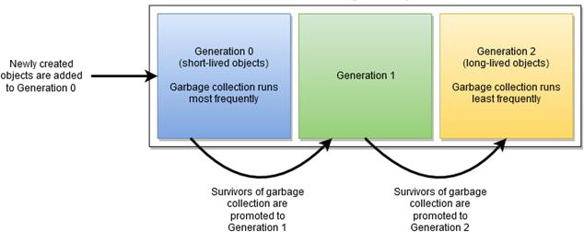Generation is a mechanism to collect the short-lived objects more frequently than the longer-lived object.

Q112



### What is the difference between “Dispose” and “Finalize”?

* Both Dispose and Finalize methods are used to release the unmanaged objects which are no longer required.

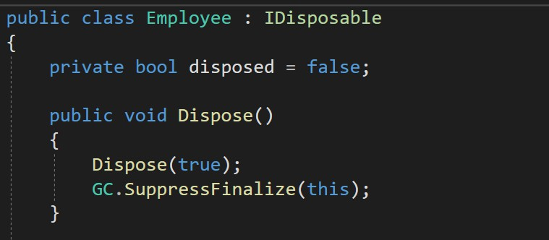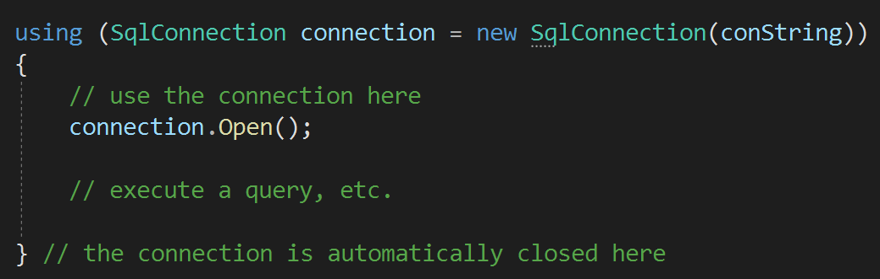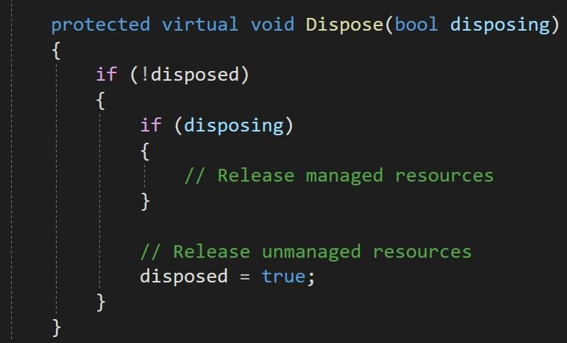

* Finalize method is called automatically by the garbage collector.
* But the Dispose method is called explicitly by the code to release any unmanaged object.
  + 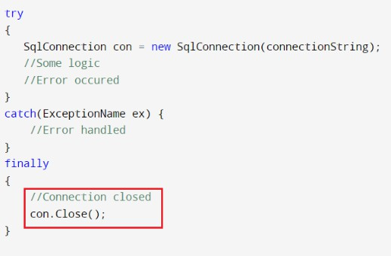 Finalize method is used for **garbage collection**. So before destroying an object this method is called as part of clean up activity by GC.



Q113

What is the difference between “Finalize” and “Finally”?

* Finally block is used in **exception handling** for executing the code irrespective of exception occurred or not.
* 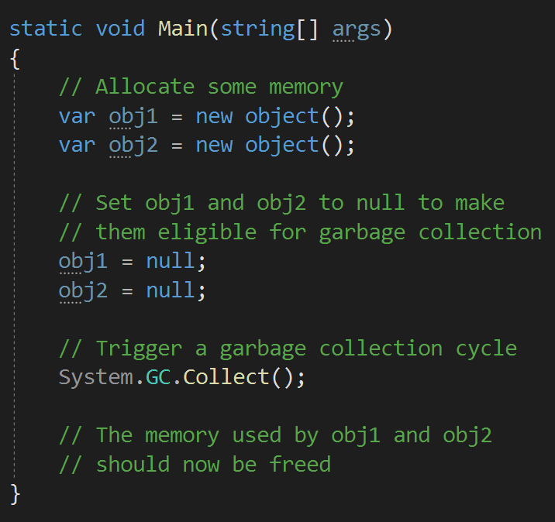Yes, by calling **GC.COLLECT()** method we can force garbage collector to run, but this is not recommended, instead use Dispose method.



Q114

Can we force Garbage Collector to run?

## Chapter 13 : .NET Framework - Threading

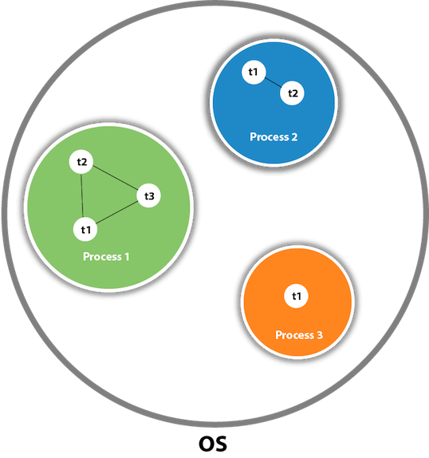Q115. What is the difference between Process and Thread?

Q116. Explain Multithreading? V Imp

Q117. What is the difference between synchronous and asynchronous programming?

What is the role of Task? V Imp

Q118. What is the difference between Threads and Tasks? What are the advantages of Tasks over Threads?

Q119. What is the role of Async and Await?

V Imp

Back to main index

Q115



### What is the difference between Process and Thread?

* 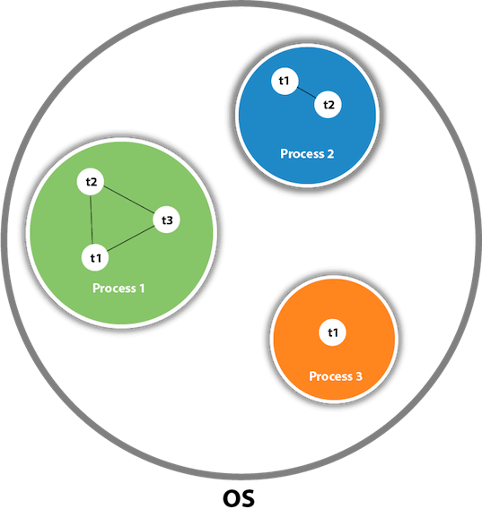A process is an instance of a program with its

**own** memory space and system resources.

* A thread is the smallest unit of process, that **shares** memory and resources with other threads within the same process.
* Multithreading refers to the ability to execute multiple threads of code **concurrently** within a single process.



Q116

Explain Multithreading?

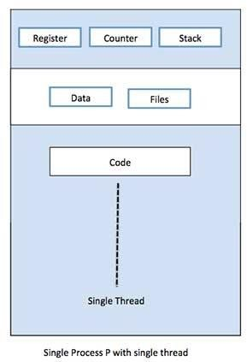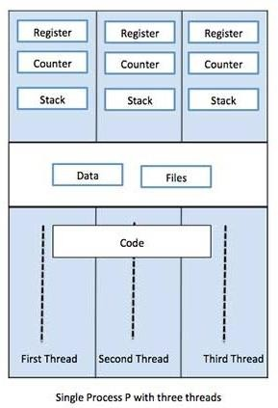

* Multithreading allows you to perform multiple tasks simultaneously, such as downloading data while displaying a progress bar.
* To create multithreaded application in C#, we need to use SYSTEM.THREADING namespace.
  + In synchronous programming, task is executed in a sequential manner.



Q117

What is the difference between synchronous and asynchronous programming? OR

What is the role of Task?

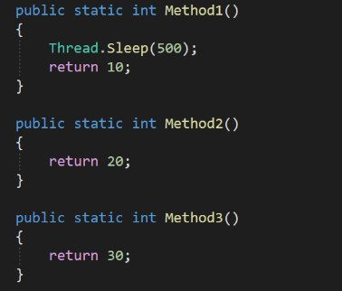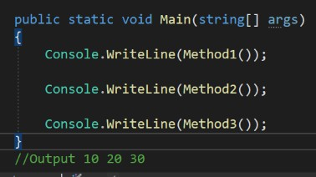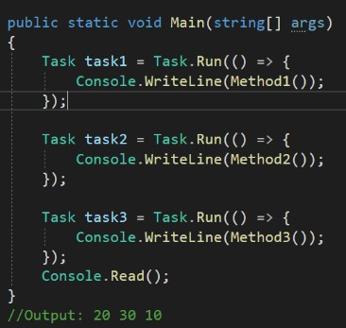

* + In asynchronous programming, tasks can be

executed independently of each other.

Synchronous Programming

Asynchronous Programming

Q118

### What is the difference between Threads and Tasks? What are the advantages of Tasks over Threads?

* In .NET, threads and tasks are two different ways for doing **multithreading**.



* Thread is a general programming concept. On the other hand, Microsoft created Task in .NET to **simplify** the use of Threads.
* Tasks are like a **wrapper** over Threads.
* Tasks **internally** uses threads only.

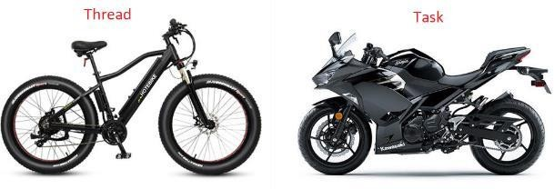

Q118

### What is the difference between Threads and Tasks? What are the advantages of Tasks over Threads?



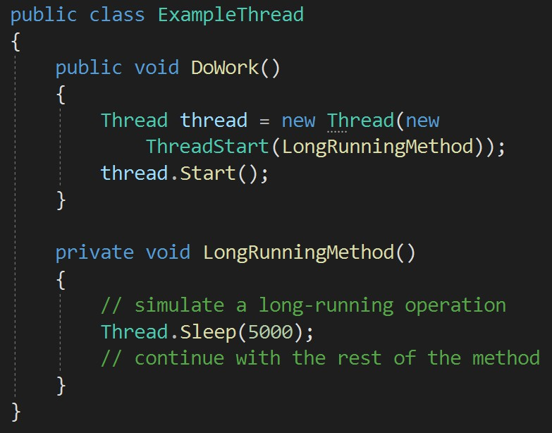 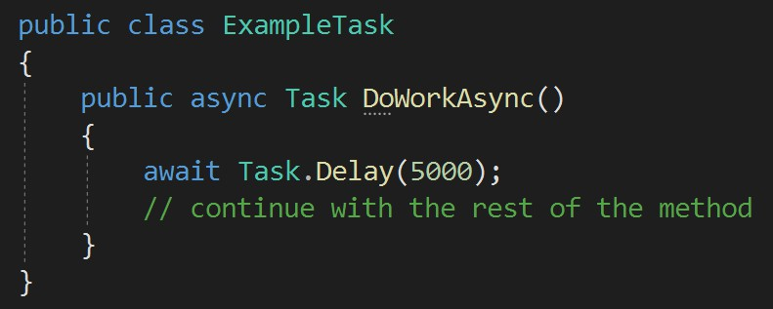

Q118

### What is the difference between Threads and Tasks? What are the advantages of Tasks over Threads?

* In .NET, threads and tasks are two different ways for doing **multithreading**.



* Thread is a general programming concept. On the other hand, Microsoft created Task in .NET to **simplify** the used of Threads.
* Tasks are like a **wrapper** over Threads.
* Tasks **internally** uses threads only.
* Advantages of Tasks over Threads:

1. Simplified Code.
2. Exception handling.
3. A Task can **return a result**, but there is no proper way to return a result from Thread.
4. We can apply **chaining** and **parent/ child** on multiple tasks, but it can be very difficult in threads.



* + In synchronous programming, task is executed in a sequential manner.



Q119

What is the role of Async and Await?



* + In asynchronous programming, tasks can be

executed independently of each other.

* + Async and Await are keywords used to enable asynchronous programming.

Synchronous Programming

Asynchronous Programming

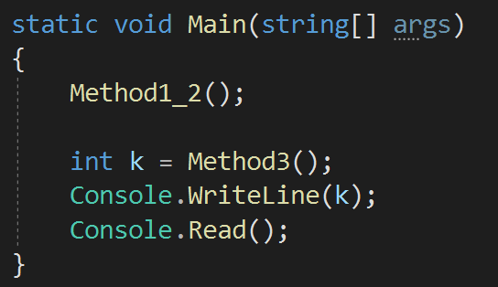

* 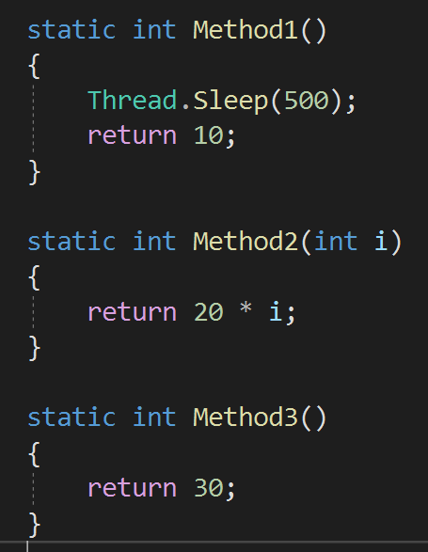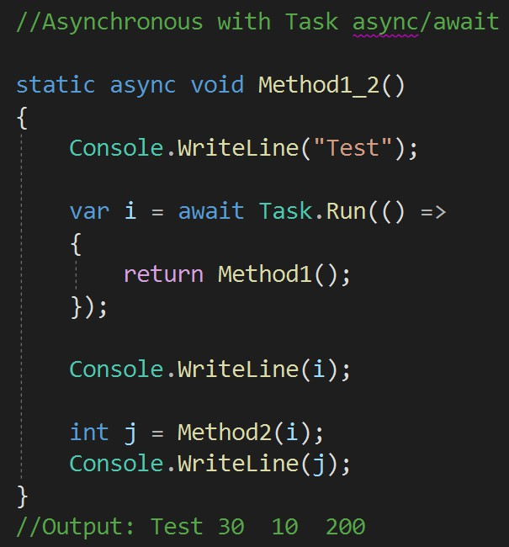The async keyword is used to mark a method as an asynchronous method.



Q119

What is the role of Async and Await?

* The await keyword is used to pause the execution of an asynchronous method until a specified operation completes.

## Microsoft SQL Server Monitoring Template | InfluxDataChapter 14 : SQL - Basics

Q120. What is the difference between DBMS and RDBMS?

Q121. What is a Constraint in SQL? What are the types of constraints? Q122. What is the difference between Primary key and Unique key?

Q123. What are Triggers and types of triggers?

V Imp

Q124. What is a View? V Imp

Q125. What is the difference between Having clause and Where clause? V Imp Q126. What is Sub query or Nested query or Inner query in SQL?

Q127. What is Auto Increment/ Identity column in SQL Server?

Back to main index



Q120

What is the difference between DBMS and RDBMS?

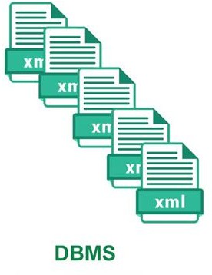 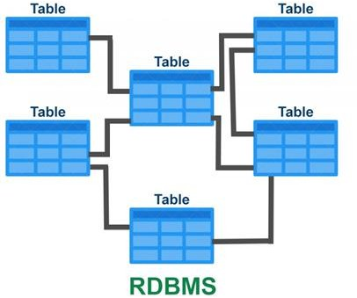



Q120

What is the difference between DBMS and RDBMS?

|  |  |
| --- | --- |
| **DBMS** | **RDBMS** |
| 1. DBMS stores data as file. | RDBMS stores data in **TABULAR** form. |
| 2. No relationship between data. | Data is stored in the form of tables which are **RELATED** to each other. Eg: Foreign key relationship. |
| 3. Normalization is not present. | **NORMALIZATION** is present. |
| 4. It deals with small quantity of data. | It deals with **LARGE** amount of data. |
| 5. Examples: XML | Examples: MySQL, PostgreSQL, SQL Server, Oracle, Microsoft Access etc. |

* SQL constraints are used to specify **rules** for the data in a table.



Q121

What is a Constraint in SQL? What are the types of constraints?

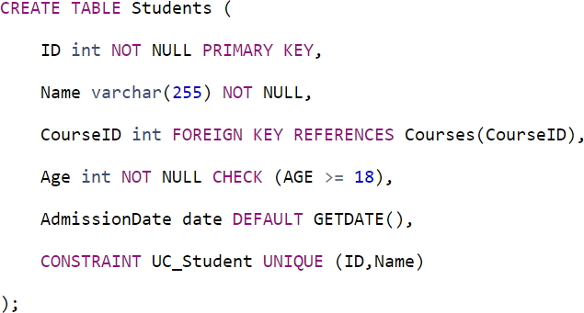

6. **UNIQUE** constraint tells that all the values in the column must be unique.

4. **CHECK** constraint helps to validate the values of a column to meet a particular condition.

5. **DEFAULT** constraint specifies a default value for the column when no value is specified by the user.

3. A **FOREIGN KEY** is a field which can uniquely identify each row in another table.

2. **NOT NULL** constraint tells that we cannot store a null value in a column.

1. A **PRIMARY KEY** is a field which can uniquely identify each row in a table.



Q122

What is the difference between Primary key and Unique key?

|  |  |
| --- | --- |
| **Primary Key** | **Unique Key** |
| 1. Primay key can’t accept null values | Unique key can accept only one null value |
| 2. Automatically create clustered index. | Create non clustered index. |
| 3. Only one primary key can be present in a table. | More than one unique key can be present in a table. |

* 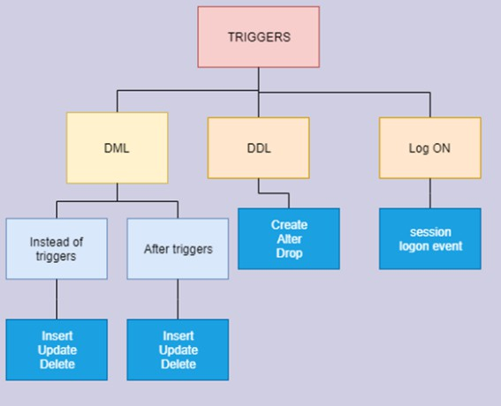Triggers are stored programs, which are **AUTOMATICALLY** executed or fired when some events (insert, delete and update) occur.



Q123

What are Triggers and types of triggers?

* Locations -> LocationHist
* Example of After(DML) Trigger

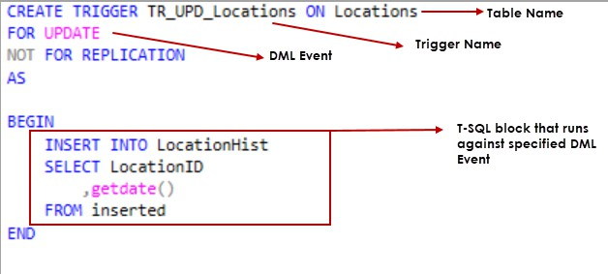

* In after trigger, update on the table executed first and then after trigger will be fired.
* Triggers are stored programs, which are **AUTOMATICALLY** executed or fired when some events (insert, delete and update) occur.



Q123

What are Triggers and types of triggers?

* Example of Instead of(DML) Trigger

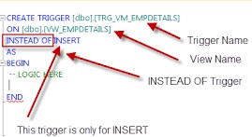

* An INSTEAD OF trigger is a trigger that allows you to **skip** an INSERT , DELETE , or UPDATE statement to a table or a view and execute other statements defined in the trigger.
  + A view is a VIRTUAL table which consists of a subset of data contained in single table or more than one table.



Q124

What is a View?

CREATE VIEW [India-Customers] AS SELECT CustomerName, ContactName FROM Customers

WHERE Country = ’India’;

* + Advantages of Views

1. Indexed Views to improve the performance.
2. Extra security – DBA can hide the actual table names and expose views for Read operations only.

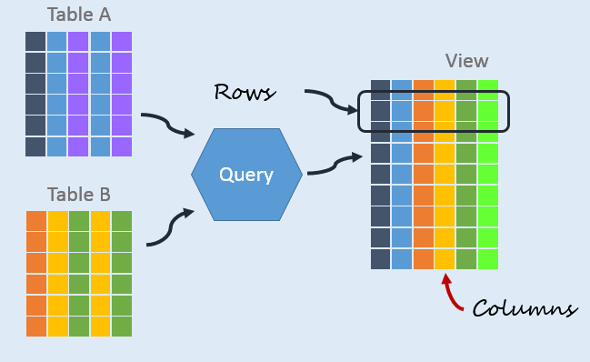

* + Remember, in case of view, only query is stored but the actual data is never stored like a table.

1. WHERE Clause is used before GROUP BY Clause.



Q125

What is the difference between Having clause and Where clause?

HAVING Clause is used after GROUP BY Clause.

1. WHERE Clause cannot contain AGGREGATE function.

HAVING Clause can contain aggregate function.

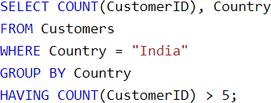

**SELECT** EmpName **FROM** Employee

**GROUP BY** EmpName

**HAVING** SUM(EmpSalary) <30000

* + A Subquery/ Inner query/ Nested query is a query within another SQL outer query and **embedded** within the **WHERE** clause.



Q126

What is Sub query or Nested query or Inner query in SQL?

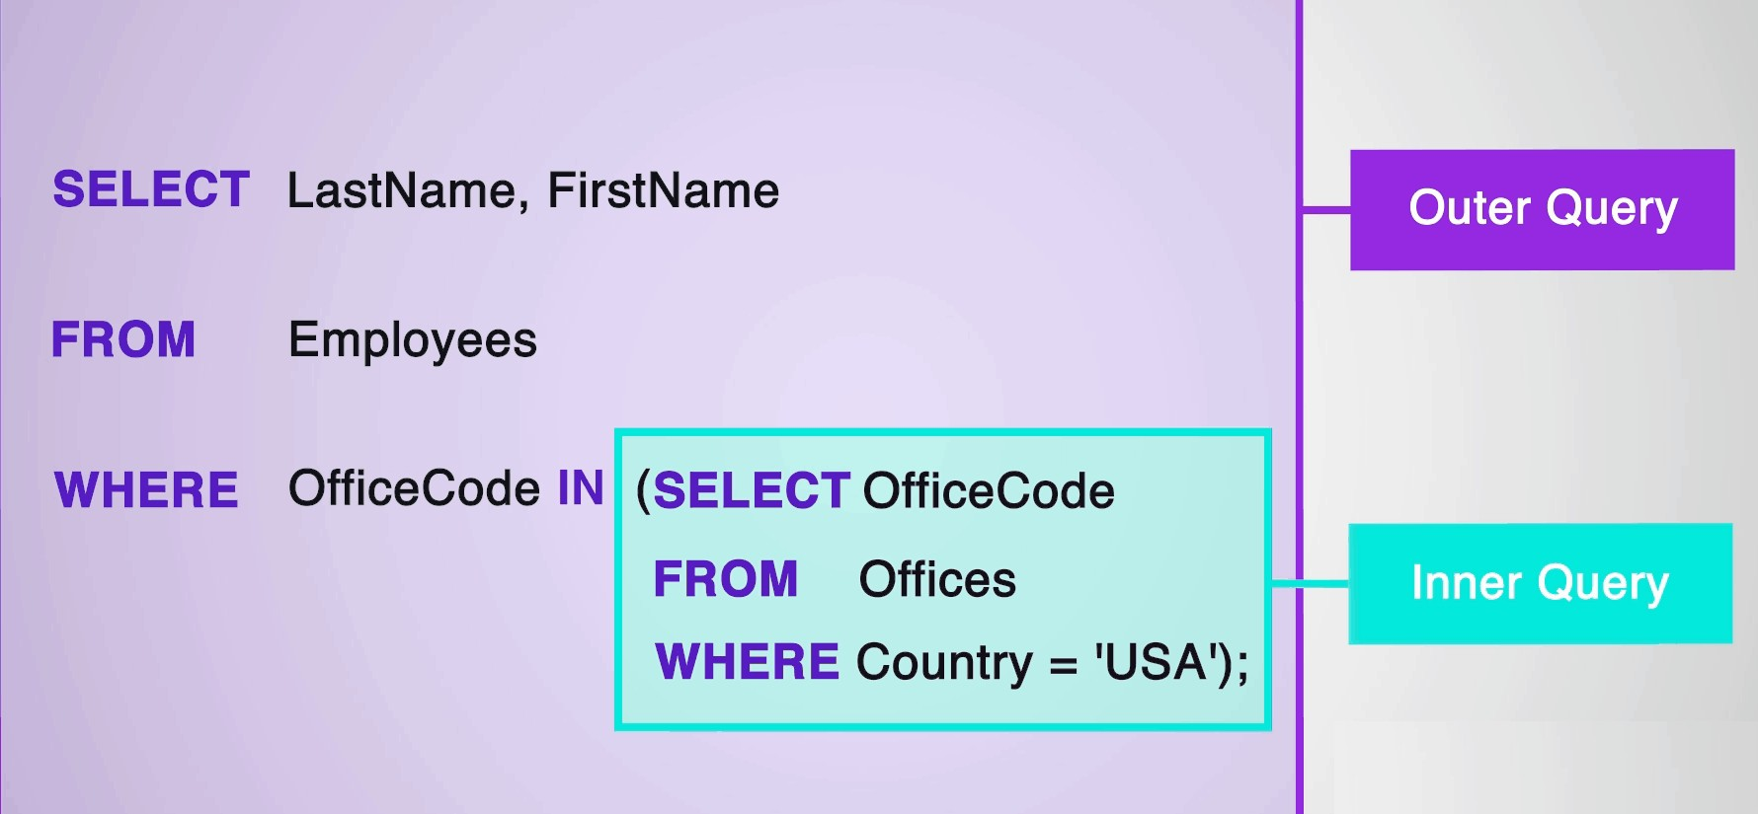

* Auto-increment allows a unique number to be **generated automatically** when a new record is inserted into a table.



Q127

What is Auto Increment/ Identity column in SQL Server?

* Mostly auto increment is set on the primary key only.

CREATE TABLE Employee (

ID int **IDENTITY(1,1)** PRIMARY KEY,

EmpName varchar(255) NOT NULL

);

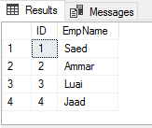

## Chapter 15: SQL - Joins & Indexes

Q128. What are Joins in SQL?

Q129. What are the types of Joins in SQL Server?

Q130. What is Self-Join?

Q131. What are Indexes in SQL Server? Q132. What is Clustered index?

Q133. What is Non-Clustered index?

V Imp

Q134. What is the difference between Clustered and Non-Clustered index? Q135. How to create Clustered and Non-Clustered index in a table?

Q136. In which column you will apply the indexing to optimize this query?

V Imp

Back to main index

* 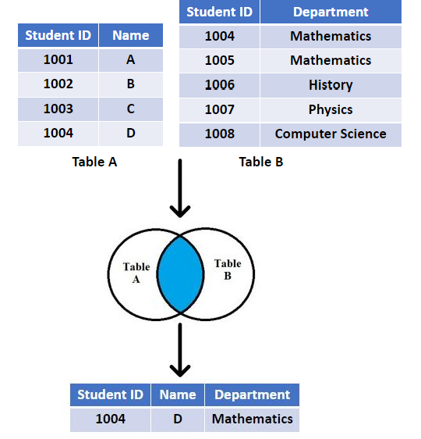A join clause is used to **combine** rows from two or more tables, based on a related column between them.



Q128

What are Joins in SQL?

back to chapter index

* 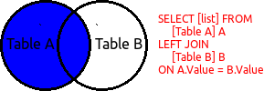**Left outer join** - A left join returns all the rows from the left table, along with any matching rows from the right table.



Q129

What are the types of Joins in SQL Server?

* 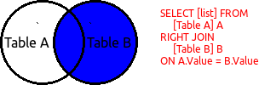**Right outer join** - A right join returns all the rows from the right table, along with any matching rows from the left table.
* 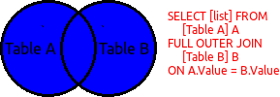**Full outer join** - A full outer join returns all the rows from both the left and right tables in the join.
  + 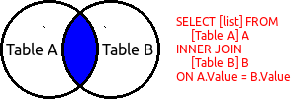**Inner join** - An inner join returns only the common rows from both tables that meet the join condition.

back to chapter index

* + - 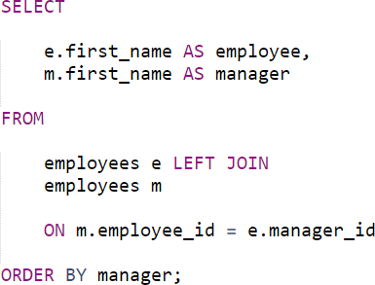A self join is a join of a table to **itself**.



Q130

What is Self-Join?

* + - 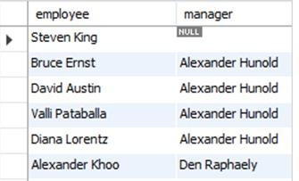When to use Self Join??

This manager id is employee id of the manager of an employee

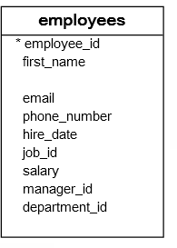

* + - Now your task is to get the employees name with their manager names??
    - SQL Indexes are used in relational



Q131

What are Indexes in SQL Server?

databases to retrieve data **VERY FAST**.

* + - They are similar to indexes at the start of the BOOKS, which purpose is to find a topic quickly.

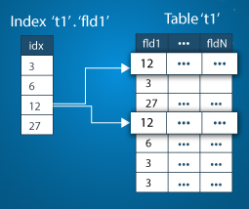 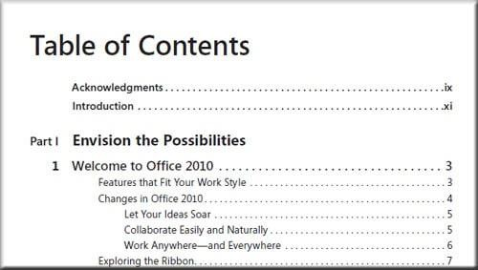

* + - * 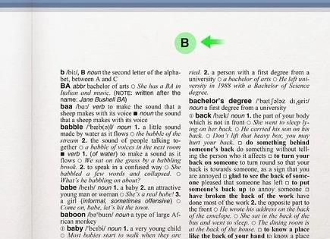 A clustered index is a type of index that determines the **physical order** of data in a table.



Q132

What is Clustered index?

* + - * Table data can be sorted in only way, therefore, there can be **only one** clustered index per table.
      * In SQL Server, if you set a primary key on a column, then it will **automatically create** a clustered index on that particular column.

Dictionary

* + - * A non-clustered index is stored at one place and table data is stored in another place.
      * A table can have multiple non-clustered index in a table.

Book Index



Q133

What is Non-Clustered index?

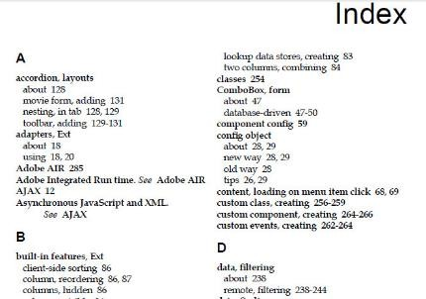

1. 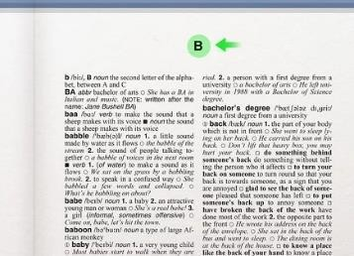A clustered index is a type of index that determines the



Q134

What is the difference between Clustered and Non-Clustered index?

**physical order** of data in a table.

A non-clustered index is stored at one place and table data is stored in another place. For example, Book Index.

1. A table can have only one clustered index.

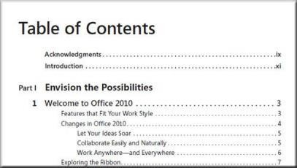A table can have multiple non-clustered index.

1. Clustered index is faster.

Non-clustered index is slower.

#### Clustered Index



Q135

How to create Clustered and Non-Clustered index in a table?

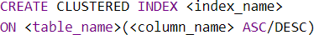

* + **Non-clustered Index**

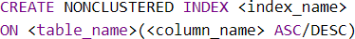

* + When you create a PRIMARY KEY constraint, a clustered index on the column is automatically created.

select id, class from student where name=”happy”



Q136

In which column you will apply the indexing to optimize this query.

“select id, class from student where name=”happy””?

* The column **after WHERE** condition, which is “NAME” here.

## Chapter 16 : SQL - Stored Procedure, Functions & Others

CREATE PROCEDURE proc_name (@Ename varchar(50),

@EId int output) AS

BEGIN

INSERT INTO Employee (EmpName) VALUES (@Ename)

SELECT @EId= SCOPE_IDENTITY()

END

Q137. What is the difference between Stored Procedure and Functions? Q138. How to optimize a Stored Procedure or SQL Query?

Q139. What is a Cursor? Why to avoid them?

Q140. What is the difference between scope_identity and @@identity?

Q141. What is CTE in SQL Server?

V Imp

Q142. What is the difference between Delete, Truncate and Drop commands? V Imp Q143. How to get the Nth highest salary of an employee?

Q144. What are ACID properties?

Q145. What are Magic Tables in SQL Server?

Back to main index

CREATE PROCEDURE proc_name (@Ename varchar(50),



Q137

What is the difference between Stored Procedure and Functions (at least 3)?

|  |  |
| --- | --- |
| **Stored Procedure** | **Function** |
| 1. SP may or may not **return** a value | Function must return a value |
| 2. Can have input/**output** parameters | Only has input parameters |
| 3. We can c**all** function inside SP | Cannot call SP insied a function |
| 4. We cannot use SP in **SQL statements** like SELECT, INSERT, UPDATE, DELETE, MERGE, etc. | We can use them with function. *SELECT *, dbo.fnCountry(city.lon g) FROM city;* |
| 5. We can use try-catch exception handling in SP | We can not use try-catch in functions |
| 6. We can use transactions inside SP. | We can not use transactions inside functions. |

@EId int output)

AS

BEGIN

INSERT INTO Employee (EmpName) VALUES (@Ename)

SELECT @EId= SCOPE_IDENTITY() END

CREATE FUNCTION function_name

(parameters) --only input parameter RETURNS data_type AS

BEGIN

-- SQL statements RETURN value

1. 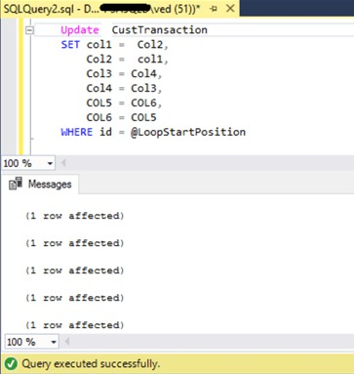Use SET NOCOUNT ON



Q138

How to optimize a Stored Procedure or SQL Query?

1. Specify column names instead of using * .

*~~SELECT * FROM table1~~  SELECT col1, col2 FROM table1*

1. Use schema name before objects or table names. *~~SELECT EmpID, Name FROM Employee~~ SELECT EmpID, Name FROM dbo.Employee*
2. Use EXISTS () instead of COUNT ().

*~~SELECT Count(1) FROM dbo.Employee~~*

*IF( EXISTS (SELECT 1 FROM db.Employees))*

1. Use TRANSACTION when required only.
2. Do not use DYNAMIC QUERIES. They are vulnerable to SQL Injections.
   * A database Cursor is a control which enables traversal/ iteration over the rows or records in the table.



Q139

What is a Cursor? Why to avoid them?

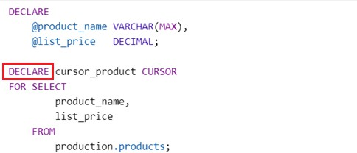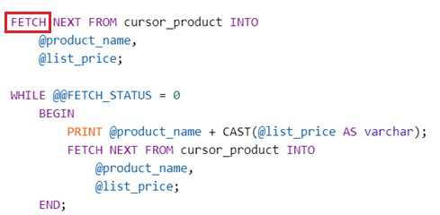

back to chapter index

* + 5 step process:

1. Declare
2. Open
3. Fetch using while loop
4. Close
5. Deallocate
   * LIMITATION

A cursor is a MEMORY resident set of pointers. Meaning it occupies lots of memory from your system which is not good for performance.

* + - Both are used to get the last value generated in the **identity**



Q140

What is the difference between scope_identity and @@identity?

column of the table.

* + - @@IDENTITY function returns the last identity value generated within the **current session**, regardless of the scope.
    - This will return a value generated by an INSERT statement in a

**trigger, stored procedure or batch** of T-SQL statements.



* + - The scope_identity() function returns the last identity created in the same session and the same **scope**.



* + - Mostly we use scope_identity() function inside stored procedures.
* 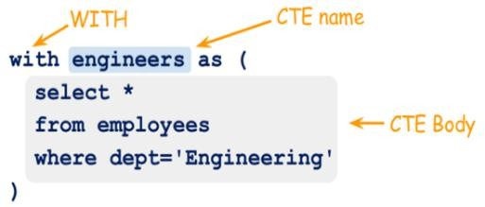A Common Table Expression, is a TEMPORARY named result set, that you can reference within a SELECT, INSERT, UPDATE, or DELETE



Q141

What is CTE in SQL Server?

statement.





Q142

What is the difference between Delete, Truncate and Drop commands?

|  |  |  |
| --- | --- | --- |
| **DELETE** | **TRUNCATE** | **DROP** |
| 1. It is a DML. | 1. It is a DDL. | 1. It is a DDL. |
| 2. It is used to delete one or all rows from the table based on where condition, but it will not delete schema. | 2. It is used to delete all rows from the table, but it will not delete schema. | 2. It is used to delete all rows from the table with structure/schema. |
| 3. It can be rollback. | 3. It can not be rollback. | 3. It can not be rollback. |

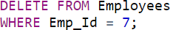

* 1. The logic is first select TOP 3 salaries in descending order.



Q143

How to get the Nth highest salary of an employee?

*SELECT DISTINCT TOP 3 SALARY*

*FROM tbl_Employees ORDER BY SALARY DESC*

|  |
| --- |
| **Salary** |
| 5000 |
| 10000 |
| 6000 |
| 4000 |
| 2000 |
| 7000 |

* 1. Put the result in “Result”

and then do order by asc

***SELECT SALARY FROM (***

*SELECT DISTINCT TOP 3 SALARY*

*FROM tbl_Employees ORDER BY SALARY DESC*

***) RESULT ORDER BY SALARY***

* 1. Select top 1 salary from result set

*SELECT* ***TOP 1*** *SALARY*

*FROM (*

*SELECT DISTINCT TOP 3 SALARY*

*FROM tbl_Employees ORDER BY SALARY DESC*

*) RESULT ORDER BY SALARY*

|  |
| --- |
| 10000 |
| 7000 |
| 6000 |

|  |
| --- |
| **Result** |
| 6000 |
| 7000 |
| 10000 |

|  |
| --- |
| **Result** |
| 6000 |

* + - ACID properties are used when you are handling **transactions** in SQL.



Q144

What are ACID properties?

*For example, multiple inserts in a table are happening at the same point of time.*

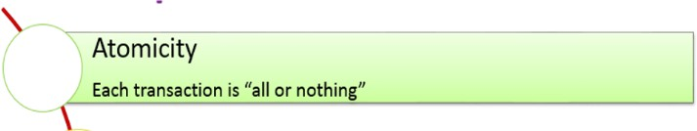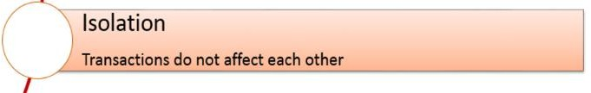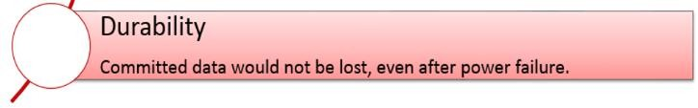

* + - * **Magic tables** are the temporary logical tables that are created by the SQL server, whenever there are **insertion or deletion or update**( D.M.L) operations.



Q145

What are Magic Tables in SQL Server?

* + - * Types of magic tables

1. **INSERTED –** When any insert query executed, then the recently inserted row gets added to the INSERTED magic table.
2. **DELETED –** When any delete query executed, then the recently deleted row gets added to the DELETED magic table.

In update case, the updated row gets stored in INSERTED magic table and the old row or previous row gets stored in the DELETED magic table.

* + The use of magic tables are TRIGGERS.

## Chapter 17 : ASP.NET – MVC - Part 1

Q146. What is MVC? Explain MVC Life cycle.

Q147. What are the advantages of MVC over Web Forms?

V Imp

Q148. What are the different return types of a controller Action method?

V Imp

Q149. What are Filters and their types in MVC?

V Imp

Q150. What is Authentication and Authorization in ASP.NET MVC? V Imp Q151. What are the types of Authentication in ASP.NET MVC?

Q152. What is Output Caching in MVC? How to implement it? Q153. What is Routing in MVC?

Q154. Explain Attribute Based Routing in MVC?

V Imp

Back to main index

* MVC is a framework for building web applications using MVC (Model View Controller) architecture.



Q146

What is MVC? Explain MVC Life cycle.

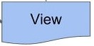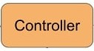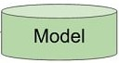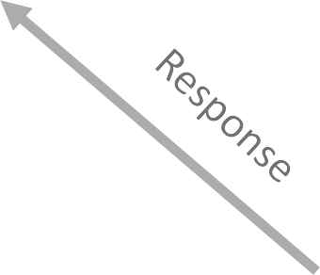

1. The **Model** represents the data.
2. The **View** displays the data.
3. The **Controllers** act as an interface between Model and View components to process all the business logic.

Request

* In web forms one aspx file will have one aspx.cs file, which means UI(aspx) is **tightly coupled** with logic in code-behind (.aspx.cs).



Q147

What are the advantages of MVC over Web Forms?

.aspx .aspx.cs

* 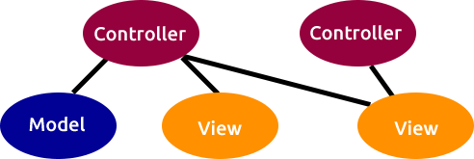In MVC, one controller can interact with multiple views and one view can interact with multiple controllers and therefore they are **loosely coupled**.

#### Advantage of MVC over Web-Forms:



Q147

What are the advantages of MVC over Web forms?

1. **Separation of concerns -** The MVC framework provides a clean separation of the UI, business logic and data with the help of MVC architecture.
2. **Multiple view support -** Due to the separation of the model from the view, the user interface can display multiple views of the same data at the same time.
3. **Change accommodation -** UI change more frequently than business rules. Now because the model does not depend on the views, modifying view will not affect the model.
4. **Testability -** ASP.NET MVC provides better support for test driven development.
5. **Light-weight** – In MVC framework, the request and response are bit lighter than webforms.
6. **Full features of Asp.Net –** Almost all the features of web-forms

are present in ASP.NET MVC.



Q148

What are the different return types of action method in controller?

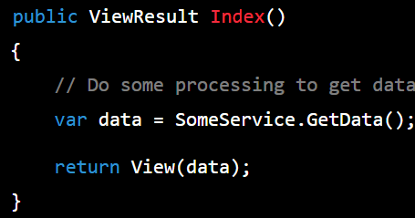

* 1. **ViewResult**: It returns a view that renders HTML to be sent to the client.



View

PartialView

Json

Content

File

RedirectToRoute

Redirect

HttpNotFoundResult

HttpStatusCodeResult

Empty

Types of Action Result

* 1. **PartialViewResult**: It returns a partial view that is rendered within another view.
  2. **JsonResult**: It returns JSON data that can be consumed by client-side JavaScript code.
  3. **ContentResult**: It returns a string of content that is directly written to the response stream. This is useful for returning plain text, XML, or other non-HTML content.



Q148

What are the different return types of a controller Action method?



View

PartialView

Json

Content

File

RedirectToRoute

Redirect

HttpNotFoundResult

HttpStatusCodeResult

Empty

* 1. **FileResult**: It returns a file to the client for download, such as a PDF, image, or video.

Types of Action Result

* 1. **RedirectToRouteResult**: It redirects the client to another action method based on a specified route.
  2. **RedirectResult**: It redirects the client to a specified URL.
  3. **HttpNotFoundResult**: It returns a 404 Not Found status code to the client.
  4. **HttpStatusCodeResult**: It returns an HTTP status code to the client, such as 401 Unauthorized or 500 Internal Server Error.
  5. **EmptyResult**: It returns an empty response to the client without any content.

back to chapter index

* + - Filters in ASP.NET MVC are used to inject logic that runs before or after an action method is executed.



Q149

What are Filters and their types in MVC?



Authorization Filter

Action Filter

Result Filter

Exception Filter

Types of Filter

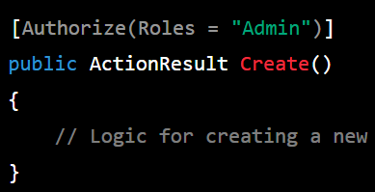

1. **Authorization Filters:** Authorization filters are used to enforce authentication and authorization rules.



Q149

What are Filters and their types in MVC?



Authorization Filter

Action Filter

Result Filter

Exception Filter

*They run before the action method is executed and can be used to verify whether the user is authenticated and authorized to perform the requested action.*

Types of Filter

**

1. 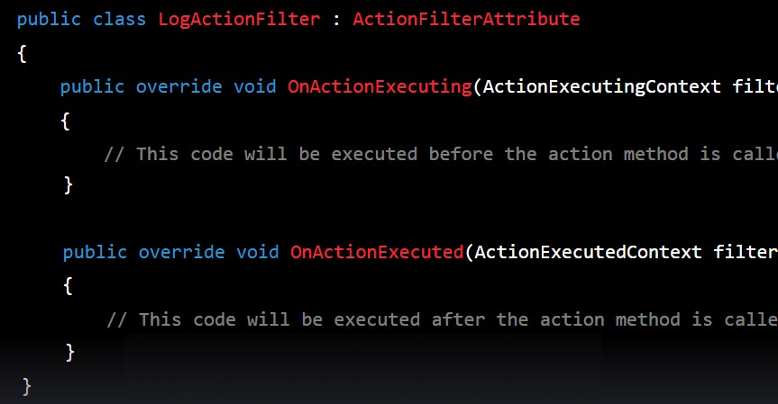**Action Filters:** Action filters run before and after an action method is executed. They can be used to modify the behavior of the action method or perform pre-processing or post- processing tasks.



Q149

What are Filters and their types in MVC?

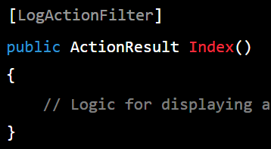

1. 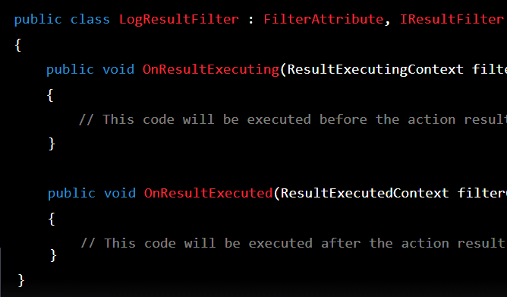**Result Filters:** Result filters run before and after the result of an action method is executed. They can be used to modify the behavior of the result or perform post- processing tasks.



Q149

What are Filters and their types in MVC?

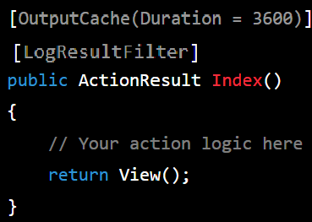

1. 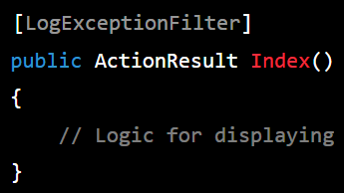**Exception Filters:** Exception filters are used to handle exceptions that occur during the execution of an action method. They run only when an unhandled exception occurs.



Q149

What are Filters and their types in MVC?

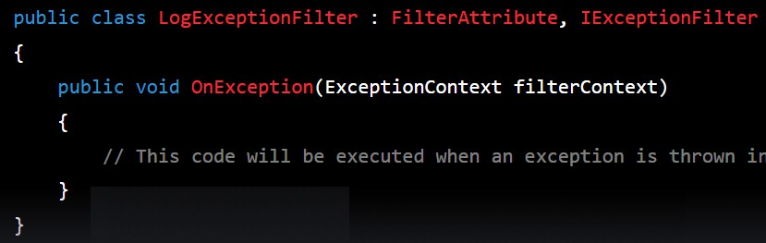

* Filters in ASP.NET MVC are used to inject logic that runs before or after an action method is executed.



Q149

What are Filters and their types in MVC?



Authorization Filter

Action Filter

Result Filter

Exception Filter

Types of Filter

* + Authentication is the process of verifying the identity of a user by validating their credentials such as username and password.



Q150

What is Authentication and Authorization in ASP.NET MVC?

* + Authorization is the process of allowing an authenticated user **ACCESS** to resources. Authentication is always precedes to Authorization.

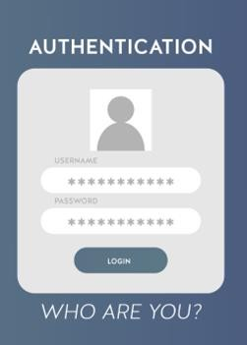 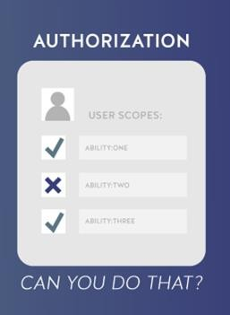

1. 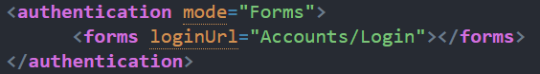**Form Authentication -** Forms authentication is a cookie- based authentication mechanism that uses user credentials stored in a database to authenticate users.



Q151

What are the types of Authentication in ASP.NET MVC?

1. 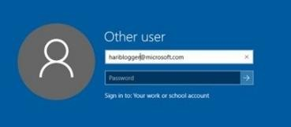**Passport Authentication -** Passport authentication is a

centralized authentication service provided by Microsoft.

1. **Token Authentication:** Token authentication is a mechanism that uses JSON Web Tokens (JWT) to authenticate users. It is commonly used in Single Page Applications (SPA) or APIs where the user's credentials are not stored on the server.
2. 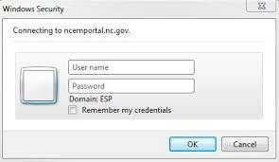**Windows Authentication -** Windows authentication is a mechanism that uses the user's Windows credentials to authenticate users. It is typically used in intranet scenarios where all users are part of the same Windows domain.
   * Output caching in MVC is a technique used to improve the performance of web applications by storing the output of an action method in cache.



Q152

What is Output Caching in MVC? How to implement it?

Client Request



Response

Cache

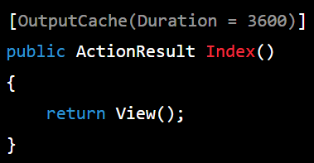Request

Server

Response

* + Outputcache is one of the type of ResultFilter only

Database

* + 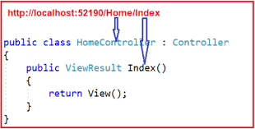Routing in MVC is the process of mapping a URL request to a specific controller action in a web application.



Q153

What is Routing in MVC?

* + The routing system is responsible for directing incoming requests to the appropriate controller, based on the URL.
  + The routing system is typically configured using a **routing table**, which maps URLs to controller actions.
  + Attribute based routing is used to manipulate the default behavior of routing in ASP.NET MVC.



Q154

Explain Attribute Based Routing in MVC?

<http://localhost:1234/home/about>

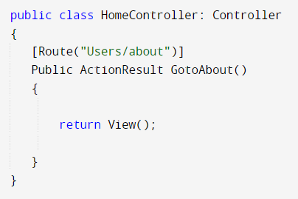

## Chapter 18 : ASP.NET – MVC - Part 2

Q155. What is the difference between ViewData, ViewBag & TempData? Q156. How can we pass the data from controller to view in MVC?

Q157. What is Partial View?

Q158. What are Areas in MVC?

Q159. How Validation works in MVC? What is Data Annotation? Q160. Explain the concept of MVC Scaffolding?

Q161. What is Bundling and Minification in MVC?

V Imp

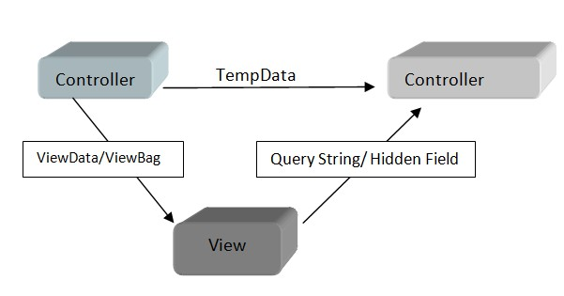Q162. How to implement Security in web applications in MVC? V Imp

Back to main index

* 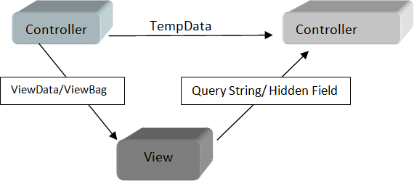ViewData, ViewBag, and TempData are all ways to **pass data** between a controller and a view.



Q155

What is the difference between ViewData, ViewBag & TempData?

1. ViewData and ViewBag are used to transfer data from controller to view.
2. TempData is used to pass data from controller to controller(pass data between two action methods).

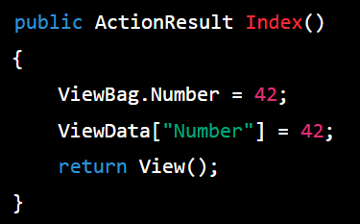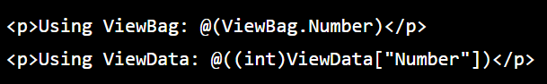

1. ViewBag doesn’t require typecasting,

whereas ViewData require the typecasting.

* + By using ViewData and ViewBag



Q156

How can we pass the data from controller to view in MVC?

* A partial view is a reusable view component that can be rendered within other views or shared across multiple pages in a web application.



Q157

What is Partial View?



View 1

Partial View 1

Partial View 2

* It helps us to reduce code duplication.

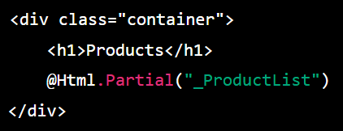View 2



Partial View 1 Partial View 3

back to chapter index

* 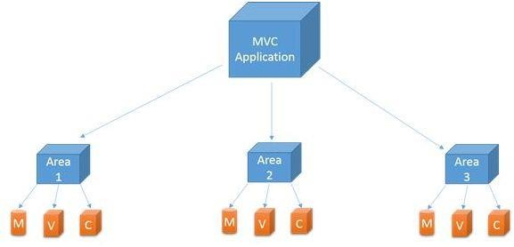Areas are just a way to divide the modules of large applications in multiple or separated MVC.



Q158

What are Areas in MVC?

* + 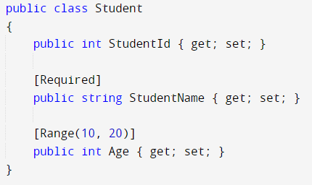Validation can be done in MVC using **DATA ANNOTATION** Attributes.



Q159

How Validation works in MVC? What is Data Annotation?

* [Required]: Specifies that a property is required and cannot be null or empty.



Q159

How Validation works in MVC? What is Data Annotation?

* [StringLength]: Specifies the minimum and maximum length of a string property.
* [RegularExpression]: Specifies a regular expression pattern that a string property must match.
* [EmailAddress]: Specifies that a string property must be a valid email address format.
* [Range]: Specifies the minimum and maximum allowed values for a numeric property.
* [Compare]: Compares the value of a property with the value of another property in the same model.
* [DataType]: Specifies the data type of a property, which can be used for formatting and validation purposes.
* [Display]: Provides metadata for displaying the property, such as the name and order of the property in a view.



Q159

How Validation works in MVC? What is Data Annotation?

* [Editable]: Specifies whether a property can be edited or displayed in a view.
* [ReadOnly]: Specifies that a property can be displayed in a view but cannot be edited.
* [HiddenInput]: Specifies that a property should be hidden in a view.
* [DisplayName]: Provides a friendly name for a property that can be used in a view.
* [DisplayFormat]: Specifies a format string for displaying the value of a property.
* [RequiredIf]: Specifies that a property is required if another property in the model has a specific value.
* [CreditCard]: Specifies that a string property must be a valid credit card number format.

back to chapter index

* + 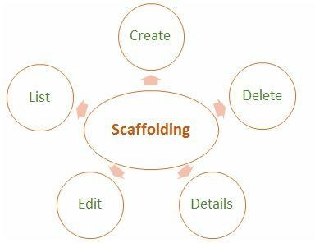In ASP.NET MVC, scaffolding is a technique that **generates code** for common web application.



Q160

Explain the concept of MVC Scaffolding?

* + The scaffolding code can include controllers, views, and data access code automatically generated that can help developers to create web applications more quickly and with less manual coding.



Q161

What is Bundling and Minification in MVC?

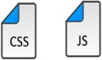 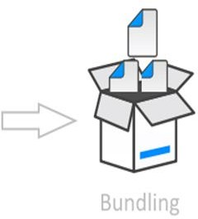 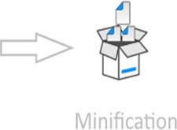

* + **BUNDLING** - It lets us combine multiple JavaScript (.js) files or multiple cascading style sheet (.css) files, so that they can be downloaded as a unit, rather than making individual HTTP requests for different js and css files.
  + **MINIFICATION** - It squeezes out whitespace and performs other types of compression to make the downloaded files as small as possible.

1. 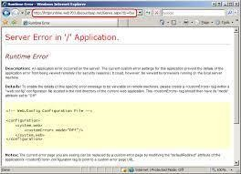Error handling - Must setup custom error page.



Q162

How to implement Security in web applications in MVC?

1. Cross-Site-Request-Forgery (CSRF) – Antiforgery token
2. Cross-Site-Scripting (XSS) attacks – Must validate input controls
3. 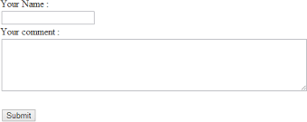Mallicious file upload – Must validate the extension of

files.

1. SQL injection attack - Validate inputs, use parameterized queries, use ORM (e.g. dapper , entity framework ), use stored procedures and avoid dynamic queries.
2. 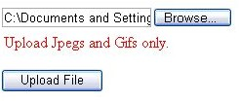Save the password in encrypted form so that even developer can’t access it.
3. Use https

## Chapter 19 : ASP.NET - Web Forms

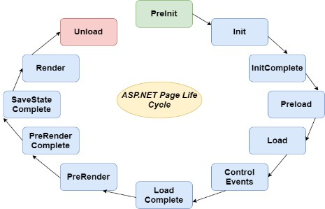Q163. What are the events in Page Life Cycle? V Imp

Q164. What is the difference between Server.Transfer() and Response.Redirect()? Q165. What are the different types of Caching?

Q166. What are the types of state management?V Imp

Q167. Where the ViewState is stored after the page postback? Q168. What are the different ways to store session state in asp.net? Q169. What is cookie less session?

Q170. How to force all the validation controls to run in a page in web forms?

Back to main index

1. 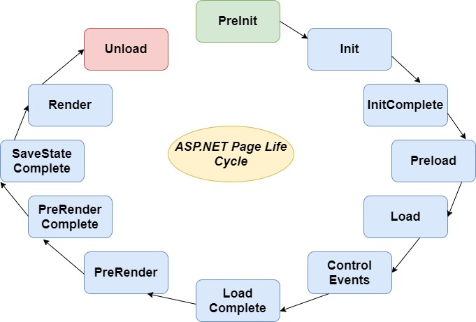**Init** - This event fires after each control has been initialized.



Q163

What are the events in Page Life Cycle? In which event are the controls fully loaded?

1. **Preload** – Set properties or default values of the control.
2. **Load** – All the controls are ready at this event.
3. **PreRender** - Allows final changes to the page or its control.
4. **Render -** The Render event generates the client-side HTML
5. **Unload -** This event is used for cleanup code.
   * In PAGE LOAD event controls are fully loaded.
   * 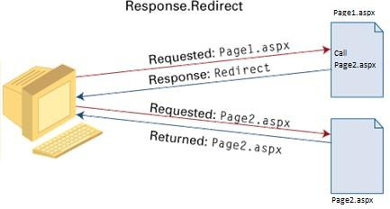Both Response.Redirect() and Server.Transfer() methods are used to **redirect** the user's browser from one page to another page.



Q164

What is the difference between Server.Transfer() and Response.Redirect()?

* + **Response.Redirect** uses **round trip** back to the client for redirecting the page.
  + 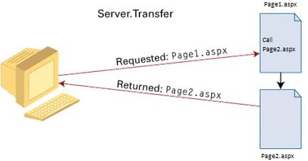It is a **slow** technique, but it maintains the URL history in the client browser for all pages.
  + In **Server.Transfer** page processing transfers from one page to the other page without making a round-trip back to the client's browser.
  + It is a **faster** technique, but it does not maintain

the URL history in the client browser for all pages.



Client



Q165

What are the different types of Caching?



Page 1



Page 2



Database

Page Output Caching Fragment Caching Data Caching

Request

Response

1. Page Output Caching: Page output caching allows you to cache the output of an **entire page**. This is useful when a page contains all static content.
2. Fragment Caching: Fragment caching allows you to cache a **portion or fragment** of a page. This is useful when a page contains dynamic content that can be separated from the rest of the page.

Request

Server

Cache

Response

1. Data Caching: Data caching allows you to cache **data** retrieved from a database or other data source. This can improve performance by reducing the number of database calls.

Database

* + State management refer to **storing** data that is required by a web application to track information between user requests and server responses.



Q166

What are the types of state management?



State Management in ASP.NET

Client Side

Server Side

Cookies

Session State

Hidden Field

Application

State

ViewState

Caching

Query String

1. Cookies: Cookies is a mechanism for storing small amounts of data on the client's machine. For example, it is used to save usernames.
2. Hidden Fields: Hidden fields are HTML form elements that can be used to store data on the client side. They are often used to pass data between pages.
3. ViewState: ViewState is a mechanism that stores the data on the client side as a hidden field. ViewState is useful for persisting data between postbacks in a WebForms application.
4. QueryString: QueryString is a mechanism for passing data from one page to another through the URL. But it is not secure as it is visible to all.



State Management in ASP.NET

Client Side

Server Side

Cookies

Session State

Hidden Field

Application

State

ViewState

Caching

Query String

* + Server-side state management techniques:



Q166

What are the types of state management?

1. Session State: Session state is a server-side mechanism that allows you to store user-specific data on the server. Session state uses a session ID to associate data with a specific user and can be used to persist data between page requests.
2. Application State: Application state is a server-side mechanism that allows you to store data that is shared by all users of an application.
3. Caching: Cache is a server-side mechanism that allows you to store frequently accessed data in memory.
   * ViewState is stored in a HIDDEN FIELD on the page at client side.



Q167

Where the ViewState is stored after the page postback?

* Session state is a mechanism that enables you to store data on server side for multiple requests. It allows you to persist data between pages.



Q168

What are the different ways to store session state in asp.net?



Types of storage for session state

In-Process

Session State

State Server

Session State

SQL Server

Session State

1. In-Process Session State: This is the default session state management mode in ASP.NET, where session data is stored in memory on the same **web server**.
2. 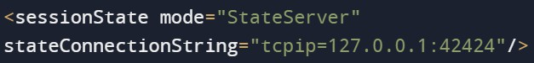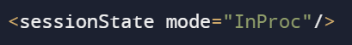State Server Session State: This mode stores session data in a separate process called the ASP.NET State Service, which runs **outside** the web server process.
3. 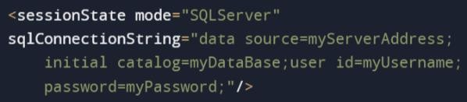SQL Server Session State: This mode stores session data in a **SQL Server database**, which provides the highest level of reliability and scalability.
   * By default, a session uses a browser cookie in the background.



Q169

What is cookie less session?

* + In cookie less, the session is passed via **url** instead of cookie.

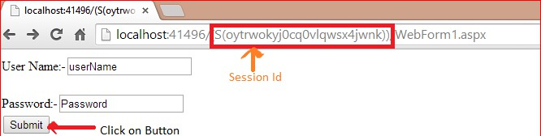



* + Page.Validate()



Q170

How to force all the validation controls to run in a page in web forms?

## Chapter 20 : ADO.NET & EF

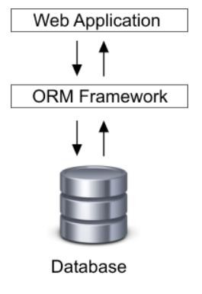Q171. What are the main components of ADO.NET? V Imp

Q172. What is Connected architecture and Disconnected architecture? Q173. What are the different Execute Methods of ADO.NET?

Q174. What are the Authentication techniques used to connect to SQL Server? Q175. What is ORM? What are the different types of ORM?

Q176. What is Entity Framework?

V Imp

Q177. How will you differentiate ADO.NET from Entity Framework?

Q178. How Entity Framework works? OR How to setup EF?

Q179. What is meant by DBContext and DBSet?

V Imp

Q180. What are the different types of application development approaches used with EF? Q181. What is the difference between LINQ to SQL and Entity Framework?

Back to main index

* 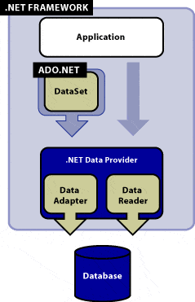**DataSet class** - A DataSet is basically a container which gets the data from one or more tables from the database. It follows disconnected architecture.



Q171

What are the main components of ADO.NET?

* **DataAdapter class** - A DataAdapter bridges the gap between the disconnected DataSet/ DataTable objects and the physical database.
* **DataReader Class** - The DataReader allows you to read the data returned by a SELECT command.
  1. It is read only.
  2. Unlike dataset we cannot update the database via this.
  3. It follows connected architecture.
* 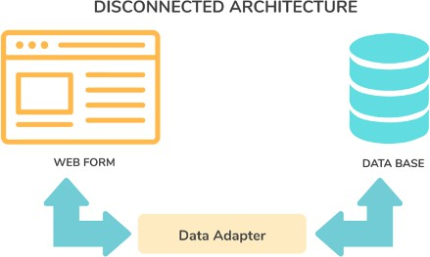**Disconnected Architecture -** Disconnected architecture means, you don’t need to connect always to get data from the database.



Q172

What is Connected architecture and Disconnected architecture?

1. Get data into DataAdapter.
2. Manipulate the DataAdapter
3. Resubmit the data.
   * It is fast and robust(data will not lose in case of any power failure).
   * 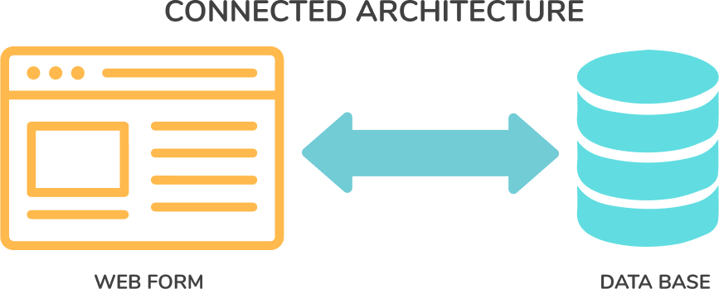**Connected Architecture -** Connected architecture means you are directly interacting with database, but it is less secure and not robust.
4. 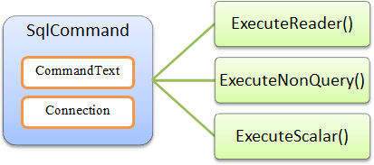**EXECUTESCALAR()** - It is used to return SINGLE value from the database.



Q173

What are the different Execute Methods of ADO.NET?

1. **EXECUTENONQUERY() –** It returns a RESULTSET from databse and it has multiple values. It can be used for insert, update and delete.
2. **EXECUTEREADER()** - It only retrieves data from

database. No update, insert. It is readonly.



Q174

What are the Authentication techniques used to connect to SQL Server?



Types of Authentications to

connect to SQL Server

Windows

Authentication

SQL Server

Authentication

Azure AD

Authentication

* 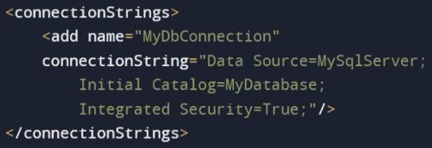The main authentication techniques are:



Q174

What are the Authentication techniques used to connect to SQL Server?

1. Windows Authentication: This technique uses the current Windows user account to authenticate to SQL Server. It is the most secure and recommended technique for applications running on a Windows domain.
2. 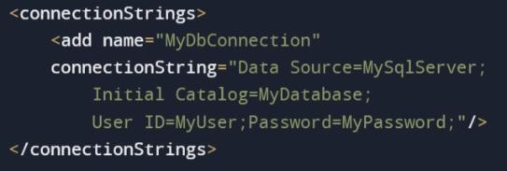SQL Server Authentication: This technique uses a SQL Server user account and password to authenticate to SQL Server.
3. Azure Active Directory Authentication: This technique allows for authentication using Azure Active Directory (AAD) identities.
   * 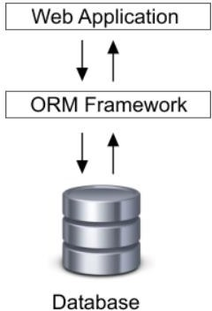ORM (Object-Relational Mapper) is for mapping objects in your application with database tables.



Q175

What is ORM? What are the different types of ORM?

* + It is like a wrapper to make database calls simple and easy.



Types of ORM’s

Entity

Framework

N Hibernate

Dapper

* + 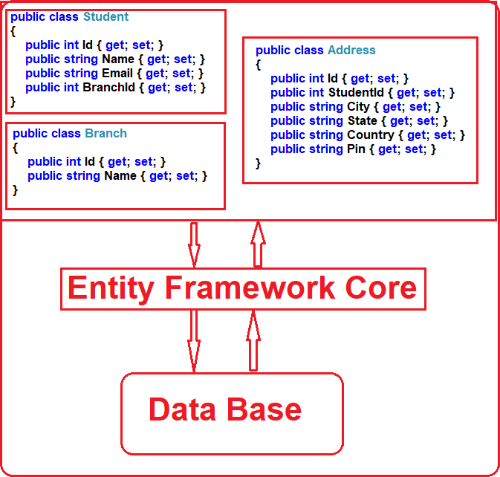An Entity Framework (EF) is an open-source **ORM**



Q176

What is Entity Framework?

(Object-Relational Mapper) from Microsoft.

* + It’s like a **wrapper** on ADO.NET.
  + Entity Framework minimizes the coding effort.

public *class* UserRepository

{

public DataSet GetAllUsersList()

{

DataSet ds = new DataSet(); // Initializes disconnected dataset to fetch results

//Create and initialize the connection using connection string

using (SqlConnection sqlConn = SqlConnection ("DataSource=localhost; Initial Catalog=TestDB; User ID=sa;Password=admin;"))

{

sqlConn.Open(); //Open connection

string sql = "select * from tblusers"; // sql query to access user from table SqlCommand sqlCmd = new SqlCommand(sql, sqlConn);

sqlCmd.CommandType = CommandType.Text; // Define Command Type

SqlDataAdapter sqlAdapter = new SqlDataAdapter(sqlCmd);

sqlAdapter.Fill(ds); //Get the data in disconnected mode

}

return ds; // return dataset result

}

}

#### ADO.NET EF



Q177

How will you differentiate ADO.NET from Entity Framework?

public *class* UserRepository

{

public static void Main(string[] args)

{

// Initializes the dbContext class User Entity using (var userContextDB = new UserContext())

{

// Create a new user object

var user = new User() { UserID = "USER-01" };

// Call Add Command userContextDB.User.Add(user);

// Execute the save command to make changes userContextDB.SaveChanges();

}

}

}



Q177

How will you differentiate ADO.NET from Entity Framework?

|  |  |
| --- | --- |
| **Entity Framework** | **ADO.NET** |
| 1. In EF, code is simpler and short. | In ADO.NET, same code is bigger. |
| 2. EF can generate SQL statements automatically based on LINQ queries. | ADO.NET requires developers to write SQL statements themselves. |
| 3. EF is designed to be database independent, which means same code can work with different databases. | ADO.NET, is tightly coupled to SQL Server and requires different code for different database systems. |
| 4. EF is slightly slower than ADO.NET because internally EF use ADO.NET only | ADO.NET is slightly faster than EF. |

ty w s? t



Q178

How Entity Framework works? OR How to setup EF?

❖

How to add records to Student table in database using EF?

* + 1. Install-Package EntityFramework

In the *Models* folder, create a class file named *Student.cs*

public class Student

{

public int ID { get; set; } public string Name { get; set; }

}

* + 1. Create the data model for the student entity
    2. Create the database context

public class SchoolContext : DbContext

{

public DbSet<Student> Students { get; set; }

}

1. Add data to student table



Q178

How Entity Framework works? OR How to setup EF?

protected void AddStudents(SchoolContext context)

{

var students = new List<Student>

{

new Student{Name=“Happy"}, new Student{Name=“John"}, new Student{Name=“Amit"},

};

students.ForEach(s => context.Students.Add(s));

context.**SaveChanges()**

}



Q179

What is meant by DBContext and DBSet?

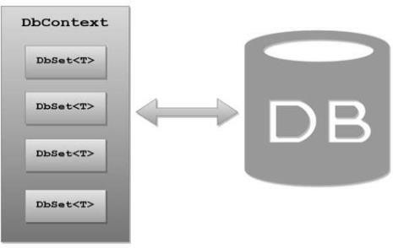

* 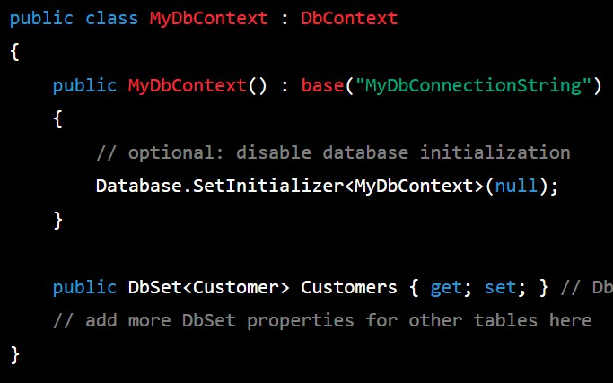DbContext is a class in the Entity Framework that helps in creating the **communication** between the database and the domain/entity class.
* The DbSet class represents an **entity set** that can be used for create, read, update, and delete operations.

1. 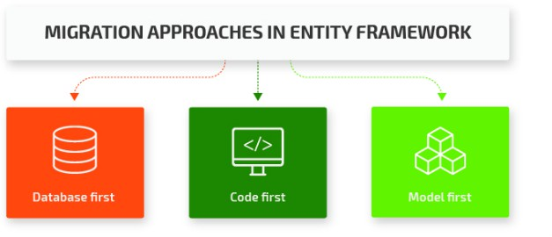**Database First** – In Database First approach first the database is created and then the entity model is generated from it.



Q180

What are the different types of application development approaches used with EF?

1. **Code First -** The Code First approach involves creating the data model using C# or VB.NET classes. Developers can define entities, relationships, and other schema elements using code, and then generate the database schema from the code.
2. **Model First -** The Model First approach involves creating the data model using visual tools such as Entity Data Model Designer in Visual Studio. Developers can create entities, relationships, and other schema elements visually, and then generate the database schema from the model.
   * LINQ to SQL and Entity Framework are both Object- Relational Mapping (ORM) frameworks that allow developers to interact with relational databases using object-oriented programming techniques.



Q181

What is the difference between LINQ to SQL and Entity Framework?

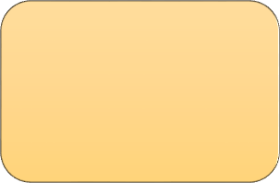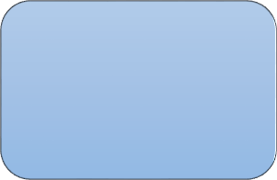

Application

Linq to SQL

Entity

Framework

Database

* + Differences between LINQ to SQL and EF:

1. LINQ to SQL is a lightweight ORM that supports only SQL

Server databases.

1. Entity Framework is a more robust ORM that supports multiple database providers, including SQL Server, Oracle, MySQL etc.
2. LINQ to SQL is suitable for small to medium-sized applications.
3. Entity Framework is suitable for large and complex applications.

## Chapter 21 : Web API - Basics

Q182. What is Web API? What is the purpose of Web API?

Q183. What are Web API advantages over WCF and web serivces? Q184. What are HTTP verbs or HTTP methods?

Q185. What is the difference Rest API and Web API?

V Imp

Q186. What are REST guidelines? What is the difference between Rest and Restful? Q187. Is it possible to use WCF as Restful services?

Q188. How to consume Web API from a .NET MVC application? Q189. What is the difference between Web API and MVC Controller?

Back to main index

* 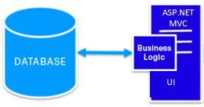Web API(Application Programming Interface) are HTTP based services that can be accessed from browser or mobile-apps.



Q182

What is Web API? What is the purpose of Web API?

* Web API enables different software applications to communicate with each other through the internet.
* 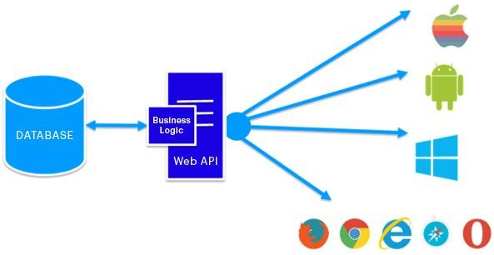Web API’s mostly use JSON and XML formats to

transfer data between different applications.

* 1. 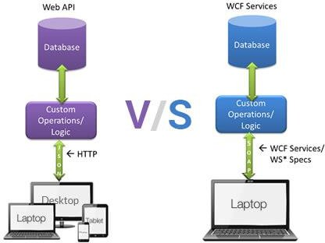Web APIs are **simpler** to use and learn, and use familiar web technologies like HTTP, JSON and XML.



Q183

What are Web API advantages over WCF and web serivces?

* 1. Web APIs are more **flexible**, can be hosted on a wide range of platforms, and are compatible with many devices including mobile devices, web browsers, and IoT devices.
  2. Web APIs are more **scalable** and can handle a large number of requests without consuming too many resources.
  3. Web APIs are **faster** than WCF because they use lightweight protocols like JSON and HTTP.



Q184

What are HTTP verbs or HTTP methods?

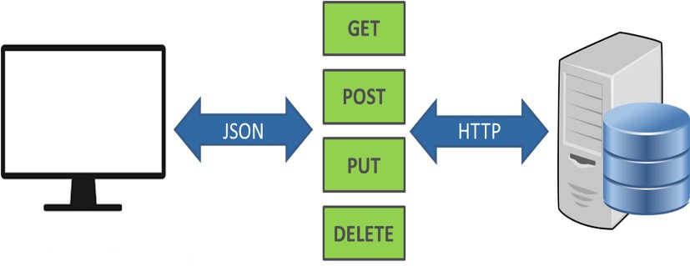

Q184

What are HTTP verbs or HTTP methods?

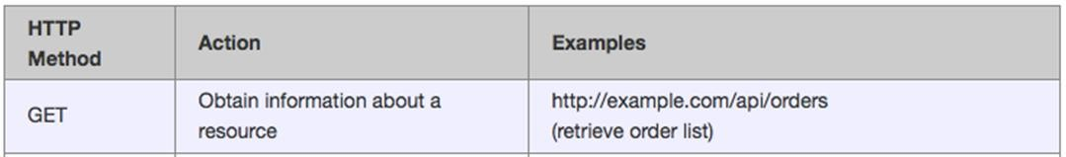

Q184

What are HTTP verbs or HTTP methods?

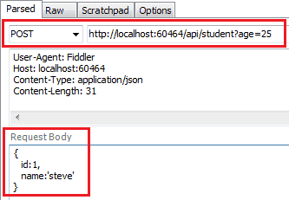

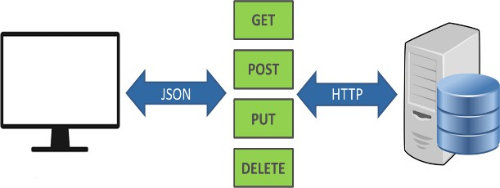

* 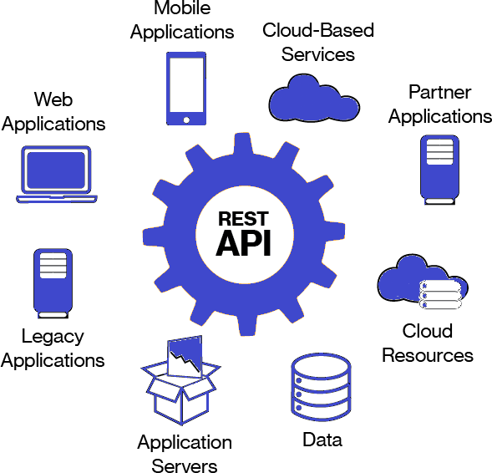REST is a **set of guidelines** which helps in creating a system where applications can easily communicate with each other.



Q185

What is the difference Rest API and Web API?

* REST stands for Representational State Transfer.

1. 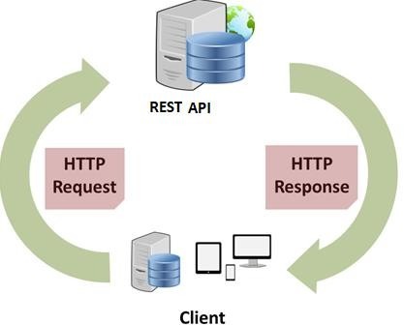**Separation of Client and Server** - The implementation of the



Q186

What are REST guidelines? What is the difference between Rest and Restful?

client and the server must be done independently.

1. **Stateless** - The server will not store anything about the latest HTTP request the client made. It will treat every request as new request.
2. **Uniform interface** – Identify the resources by URL [www.abc.com/api/questions](http://www.abc.com/api/questions)
3. **Cacheable** – The API response should be cacheable to

improve the performance.

1. **Layered system** - The system should follow layered pattern. For example, MVC is a layered system.
   * **RESTFUL Service**: If a system written by applying REST guidelines,

then it is also called REST service or RESTful services.

* + - Yes, we can develop RESTful services with WCF by following the REST guidelines in WCF service.



Q187

Is it possible to use WCF as Restful services?

5. Checking the response is successful or not.

4. GetAsync method will send request to find api resource GetAllEmployees. And then store the response in HttpResponseMessage class object.

3. Add media type, the request format of data. Here it is json.

Q188. eb



Q188

How to consume Web API from a .NET MVC application?

❖

Web API methods can be consumed

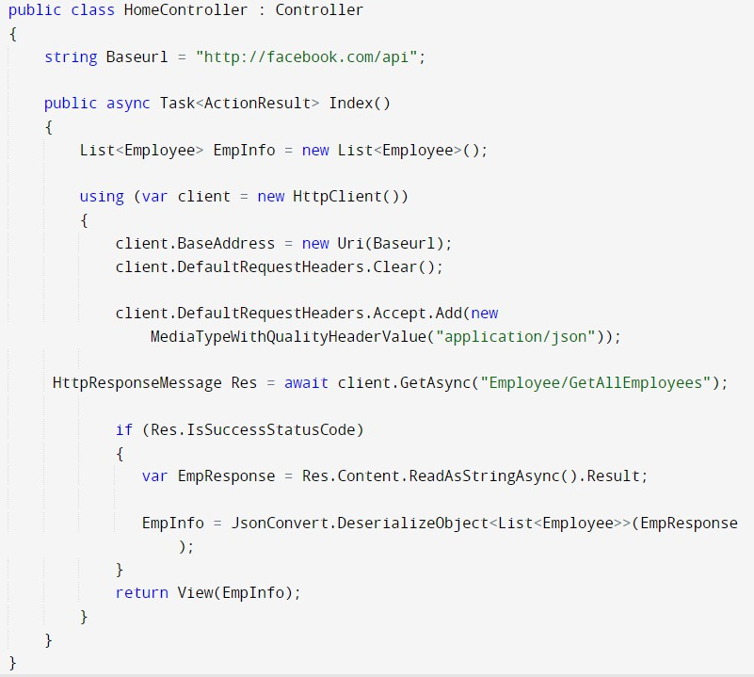

with the help of **HttpClient** class.

2. Set the BaseAddress property of client object.

1. Create the object of HttpClient class.

6. If successful then result is saved in a variable

back to chapter index

7. Then the variable will be deserialized from json format

to Employee object.

* + - * Web API Controller



Q189

What is the difference between Web API and MVC Controller?

|  |  |
| --- | --- |
| **Web API Controller** | **MVC Controller** |
| 1. Web api controller derives from SYSTEM.WEB.HTTP.APICO  NTROLLER class. | ASP.NET MVC controller derives from SYSTEM.WEB.MVC.CONT  ROLLER class. |
| 2. Web API controller does not give view support. | ASP.NET MVC gives view  support. |

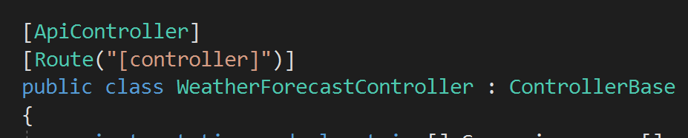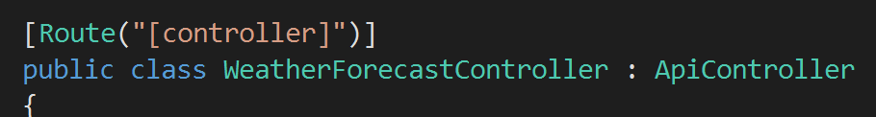

* + - * MVC Controller

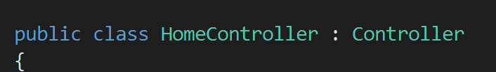

back to chapter index

## Chapter 22 : Web API – Authentication & JWT

Q190. What are the types of authentication techniques in web api? Q191. What is Basic Authentication in Web API?

Q192. What is API Key Authentication in Web API?

Q193. What is Token based authentication?

V Imp

Q194. What is JWT Authentication?

V Imp

Q195. What are the parts of JWT token? Q196. Where JWT token reside in the request?

Back to main index

* Authentication is the process of verifying the identity of a user by validating their credentials such as username and password.



Q190

What are the types of authentication techniques in web api?



Basic Authentication

API Key

Authentication

Types of

Authentication techniques

Token-based

Authentication

Certificate-based

Authentication

Windows

Authentication

Multi-Factor

Authentication



* 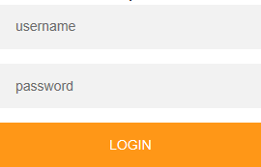In Basic Authentication, the user passes their credentials on a post request. At the WebAPI end, credentials are verified, and response is sent back.



Q191

What is Basic Authentication in Web API?

* 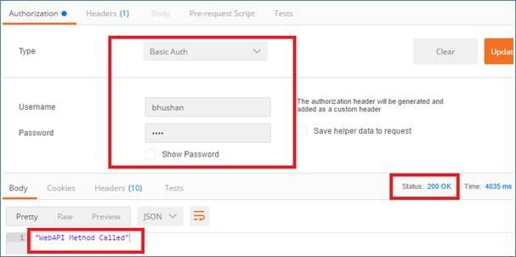The disadvantage of it is, Basic Authentication sends credentials in plain text over the network, so it is not considered a secure method of authentication.
* 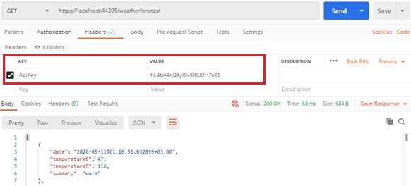**API Key Authentication -** In API Key Authentication, the API owner will share an API key with the users and this key will authenticate the users of that API.



Q192

What is API Key Authentication in Web API?

* The disadvantage of it is, API keys can be shared or stolen therefore it may not be suitable for all scenarios.
  + 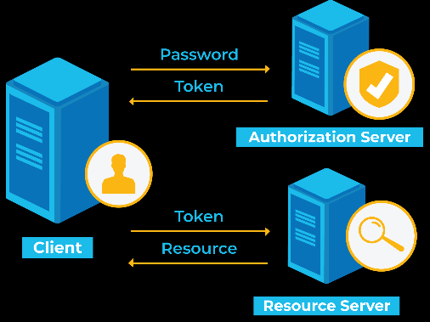Token-based authentication is a 4 step process:



Q193

What is Token based authentication?

1. Client application first sends a request to Authentication server with valid **credentials**.
2. The Authentication server/ Web API sends an

**Access token** to the client as a response.

1. In next request, the client uses the same token to access the restricted resources until the token is **valid** or not expired.
2. If the Access token is expired, then the client application can request for a new access token by using **Refresh token**.
   * JWT authentication is a token base authentication



Q194

What is JWT Authentication?

where JWT is a token format.

* + JWT stands for JSON Web Token.

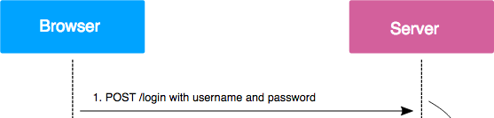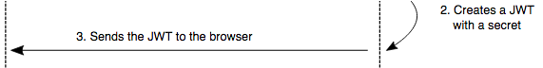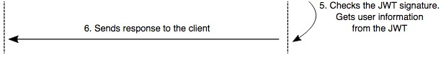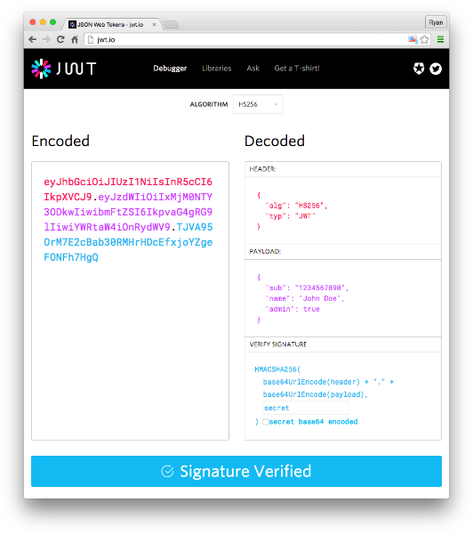

* + JWT token has 3 parts:



Q195

What are the parts of JWT token?

1. Header
2. Payload

Algorithm used to generate the token.

1. Signature

JWT Token

The type of the token, which is JWT here.

The payload contains the CLAIMS.

The signature is a string that is used to ensure the INTEGRITY of the token and verify that it has not been tampered with.

* + 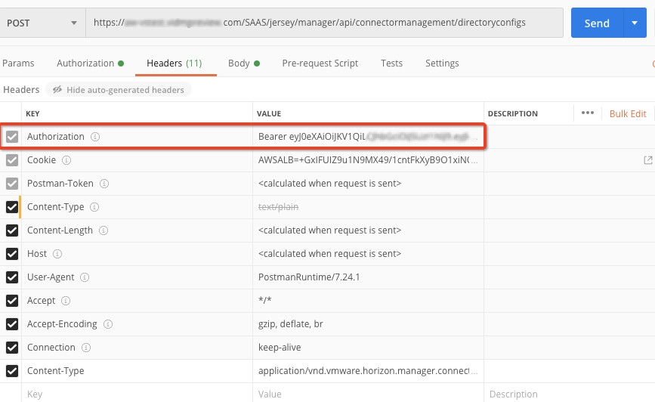In REQUEST HEADER.



Q196

Where JWT token reside in the request?

KEY **-** Authorization VALUE - Token

## Chapter 23 : Web API - More

Q197. How to test Web API? What are the tools?

Q198. What are main Return Types supported in Web API?

V Imp

Q199. What is the difference between HTTPResponseMessage and IHttpActionResult?

Return Types in Web API

Q200. What is the difference between IActionResult and IHttpActionResult?

Q201. What is Content Negotiation in Web API?

V Imp

Q202. What is MediaTypeFormatter class in Web API? Q203. What are Response Codes in Web API?

Back to main index



HttpResponseMessage

IHttpActionResult

JsonResult

XmlResult

FileStreamResult

EmptyResult

StatusCodeResult

RedirectResult

* Postman, Swagger and Fiddler tools



Q197

How to test Web API? What are the tools?

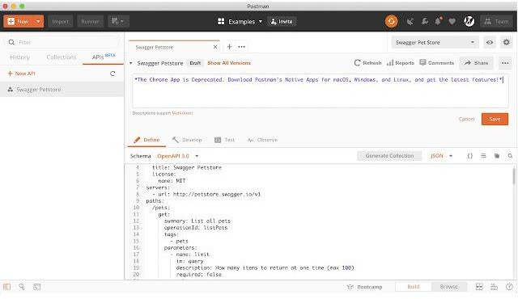

1. HttpResponseMessage: This class allows developers to create and return HTTP responses with a customized status code, headers, and content.



Q198

What are main return types supported in Web API?



HttpResponseMessage

IHttpActionResult

JsonResult

XmlResult

FileStreamResult

EmptyResult

StatusCodeResult

RedirectResult

Return Types in Web API

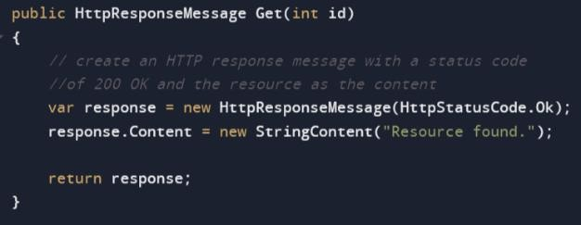

1. IHttpActionResult: This interface provides a level of abstraction between the controller and the HTTP response, allowing developers to return a variety of response types that implement the interface.



Q198

What are main return types supported in Web API?



HttpResponseMessage

IHttpActionResult

JsonResult

XmlResult

FileStreamResult

EmptyResult

StatusCodeResult

RedirectResult

Return Types in Web API

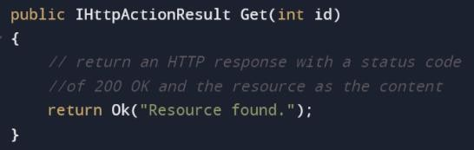

1. JsonResult: This class is used to serialize an object to JSON format and return it as an HTTP response message.

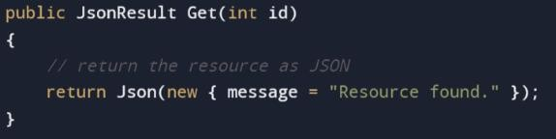

1. XmlResult: This class is used to serialize an object to XML format and return it as an HTTP response message.



Q198

What are main return types supported in Web API?



HttpResponseMessage

IHttpActionResult

JsonResult

XmlResult

FileStreamResult

EmptyResult

StatusCodeResult

RedirectResult

1. FileStreamResult: This class is used to return a file as an HTTP response message by reading the file as a stream.

Return Types in Web API

1. EmptyResult: This class is used to return an empty HTTP response message with a specified status code.
2. StatusCodeResult: This class is used to return an HTTP response message with a specified status code and no content.
3. RedirectResult: This class is used to redirect the client to a different URL by returning an HTTP response message with a redirect status code.

* In web API version 1.0, We have a response type class called **HttpResponseMessage** for returning Http response message from API.



Q199

What is the difference between HTTPResponseMessage and IHttpActionResult?

* In Web API version 2.0 **IHttpActionResult/ IActionResult** is introduced which is basically the replacement of HttpResponseMessage.

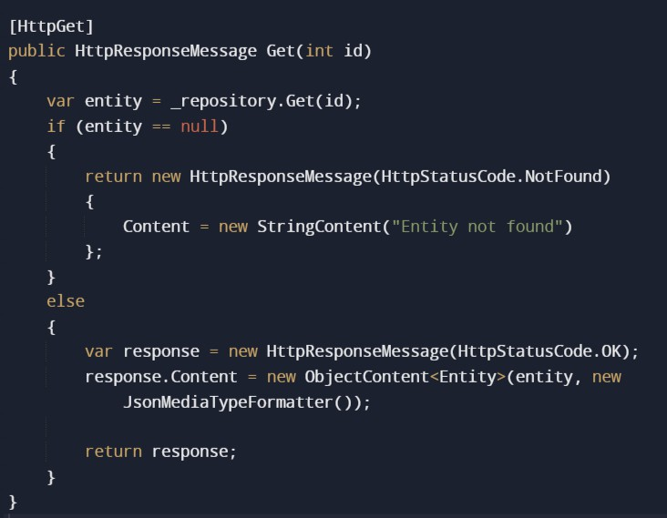 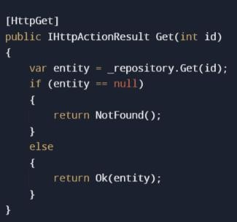

Benefits of IHttpActionResult:



Q199

What is the difference between HTTPResponseMessage and IHttpActionResult?

1. **Readability**: The IHttpActionResult implementation is more readable as it uses simple NotFound() and Ok() methods.
2. **Testability**: The IHttpActionResult implementation is more testable, as it allows for easier mocking of the return values.
3. **Flexibility**: The IHttpActionResult implementation is more flexible, as it allows for easy customization of the HTTP response without needing to construct a HttpResponseMessage object manually.
   * In Web API version 2.0 **IHttpActionResult/ IActionResult** is introduced which is basically the replacement of HttpResponseMessage.
     + IHttpActionResult is used in ASP.NET Web API,



Q200

What is the difference between IActionResult and IHttpActionResult?

while IActionResult is used in ASP.NET Core.

* 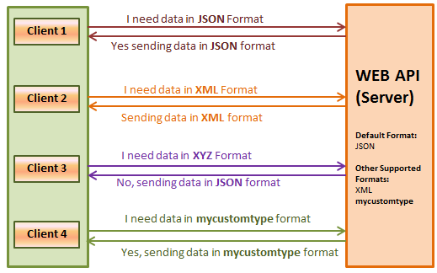Content negotiation is a way for the client and server to agree on the format(json/ xml) of the data being exchanged.



Q201

What is Content Negotiation in Web API?

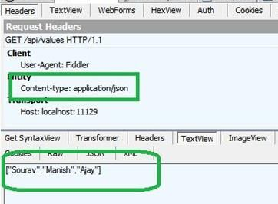

* Content negotiation can be implemented with the help of MediaTypeFormatter class.



Q202

What is MediaTypeFormatter class in Web API?

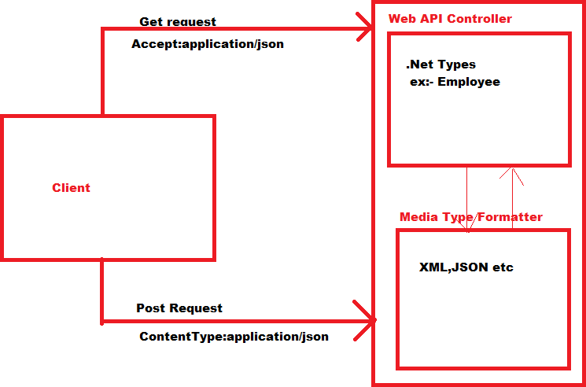

* + MediaTypeFormatter is a class in ASP.NET Web API that handles the conversion of objects into serialized formats(JSON, XML, and other media ) that can be transmitted over the web.



Q202

What is MediaTypeFormatter class in Web API?

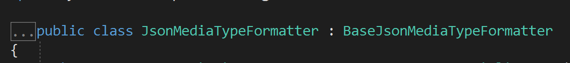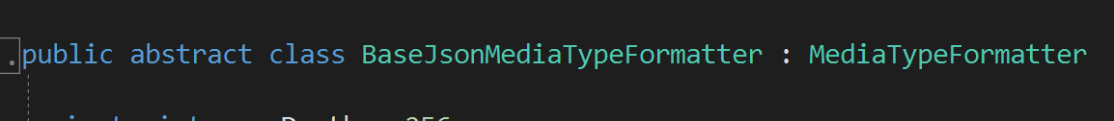

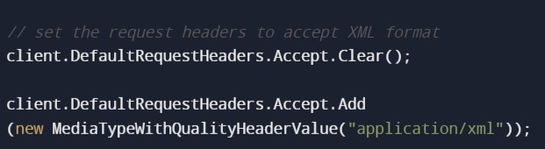

1. 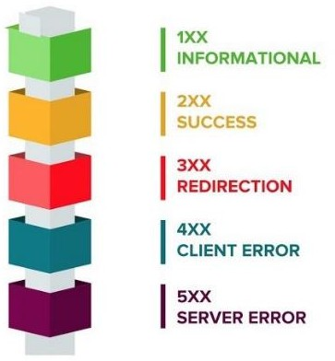**1xx: Informational** – Communicates transfer protocol-level information.



Q203

What are Response Codes in Web API?

1. **2xx: Success** – Indicates that the client’s request was

accepted successfully.

1. **3xx: Redirection** – This means request is not complete. The client must take some additional action in order to complete their request.
2. **4xx: Client Error** – This means there is some error in

API code.

1. **5xx: Server Error** – This means the error is not due to web api code but due to some environment settings.

* 200 OK: The request was successful, and the server has



Q203

What are Response Codes in Web API?

returned the requested data in the response body.

* 204 No Content: The request was successful, but the server has no data to return in the response body.
* 400 Bad Request: The client's request was invalid or could not be understood by the server.
* 401 Unauthorized: The client is not authorized to access the requested resource. The client should include authentication credentials in the request header to authenticate itself.
* 403 Forbidden: The client is authenticated, but not authorized to access the requested resource.
* 404 Not Found: The requested resource could not be found on the server.
* 500 Internal Server Error: An error occurred on the server while processing the request.



back to chapter index

## Chapter 24 : .NET Core - Basics

Q204. What is .NET Core? Q205. What is .NET Standard?

Q206. What are the advantages of .NET Core over .NET framework? Q207. What is the role of Program.cs file in ASP.NET Core?

Q208. What is the role of ConfigureServices method? Q209. What is the role of Configure method?

V Imp

Q210. Describe the complete Request Processing Pipeline for ASP.NET Core MVC? Q211. What is the difference between .NET Core and .NET 5?

Q212. What is Metapackage? What is the name of Metapackage provided by ASP.NET Core?

Back to main index

* 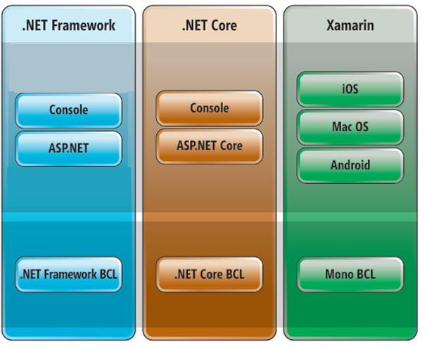.NET Core is completely a **NEW** framework.

**What is .NET Core?**



Q204

What is .NET Core?

* It is **FREE** and **OPEN-SOURCE** platform.
* It is developed by Microsoft.



Q205

What is .NET Standard?

* + .NET Standard is a set of rules that is common across all .NET frameworks.

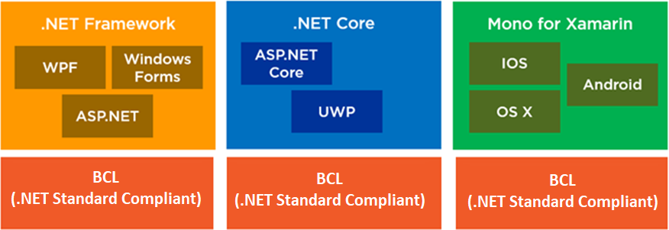



Q206

What are the advantages of .NET Core over .NET framework?



CROSS

PLATFORM

* Windows
* Linux
* MacOS

.NET

Framework only supports Windows



OPEN SOURCE

* Free to use
* Modify
* Distribute

.NET

Framework is paid



HOSTING

* Kestrel
* IIS
* Nginx

.NET

Framework only support IIS Hosting



BUILT-IN

DEPENDENCY INJECTION

* Loosely

Coupled Design

* Reusability
* Testability

.NET framework

don’t have built in dependency injection



SUPPORT

MULTIPLE IDE

* Visual Studio
* Visual Studio for Mac
* Visual Studio Code

.NET framework

only support Visual Studio IDE



Q207

What is the role of Program.cs file in ASP.NET Core?

* 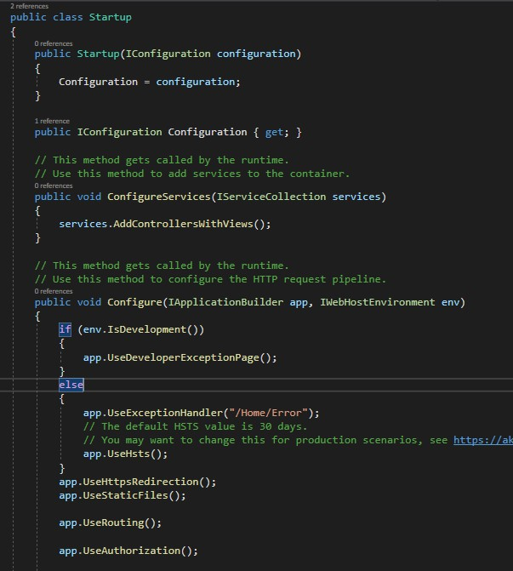Program.cs file contains the application startup code.
* The main method of Program.cs file is the entry point of application.

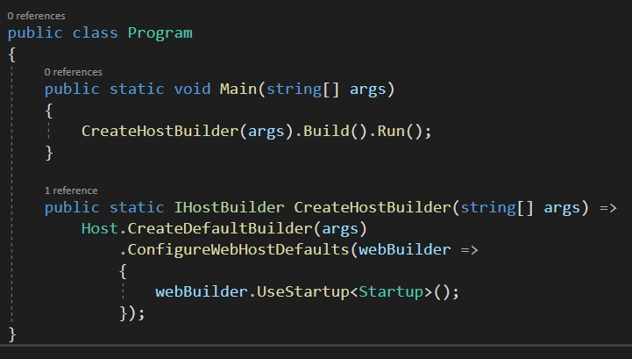

back to chapter index

* From .NET 6.0, the startup class code is merged in Program.cs file and therefore there is no separate Startup.cs class.



Q207

What is the role of Program.cs file in ASP.NET Core?

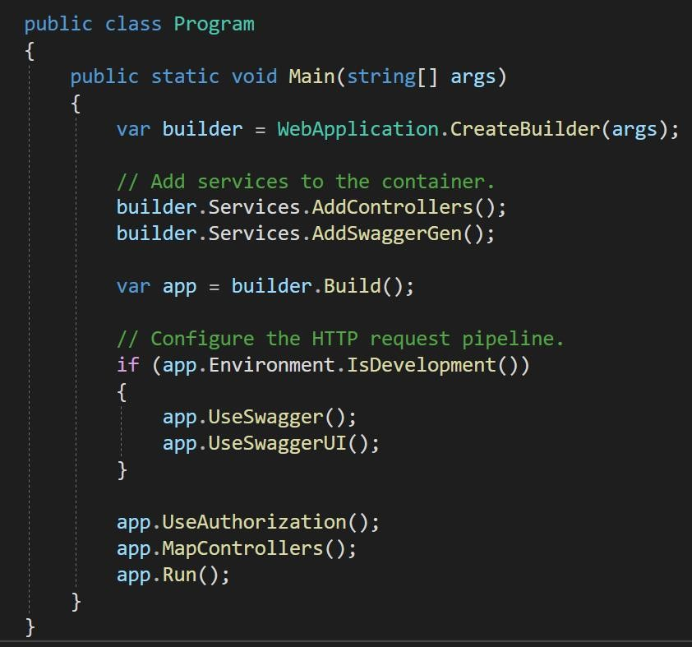

back to chapter index

Q208

### What is the role of ConfigureServices method?

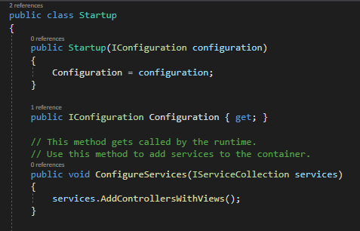

1. ConfigureServices is used to add services to the application.
2. ConfigureServices method always execute before Configure method.
3. ConfigureServices is an optional method. It’s not

necessary that all its methods will be execute.

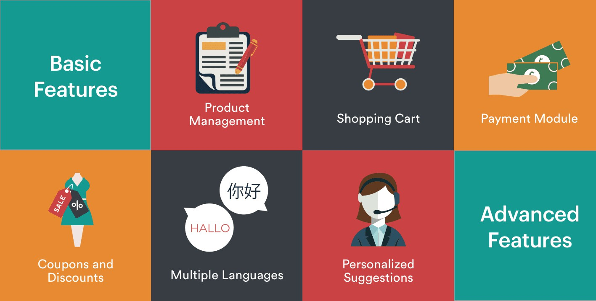

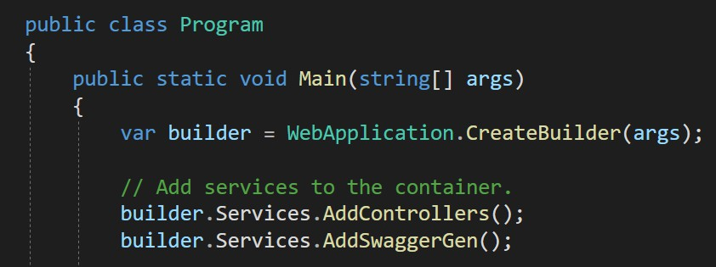back to chapter index

Q209

### What is the role of Configure method?

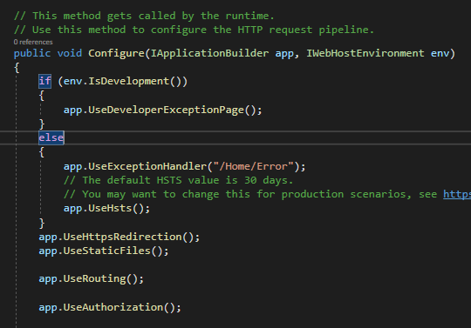

1. Configure method will configure the request pipeline.
2. Configure method executes after ConfigureServices method.
3. For each and every request, all the methods will execute inside the Configure method and in the same sequence.

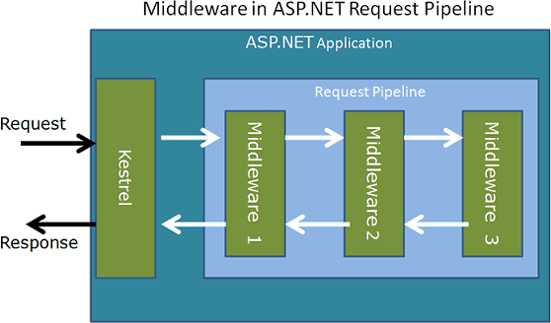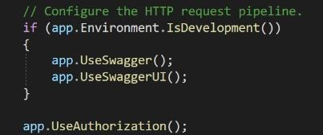



Q210

Describe the complete Request Processing Pipeline for ASP.NET Core MVC?

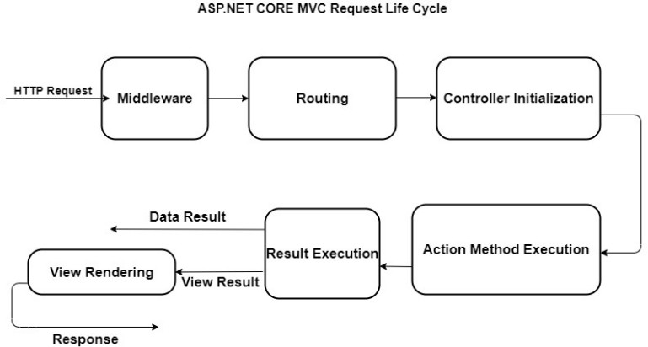

<http://localhost:1234/home/about>

* 1. .NET 5 is the next major release after .NET Core 3.1.



Q211

What is the difference between .NET Core and .NET 5?

* 1. The word ‘Core’ is dropped from the name to emphasize that .NET 5 is the future of all earlier versions of .NET Core.
  2. Recently, Microsoft has introduced .NET 6.

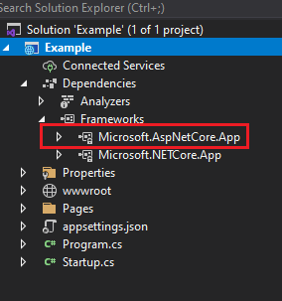

* Metapackage is a consolidated package of many

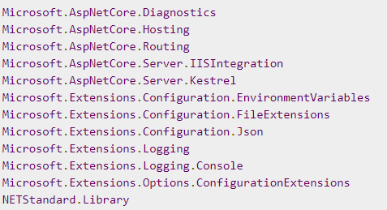

ovided by ASP.NET Core?



Q212

What is Metapackage? What is the name of Metapackage provided by ASP.NET Core?

dependencies.

## Chapter 25 : .NET Core - Dependency Injection

Q213. What is Dependency Injection?

V Imp

Q214. How to implement Dependency injection in .NET Core? V Imp

Q215. What are the advantages of Dependency Injection in .NET Core? Q216. How to use Dependency Injection in Views in ASP.NET Core?

V Imp

Back to main index

* Dependency Injection (DI) is a software **design pattern** in which we inject the dependency object of a class into another class.



Q213

What is Dependency Injection?

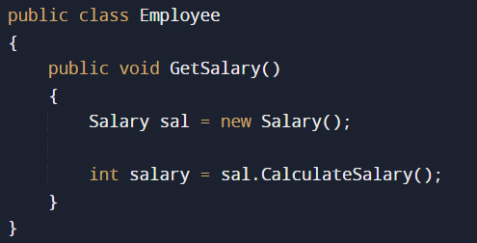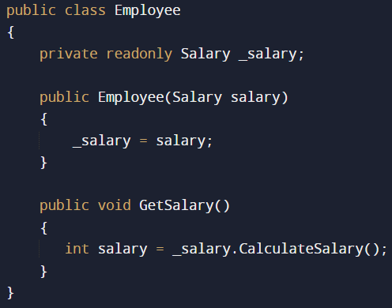

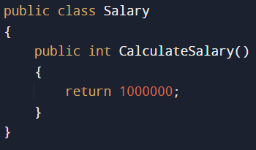

back to chapter index



Q214

How to implement Dependency injection in .NET Core?

100 Controllers (Big/Enterprise Level Application)

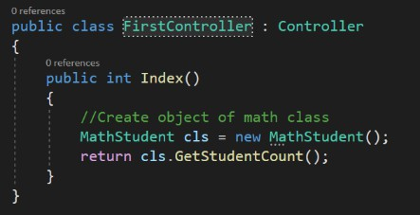  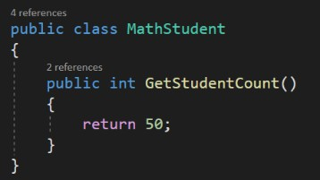

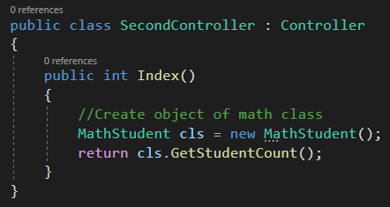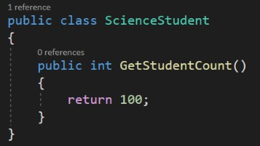



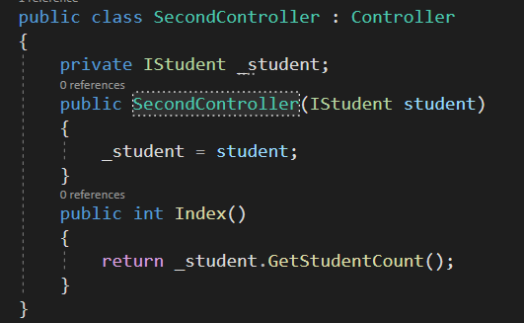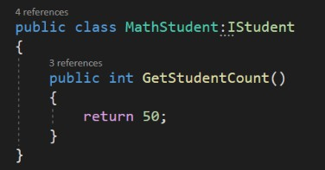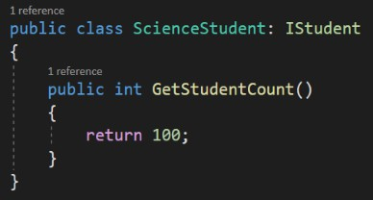

Q214

How to implement Dependency injection in .NET Core?

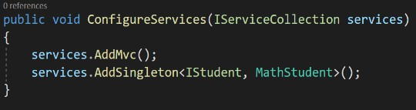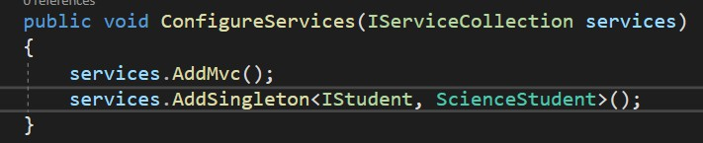

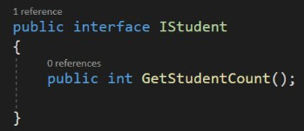

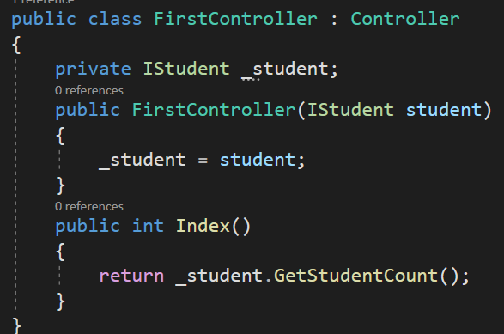

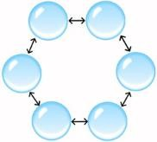Dependency njection



Q215

What are the advantages of Dependency Injection in .NET Core?



1. **Flexibility**: DI allows you to easily change the behavior of an application without modifying its code. By injecting dependencies, you can easily switch between different implementations of a service/ class.
2. **Easier unit testing**: DI makes it easy to unit test your code by allowing you to easily replace real dependencies with mock with the help of interfaces.
3. **Independent modules**: By separating dependencies, it becomes easier to make changes to your code without affecting the rest of the system.
4. **Reusability**: DI promotes reuse of components by making them independent of their environment. This allows you to reuse the same components in different applications without modification.

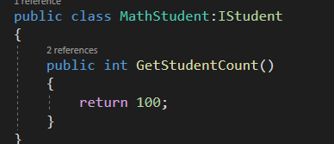

* 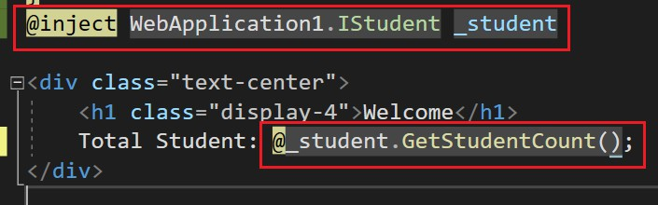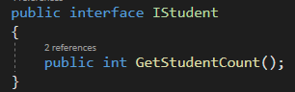A service can be injected into a view using the **@inject directive**.



Q216

How to use Dependency Injection in Views in ASP.NET Core?

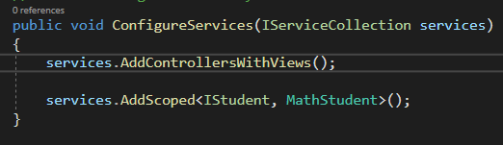back to chapter index

## Chapter 26 : .NET Core - Service Lifetimes, Middleware & Hosting

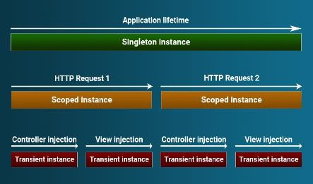Q217. What are the types of Service Lifetimes of an object in ASP.NET Core?

Q218. What is AddSingleton, AddScoped and AddTransient method? V Imp

Q219. What is Middleware in ASP.NET Core? What is custom middleware?

Q220. How ASP.NET Core Middleware is different from HttpModule?

Q221. What is Request Delegate in .NET Core?

Q222. What is Run(), Use() and Map() method? V Imp

V Imp

Q223. What are the types of Hosting in ASP.NET Core? What is In process and Out of process hosting?

Q224. What is Kestrel? What is the difference between Kestrel and IIS?

Back to main index



Q217

What are the types of Service Lifetimes of an object/ instance in ASP.NET Core?

* 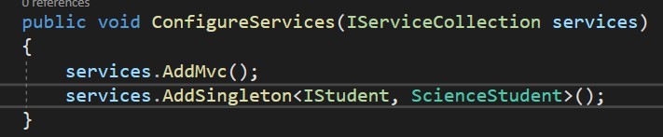The Service Lifetime refers to the lifespan of a registered service. Or
* The service lifetime controls how long a result object will live for after it has been created by the container.

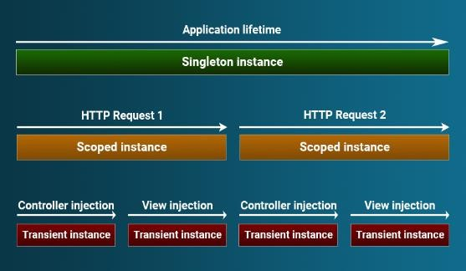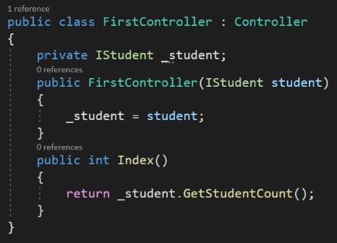



Q218

What is AddSingleton, AddScoped and AddTransient method?

* 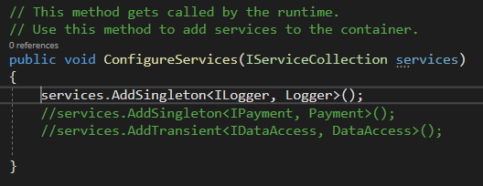AddSingleton method create only **one instance** when the service is requested for first time. And then the same instance will be shared by all different http requests.

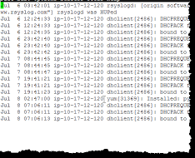



Q218

What is AddSingleton, AddSoped and AddTransient method?

Request 2

Client1

Payment

Service

Request 3

Client1

Client1

Request 1

* 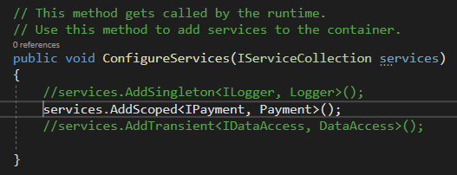AddScoped method create single instance per request. For every individual request there will be a single instance or object.



Q218

What is AddSingleton, AddSoped and AddTransient method?

* 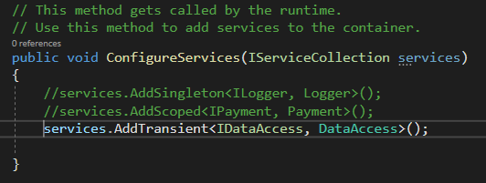AddTransient instance will not be shared at all, even with in the same request. Every time a new instance will be created.

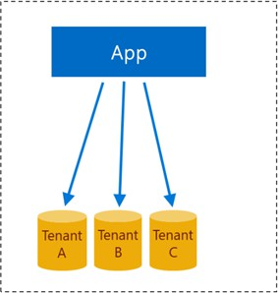



Q219

What is Middleware in ASP.NET Core? What is custom middleware?

* 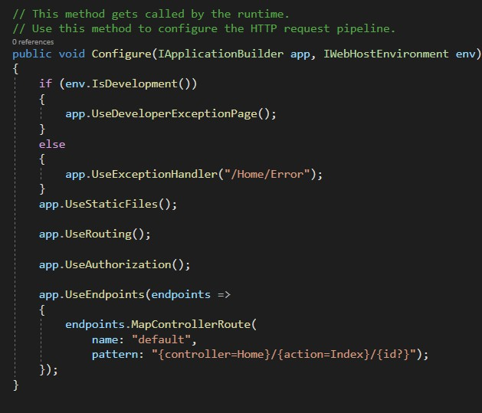A middleware is a component that is executed on every request in the ASP.NET Core application.

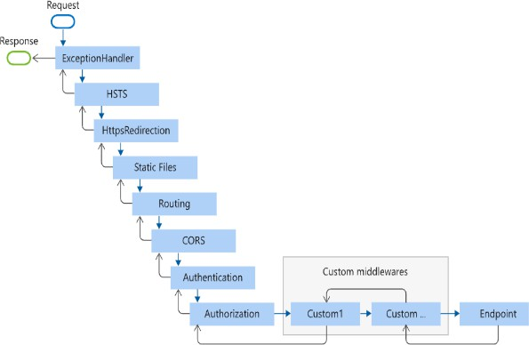



Q219

What is Middleware in ASP.NET Core? What is custom middleware?

* 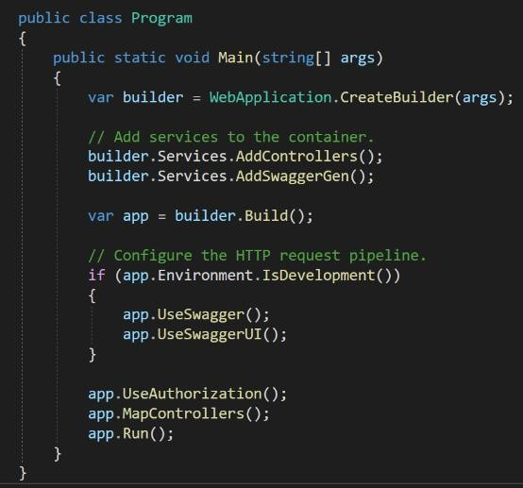A middleware a component that is executed on EVERY REQUEST in the ASP.NET Core application.
* We can set up the middleware in ASP.NET using the CONFIGURE method of our STARTUP class.





Q220

How ASP.NET Core Middleware is different from HttpModule?

* 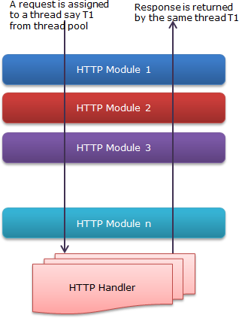HttpModules are nothing else, but they are

very similar to Middlewares only.

* HttpModules are registered in the web.config or global.asax file of the ASP.NET framework, while a Middleware is registered via Configure method of the startup.cs class.



Q221

What is Request Delegate in .NET Core?

* + Request delegates are used to **build** the

Request Pipeline

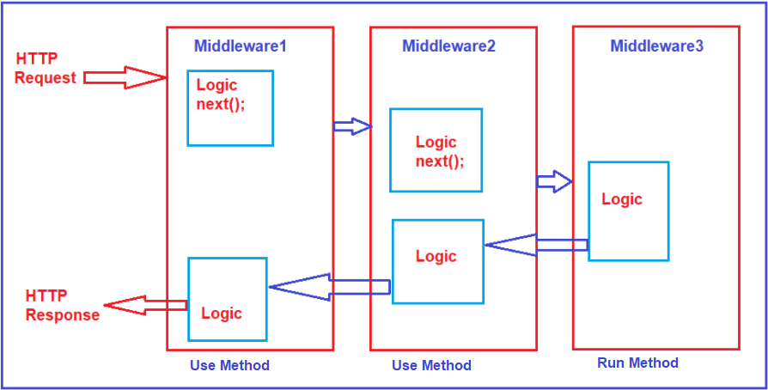request pipeline.

* + Request delegates are configured using

**Run**, **Map**, and **Use** extension methods.



Q222

What is Run(), Use() and Map() method?

* 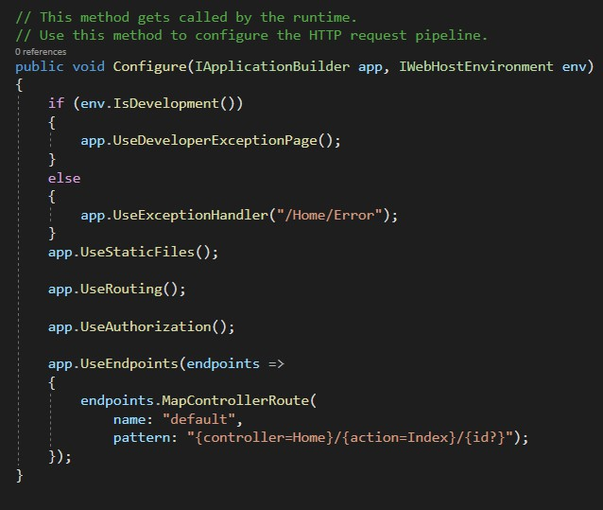For any request, Use method will execute the middleware component and then pass the execution to the **next** middleware or component.

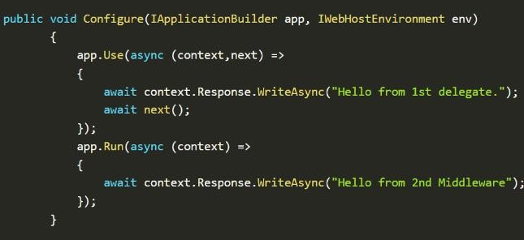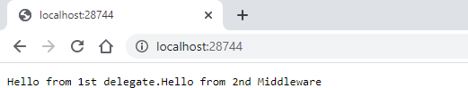



Q222

What is Run(), Use() and Map() method?

* Run method will execute the middleware component and then **terminate** the execution.
* It should be placed at the end of any pipeline.

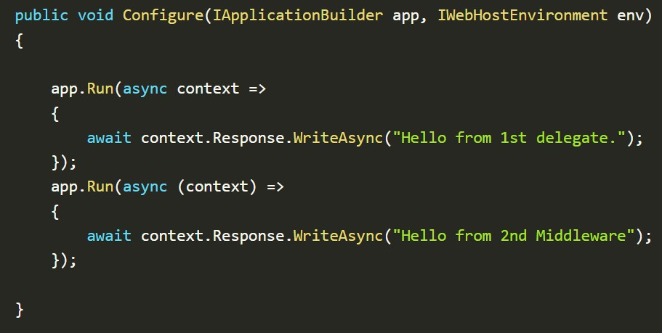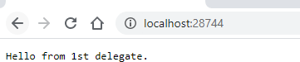





Q222

What is Run(), Use() and Map() method?

* 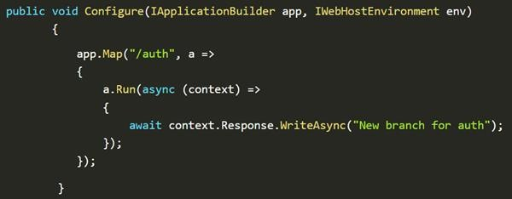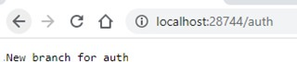The Map method is used to **map** a specific request url path to a middleware component.
  + In Process Hosting



Q223

What are the types of Hosting in ASP.NET Core? OR What is in process and out of process hosting?

|  |  |
| --- | --- |
| **In-Process** | **Out of Process** |
| Process name is w3wp.exe | Process name is dotnet.exe |
| Only one web server (IIS) | Two web server (IIS/Nginx/Apache + Kestrel) One web server (Kestrel) |

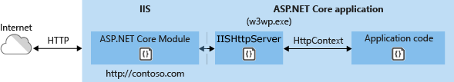

* + Out of Process Hosting

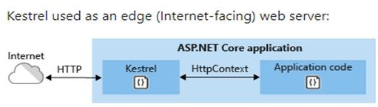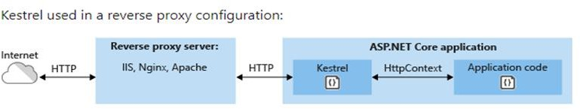

* + Kestrel is **a lightweight cross-platform** web server for asp.net core.



Q224

What is Kestrel? What is the difference between Kestrel and IIS?

* + It is a type of out of process hosting. It can be used alone, or it can be used with IIS or Nginx web servers.

|  |  |
| --- | --- |
| **Kestrel** | **IIS** |
| 1. Kestrel is a lightweight web server used for hosting. | IIS is a complete web server which is also used for hosting. |
| 2. Kestrel is cross platform and can be used with other web servers like IIS, Nginx and Apache. | IIS is not cross platform and can only run- in windows. |
| 3. Kestrel is open source like .NET Core | IIS is not open source |

## Distributed Caching in ASP.NET Core with Redis - Sahan Serasinghe - Personal BlogChapter 27 : .NET Core - Routing, Files, CORS & More…

Q225. What is Routing? Explain attribute routing in ASP.NET Core? Q226. Explain default project structure in ASP.NET Core application? Q227. How ASP.NET Core serve static files?

V Imp

Q228. What are the roles of Appsettings.Json and Launchsetting.Json file?

Q229. What are the various techniques to save configuration settings in .NET Core? Q230. What is CORS? Why is CORS restriction is required? How to fix CORS error?

Q231. What is In-Memory caching & Distributed Caching? Q232. How to handle errors in ASP.NET Core?

Q233. What are Razor pages in .NET Core?

V Imp

Back to main index

* Routing in MVC is the process of mapping a URL request to a specific controller action in a web application.



Q225

What is Routing? Explain attribute routing in ASP.NET Core?

* The routing system is responsible for directing incoming requests to the appropriate controller, based on the URL.
* The routing system is typically configured using a **routing table**, which maps URLs to controller actions.
* Attribute based routing is used to manipulate the default behavior of routing in ASP.NET MVC.



Q225

What is Routing? Explain attribute routing in ASP.NET Core?

<http://localhost:1234/home/about>



* 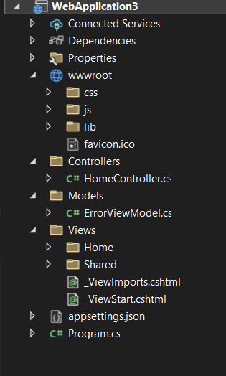wwwroot - Store static files of the application like js/css/images.



Q226

Explain default project structure in ASP.NET Core MVC application?

* Appsettings.json – Configuration settings like database connection strings and other things are saved here.
* Program.cs – Entry point of the application.
* WWWROOT contains all the static files.
* USESTATICFILES() enables the static files to be served to client.



Q227

How ASP.NET Core serve static files?

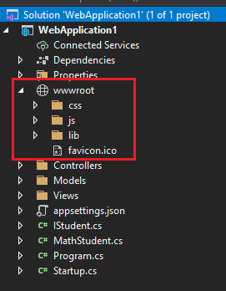 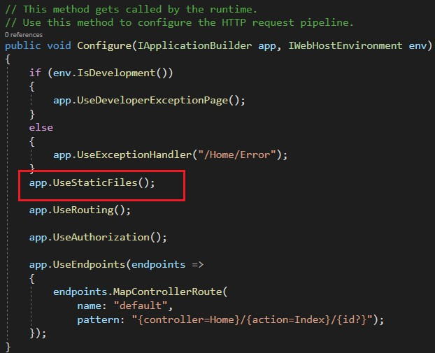

* 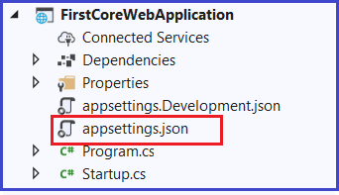The appsettings. json file is an application configuration file used to **store configuration settings** such as database connections strings etc.



Q228

What are the roles of Appsettings.Json and Launchsetting.Json file in ASP.NET Core?

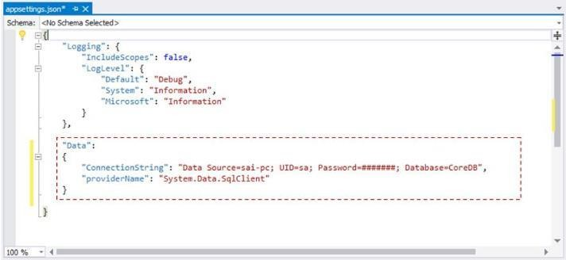

* + 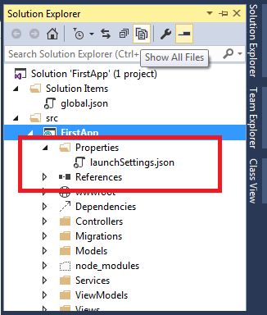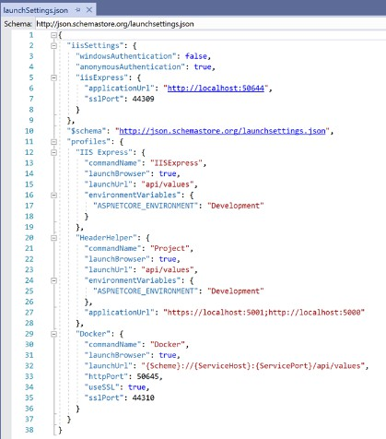The launchSettings. json file is used to store the configuration information, which is used to **start** the ASP.NET Core application.



Q228

What are the roles of Appsettings.Json and Launchsetting.Json file in ASP.NET Core?

* + - Appsettings.json (Default) (Mostly Used)



Q229

What are the various techniques to save configuration settings in ASP.NET Core?

* + - Azure Key Vault (Application is hosted on Azure)
    - Environment variables
    - In-memory .NET objects
    - Command Line Arguments
    - Custom Providers



Q230

What is CORS in ASP.NET Core?

Why is CORS restriction required? How to fix CORS error?

<http://interviewhappy.com/senddata>

<http://xyz.com/senddata>

http:// api.interviewhappy.com /senddata

https://interviewhappy.com/senddata

* + - CORS stands for Cross-Origin Resource Sharing.



<http://interviewhappy.com/getdata>

<http://interviewhappy.com:12/senddata>

* + - 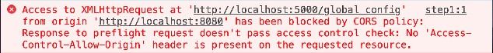CORS is a security feature implemented in web browsers that restricts web pages or scripts from making requests to a different domain than the one that served the web page.
    - CORS stands for Cross-Origin Resource Sharing.



Q230

What is CORS in ASP.NET Core?

Why is CORS restriction required? How to fix CORS error?

* + - 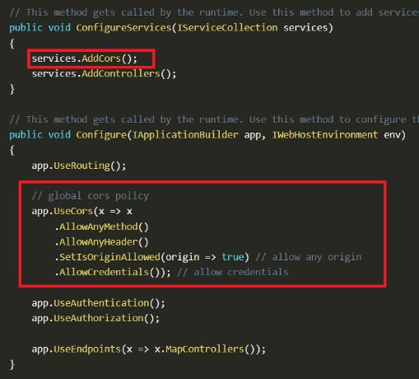CORS is a security feature implemented in web browsers that restricts web pages or scripts from making requests to a different domain than the one that served the web page.

#### Why CORS is required?

Because of security reason. So that you can make your api secure by default. Otherwise, any external website can try to access your data.

#### How to fix CORS error?

1. Add Microsoft.AspNetCore.Cors nuget package to

your project.

1. In startup class, edit the Configure and ConfigureServices method.



Q231

What is In-Memory caching & Distributed Caching?

|  |  |
| --- | --- |
| **In-Memory Caching** | **Distributed Caching** |
| 1. It’s the normal way of caching.  In this cache is stored in the memory of a **single server** which is hosting the application. | Distributed caching is when you want to handle caching outside of your application. A different server is used for store cached data. |
| 2. It can be implemented with the  IMemoryCache Interface in ASP.NET Core. | It can be implemented with the help of Redis  Cache. |

* + 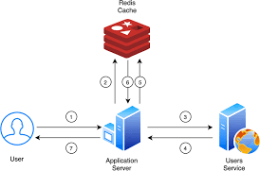Redis is an open-source, highly replicated, performant, non-relational kind of database and caching server.
  + When to use which caching?

In normal cases where the application size is small, use in-memory cache.

But where application is very big or it’s a microservices based architecture, then use distributed caching.

Q232

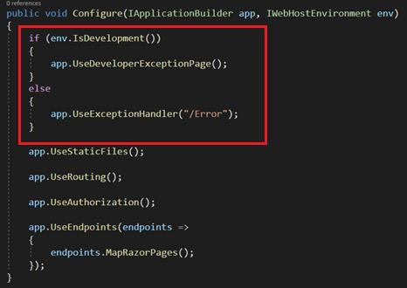

### How to handle errors in ASP.NET Core?

* + Error handling for development and other environments can be set in CONFIGURE method of Startup.cs class.
  + The IsDevelopment() method will check the

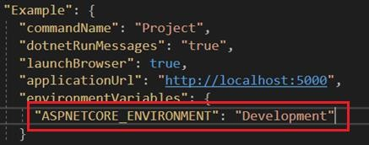ASPNETCORE_ENVIRONMENT value in

LaunchSettings.json file.

* + - Razor pages follows a page-centric development model just



Q233

What are Razor pages in .NET Core?

like ASP.NET web forms.

## SOLID Principles in Day to Day LifeChapter 28 : SOLID Principles

Q234. What are SOLID Principles? What is the difference

between SOLID Principles and Design Patterns?

V Imp

Q235. What is Single Responsibility Principle? Q236. What is Open-closed Principle?

V Imp

Q237. What is Liskov Substitution Principle? V Imp

Q238. What is Interface Segregation Principle? Q239. What is Dependency Inversion Principle? Q240. What is DRY principle?

Back to main index

* SOLID principles are a set of principles, which must be followed to develop flexible, maintainable, and scalable software systems.



Q234

What are SOLID Principles? What is the difference between SOLID Principles and Design Patterns?

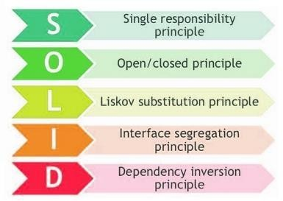

* SOLID principles aren't concrete - rather abstract.
* Design patterns are concrete and solve a particular kind of problem in software's.

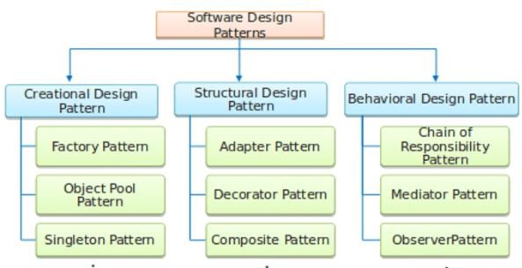

* Design patterns are concrete and solve a particular kind of problem in a specific and fixed manner.
* 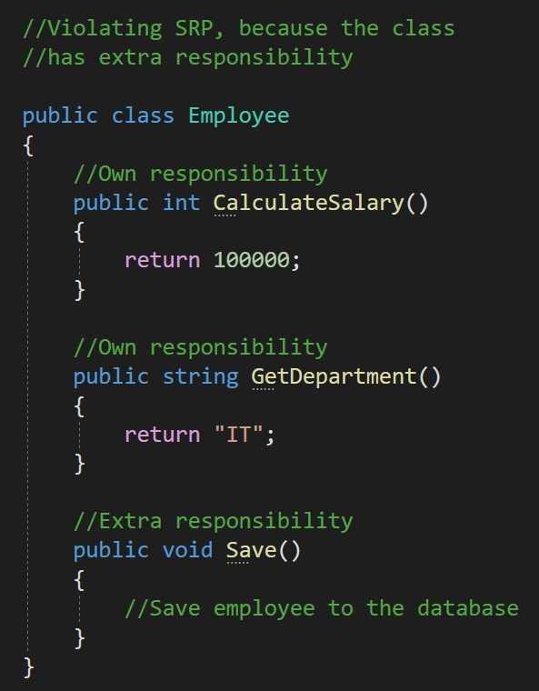Single Responsibility Principle (SRP) states that a class should have only **one responsibility**.



Q235

What is Single Responsibility Principle?

* Or a class should have only **one reason** to change.
* 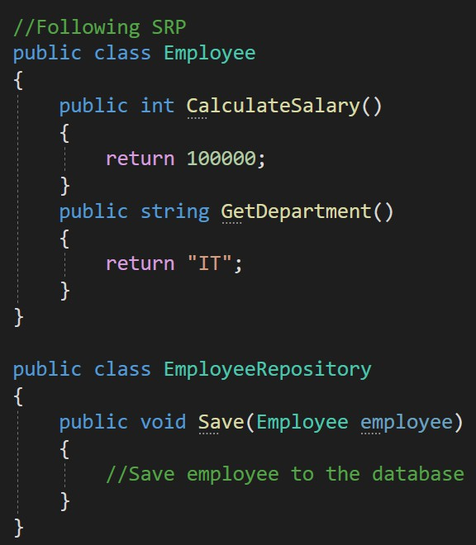Single Responsibility Principle (SRP) states that a class should have only **one responsibility**.



Q235

What is Single Responsibility Principle?

* Or a class should have only **one reason** to change.
* When a class has only one responsibility, it becomes easier to change and test. If a class has multiple responsibilities, changing one responsibility may impact others and more testing efforts will be required then.

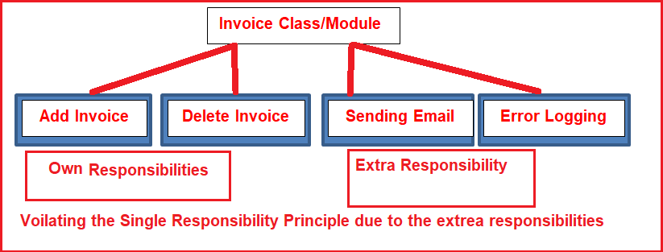

* + Open-Closed Principle (OCP) states that software entities(classes, modules) should be open for **extension**, but closed for **modification**.

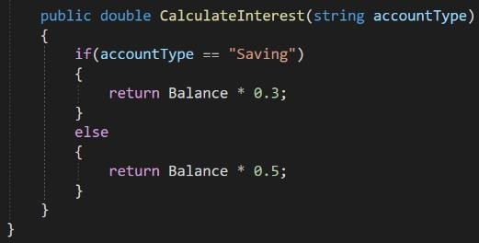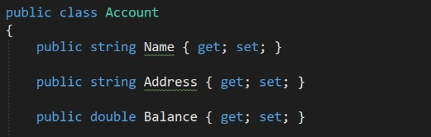

Q236

What is Open-closed Principle?

Inserting one more else if{} will violate the open closed principle because you are modifying the class rather than extending it.

* + Open-Closed Principle (OCP) states that software entities(classes, modules) should be open for **extension**, but closed for **modification**.

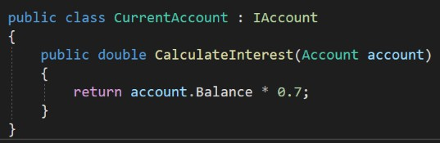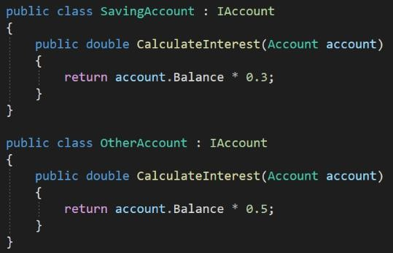

Q236

What is Open-closed Principle?

* + SRP is the **prerequisite** for OCP.

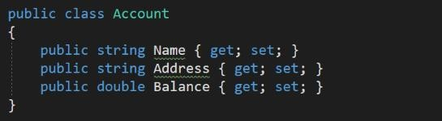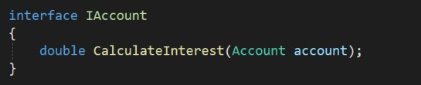

* + - The benefit is **simple testing** is required to test individual classes, but if you will keep on adding and modifying in one class. Then even for the smallest modification, the whole class needs to be tested.

back to chapter index

Q237

### What is Liskov Substitution Principle?

* + - * The Liskov Substitution Principle (LSP) states that an object of a child class must be able to **replace** an object of the parent class without **breaking** the application.
      * All the base class methods must be applicable for the derived class.

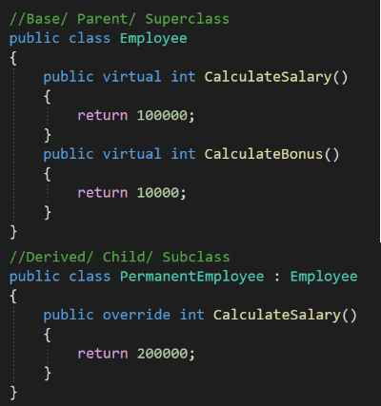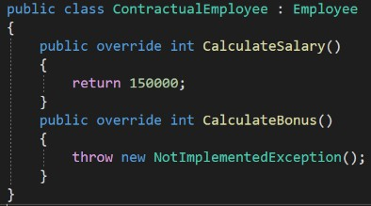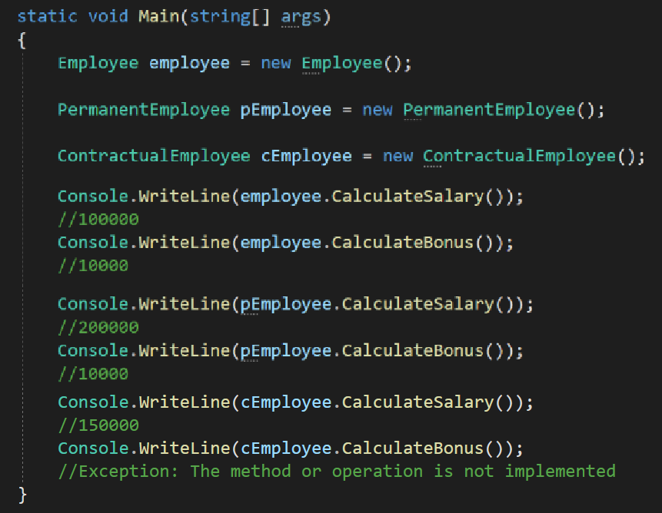

back to chapter index

* + - * + 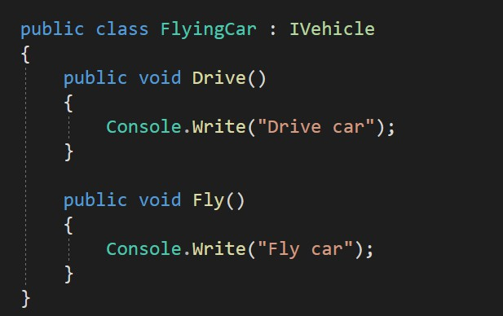The Interface Segregation (ISP) states that a class should not be forced to implement interfaces that it does not use.



Q238

What is Interface Segregation Principle?

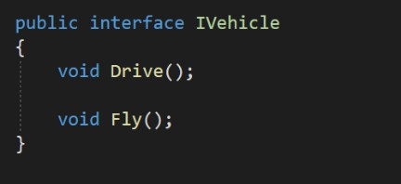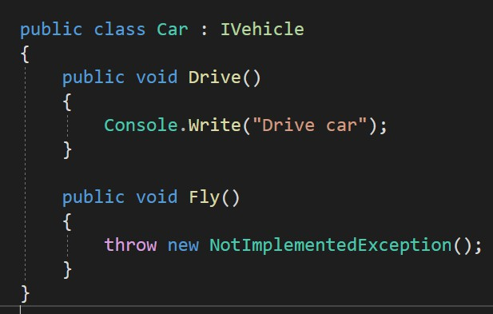

* + - * + 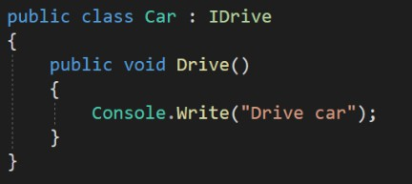The Interface Segregation (ISP) states that a class should not be forced to implement interfaces that it does not use.



Q238

What is Interface Segregation Principle?

* + - * + It is better to have multiple smaller interfaces than larger interfaces.

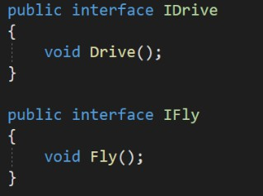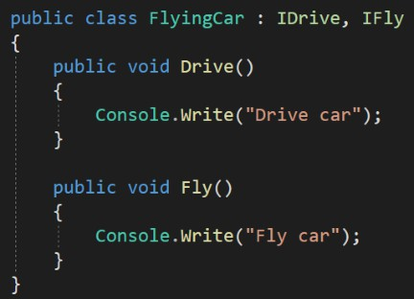

* + The Dependency Inversion Principle (DIP) states that a **high-level class** must not depend upon a **lower level class**.



Q239

What is Dependency Inversion Principle?

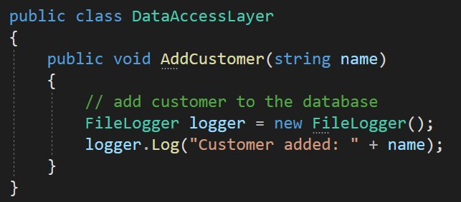

Lower Level Class

Higher Level Class

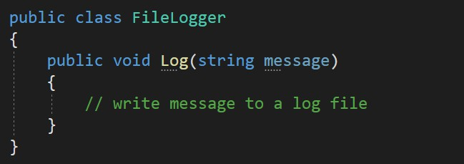

* + The Dependency Inversion Principle (DIP) states that a **high-level class** must not depend upon a **lower level class**.



Q239

What is Dependency Inversion Principle?

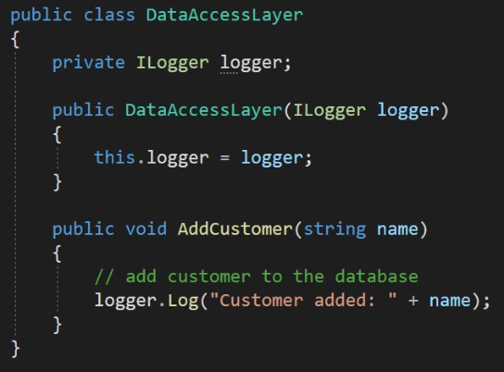

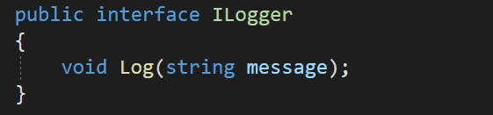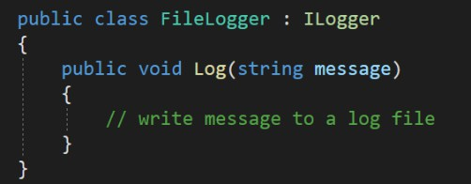

* + - DRY stands for DON’T REPEAT YOURSELF.



Q240

What is DRY principle?

* + - Don’t write the same functionality multiple

time.

* + - Instead write code once and then use it at multiple places using inheritance.

## Chapter 29 : Design Patterns

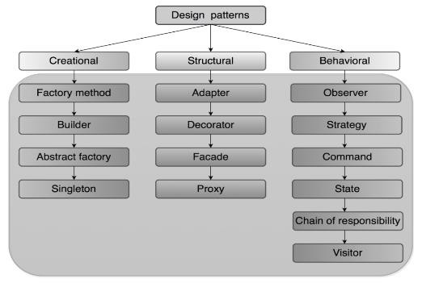Q241. What are Design Patterns and what problem they solve? V Imp

Q242. What are the types of Design Patterns? Q243. What are Creational Design Patterns?

Q244. What are Structural Design Patterns? Q245. What are Behavioral Design Patterns?

V Imp

Q246. What is Singleton Design Pattern? V Imp

Q247. How to make singleton pattern thread safe? V Imp

Q248. What is Factory pattern? Why to use factory pattern? Q249. How to implement Factory method pattern?

Q250. What is Abstract Factory pattern?

Back to main index

* 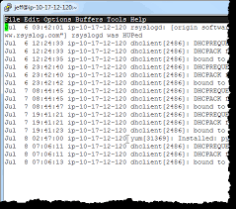Design patterns are **reusable solutions** for common problems in software design.



Q241

What are Design Patterns and what problem they solve?



Q242

What are the types of Design Patterns?

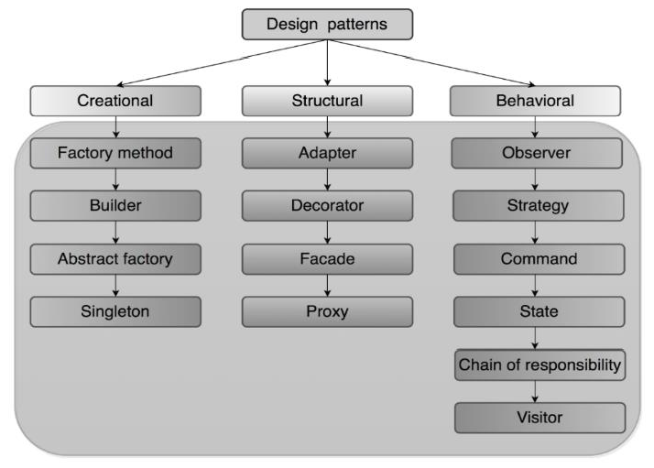

* 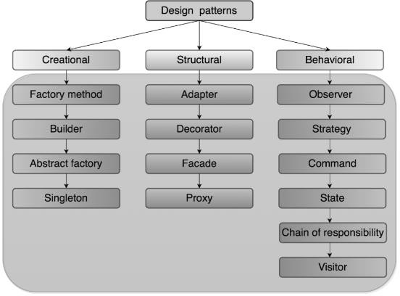Creational design patterns are design patterns that deal with **object creation** mechanisms.



Q243

What are Creational Design Patterns?

* Why direct object creation is a problem?

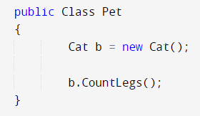

* The reason is in a large/enterprise application, if you want to change this Class from Cat to Dog, then you have to change it everywhere wherever you have used it and then it will be a testing issue. You have to retest all these classes like Pet class.
* Structural Design Pattern is used to manage the structure of classes and interfaces to manage the **relationship** between the classes.



Q244

What are Structural Design Patterns?

* + Adapter pattern

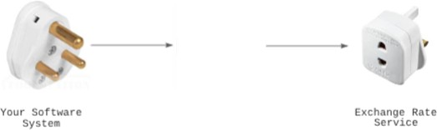

* Behavioral design patterns defines the way to



Q245

What are Behavioral Design Patterns?

**communicate** between classes and object.

* For example, in strategy pattern we can choose the best strategy at run time for doing any operation .

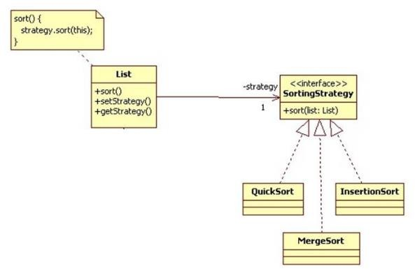

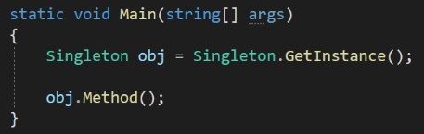

2 ng

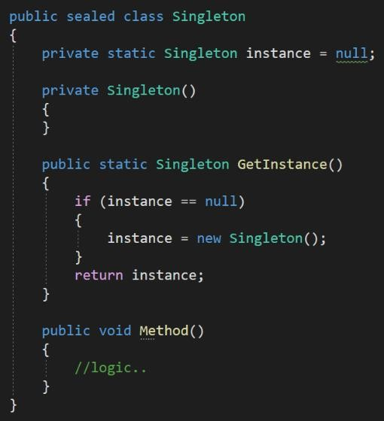

4. Create a method which will check whether the instance is null, if yes then it will create the new instance and if not null then it will return the same instance.

3. Create a private constructor so that no one can create the object of this class.

2. Declare a static instance of this class.

1. Declare class as sealed to prevent any further inheritance



Q246

What is Singleton Design Pattern?

❖

The Singleton design pattern is a

creational design pattern that ensures a class has only **one instance** of it.

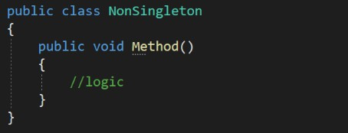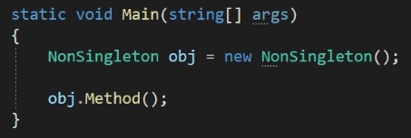



T1

T2

* 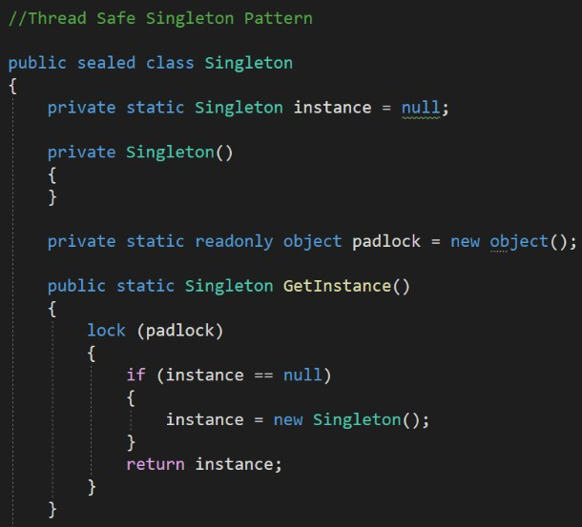Normal Singleton Pattern



Q247

How to make Singleton pattern Thread safe?

* The Factory Pattern is a **creational** design pattern which manages object creation.



Q248

What is Factory pattern? Why to use factory pattern?



Factory Design Patterns

Simple Factory

Factory Method

Abstract Factory

* 1. 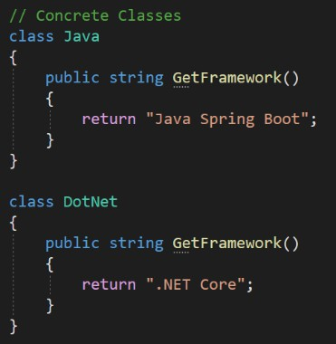Lots of **new**

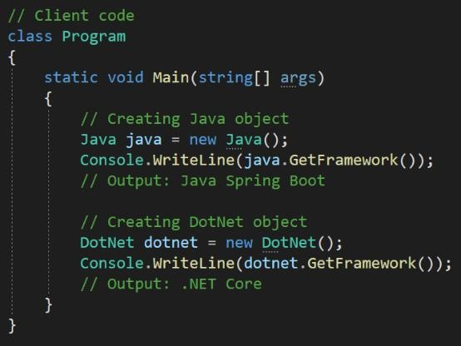

keywords

2. Client will know all the concrete classes name

back to chapter index

* Factory Pattern provides an **interface** or abstract class for creating objects, but lets the subclasses decide which class to instantiate.



Q248

What is Factory pattern? Why to use factory pattern?



Factory Design Patterns

Simple Factory

Factory Method

Abstract Factory

* Or In simple factory pattern, one factory class is responsible for creating all the objects for its derived or sub class.

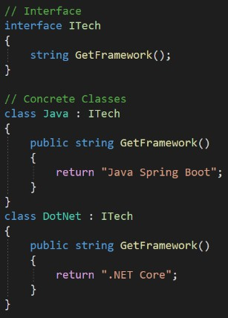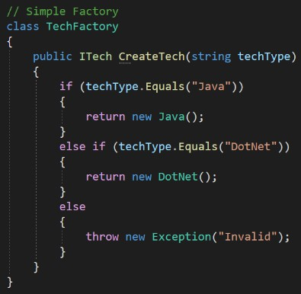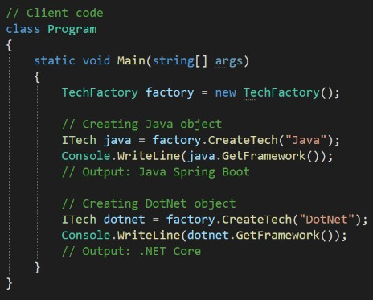

* + Simple Factory pattern provides a single factory class that creates objects, while the Factory Method pattern uses inheritance and polymorphism, so it provide more flexibility and extensibility.



Q249

How to implement Factory method pattern?



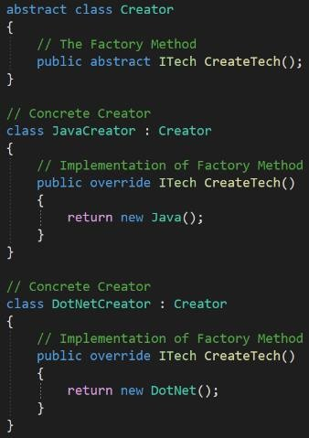

* + 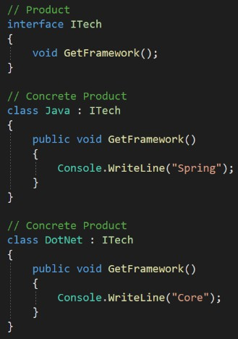Simple Factory pattern provides a single factory class that creates objects, while the Factory Method pattern uses inheritance and polymorphism, so it provide more flexibility and extensibility.



Q249

How to implement Factory method pattern?

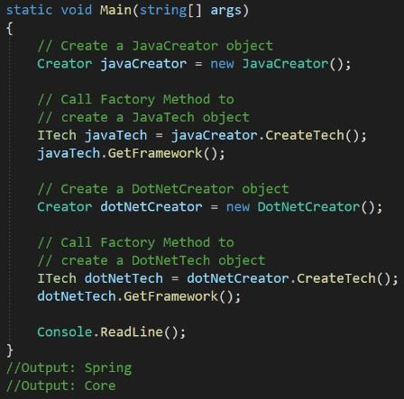

* + 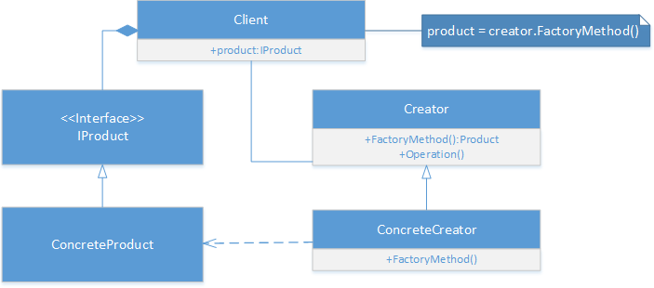Things to remember about Factory(simple factory and factory method) design patterns.



Q249

How to implement Factory method pattern?

1. The Factory Pattern is a **creational** design pattern

which manages object creation.

1. Factory Pattern provides an **interface** or abstract class for creating objects, but lets the subclasses decide which class to instantiate.
2. Or In simple factory pattern, one factory class is responsible for creating all the objects for its derived or sub class.
3. Simple Factory pattern provides a single factory class that creates objects, while the Factory Method pattern uses inheritance and polymorphism, so it provide more flexibility and extensibility.
   * The Abstract Factory pattern is a creational design pattern that provides an interface for creating related families of objects without specifying their concrete classes.



Q250

What is Abstract Factory pattern?

Big IT Company Hiring

Direct – DotNet

Direct Java

* + Abstract Factory pattern can be thought of as a "factory of factories".

No factory pattern

Big IT Company Hiring

Big IT Company Hiring

Non-Tech Agency

Tech Agency

Abstract Factory Pattern Factory Method Pattern

Agency

DotNet

Java

Finance

Account

Java

DotNet

C# Coding Problems

Array Problems



String Problems

Number Problems

# Array Coding Problems



Q. What are the must-know pre-requisites for solving basic coding problems?

Q. What is the common approach for solving coding problems?

Q. Write a function to calculate the sum of all elements in an array.

Q. Write a function to calculate the average of an array of numbers.

Q. Write a function to find the smallest number in an array.

Q. Write a function to find the largest number in an array.

Q. Write a function to find the second largest number in an array.

Q. What are the must-know pre-requisites for solving basic coding problems?







**1. Data types &**

**Variables**

* int
* char
* boolean
* String
* Array

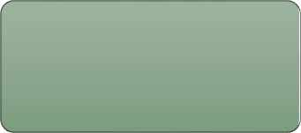

**2. Classes &**

**Methods**

* Create

class

* Main method
* Functions



**3. Operators**

• +, -, *, /

• ++, --

• ==, !=, >,

<, >=, <=

* &&, ||



**4. Control**

**statements**

* if-else
* for loop
* while loop
* foreach loop
* break &

continue

* return



**5. Array & String**

**methods**

* length
* indexOf
* substring
* sort
* replace
* trim
* split

Q. What are the steps or approach for solving coding problems?

1. Read and understand the problem

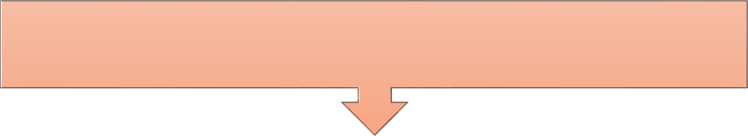

1. Set the input & imagine the output.
2. Define variable to receive the output from a function.
3. Print the output.

// Find the length of the array public class ArrayLength

{

public static void Main(string[] args)

{

int[] numbers = { 1, 2, 3, 4, 5}; // Input

int length = ArrayLengthMethod(numbers); Console.WriteLine(length); // Output: 5

}

1. Write function logic and return result.



1. Test the code for success result.
2. At last check edge cases constraints.

public static int ArrayLengthMethod(int[] array)

{

int length = array.Length; return length;

}

}

Q. Write a function to calculate the sum of all elements in an array.



* Tip: Break down the big problem into smaller problems and then solve them.

numbers

15

public class SumOfArrayElements

{

public static void Main(string[] args)

{

int[] numbers = { 1, 2, 3, 4, 5 }; // Input int sum = CalculateSum(numbers); Console.WriteLine(sum); // Output: 15

}

public static int CalculateSum(int[] array)

{

int sum = 0; // Assume 0 as initial sum value

// Iterate through the array to extract each element for (int i = 0; i < array.Length; i++)

{

sum += array[i]; // Add each element to the sum

}

return sum;

}

}

|  |  |  |  |  |
| --- | --- | --- | --- | --- |
| **0** | **1** | **2** | **3** | **4** |
| 1 | 2 | 3 | 4 | 5 |

|  |  |  |  |
| --- | --- | --- | --- |
| 1+2=3 | 3+3=6 | 6+4=10 | 10+5=15 |



sum



sum

Q. Write a function to calculate the average of an array of numbers.



numbers



15

public class AverageOfArrayElements

{

public static void Main(string[] args)

{

int[] numbers = { 1, 2, 3, 4, 5 }; // Input double average = CalculateAverage(numbers); Console.WriteLine(average); // Output: 3

}

public static double CalculateAverage(int[] array)

{

int sum = 0; // Assume 0 as initial sum value

// Iterate through the array to extract each element for (int i = 0; i < array.Length; i++)

{

sum += array[i]; // Add each element to the sum

}

return (double)sum / array.Length;

}

}

|  |  |  |  |  |
| --- | --- | --- | --- | --- |
| **0** | **1** | **2** | **3** | **4** |
| 1 | 2 | 3 | 4 | 5 |

|  |  |  |  |
| --- | --- | --- | --- |
| **1+2=3** | **3+3=6** | **6+4=10** | **10+5=15** |



sum sum

average



15/5 = 3.0

Q. Write a function to find the smallest number in an array.

numbers

|  |  |  |  |  |
| --- | --- | --- | --- | --- |
| **0** | **1** | **2** | **3** | **4** |
| 3 | 5 | 7 | 2 | 8 |

public class SmallestNumberFinder

{

public static void Main(string[] args)

{

smallest



|  |  |  |  |
| --- | --- | --- | --- |
| 3 | 3 | 2 | 2 |
| 3>5 | 3>7 | 3>2 | 2>8 |

int[] numbers = { 3, 5, 7, 2, 8 };

int smallest = FindSmallestNumber(numbers); Console.WriteLine(smallest); // Output: 2

}

compare



2

public static int FindSmallestNumber(int[] array)

{

smallest

// Assume the first element as the smallest

int smallest = array[0];

// Iterate through the array to extract each element for (int i = 1; i < array.Length; i++)

{

// Compare smallest with current element if (smallest > array[i])



* Tip: Most of the coding problems need a **for loop** for iterating over elements and **if condition** inside it for comparing elements.

{

smallest = array[i]; // Set current as smallest

}

}

return smallest;

}

}

Q. Write a function to find the largest number in an array.

numbers

|  |  |  |  |  |
| --- | --- | --- | --- | --- |
| **0** | **1** | **2** | **3** | **4** |
| 10 | 7 | 23 | 45 | 8 |

public class LargestNumberFinder

{

public static void Main(string[] args)

{

largest



|  |  |  |  |
| --- | --- | --- | --- |
| 10 | 23 | 45 | 45 |
| 10<7 | 10<23 | 23<45 | 45<8 |

int[] numbers = { 10, 7, 23, 45, 8 }; // Input int largestNumber = FindLargestNumber(numbers); Console.WriteLine(largestNumber); // Output: 45

}

compare



45

public static int FindLargestNumber(int[] array)

{

largest

// Assume the first element as the largest int largest = array[0];

// Iterate through the array to extract each element for (int i = 1; i < array.Length; i++)

{

// Compare largest with current element if (largest < array[i])



* Tip: To find the result, first set result initial values with either array first value/ minimum value/ 0/ blank. Then by the logic update them with the new result values.

{

largest = array[i]; // Set current as largest

}

}

return largest;

}

}

Q. Write a function to find the second largest number in an array.

numbers

|  |  |  |  |  |
| --- | --- | --- | --- | --- |
| **10** | **7** | **23** | **45** | **8** |



largest

compare

public class SecondLargestElement

{



public static void Main(string[] args)

{

int[] array = { 10, 7, 23, 45, 8 };

int secondLargest = FindSecondLargest(array); Console.WriteLine(secondLargest); // Output: 23

}

2nd largest

|  |  |  |  |
| --- | --- | --- | --- |
| 10 | 23 | 45 | 45 |
| 10<7 | 10<23 | 23<45 | 45<8 |
| **0** | **10** | **23** | **23** |

2nd largest 23

public static int FindSecondLargest(int[] array)

{

int largest = array[0]; // Or int.MinValue Or 0 int secondLargest = int.MinValue; // Or 0

for (int i = 1; i < array.Length; i++)

{

int num = array[i]; if (largest < num) {



* Tip: Solve the simple case first.

secondLargest = largest; largest = num;

} // { 10, 7, 23, 45, 30 }; // complex case

* Tip: Solve the edge case or complex cases later.

else if (num > secondLargest && num != largest) secondLargest = num;

}

return secondLargest;

}

}

# Array Coding Problems Using Functions



Q. What are the top 5 important array functions used in coding problems?

Q. Write a function to check whether two arrays are same or not?

Q. Write a function to check if a given array is sorted in ascending order or not.

Q. Write a function to merge two arrays into a single sorted array.

Q. Write a function to remove a specific element from an array.

Q. What are the top 5 important array functions used in coding problems?

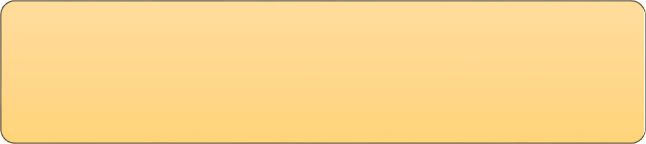

**Array class important methods**

string.Join(", ", array);

Array.Sort(array)

Array.Reverse(array)

Array.Fill(array, 1)

Array.Copy(array,

newArray, alength)

public class ArrayMethodsExample1

{

public static void Main(string[] args)

{

int[] array = { 5, 3, 1, 4, 2 }; // Initializing an array

string arrayStr = string.Join(", ", array); // Convert array to a string Console.WriteLine(arrayStr); // Output: 5, 3, 1, 4, 2

Array.Sort(array); // Sort the array in ascending order Console.WriteLine(string.Join(", ", array)); // Output: 1, 2, 3, 4, 5

Array.Reverse(array); // Reverses the array Console.WriteLine(string.Join(", ", array)); // Output: 5, 4, 3, 2, 1

Array.Fill(array, 1); // Fill the array with a specific value Console.WriteLine(string.Join(", ", array)); // Output: 1, 1, 1, 1, 1

array = new int[] { 5, 3, 1, 4, 2 }; // Reinitialize the array

// Copy the array to a new array of specified length int[] newArray = new int[7];

Array.Copy(array, newArray, array.Length); Console.WriteLine(string.Join(", ", newArray));

// Output: 5, 3, 1, 4, 2, 0, 0

}

}

Q. Write a function to check whether two arrays are same or not?



public class CompareArrays

{

Console.WriteLine(array1.SequenceEqual(array2));

// Output: true

}

}

* Tip: Knowing important Array class methods is beneficial for solving coding problems.

|  |  |  |
| --- | --- | --- |
| public static void  { | Main(string[] | args) |
| int[] array1 = | { 5, 2, 9, 1, | 5, 6 }; |
| int[] array2 = | { 5, 2, 9, 1, | 5, 6 }; |

Q. Write a function to check if a given array is sorted in ascending order or not.



numbers

public class CheckIfArraySorted

{

public static void Main(string[] args)

{

int[] array1 = { 1, 2, 3, 4, 5 }; Console.WriteLine(IsSorted(array1)); // Output: true

}

public static bool IsSorted(int[] array)

{

// Iterate through the array to extract each element for (int i = 0; i < array.Length - 1; i++)

{

// Check if current element is greater than next element if (array[i] > array[i + 1])

{

return false;

}

}

return true;

}

}

|  |  |  |  |  |
| --- | --- | --- | --- | --- |
| **1** | **2** | **3** | **4** | **5** |



compare

|  |  |  |  |
| --- | --- | --- | --- |
| false | false | false | false |
| 1>2 | 2>3 | 3>4 | 4>5 |



true (sorted)

* Don’t start code immediately. First read and understand the problem carefully and try to think about the input, output and the simplest logic to solve it.

Q. Write a function to merge two arrays into a single sorted array.



array1 array2

|  |  |  |  |
| --- | --- | --- | --- |
| **0** | **1** | **2** | **3** |
| 3 | 5 | 1 | 4 |

|  |  |  |  |
| --- | --- | --- | --- |
| **0** | **1** | **2** | **3** |
| 8 | 2 | 7 | 6 |



public class MergeAndSortArrays

{

public static void Main(string[] args)

{

int[] array1 = { 3, 5, 1, 4 };

int[] array2 = { 8, 2, 7, 6 };

int[] mergedArray = MergeAndSort(array1, array2); Console.WriteLine($"[{string.Join(", ", mergedArray)}]");

// Output: [1, 2, 3, 4, 5, 6, 7, 8]

}

public static int[] MergeAndSort(int[] array1, int[] array2)

{

int len1 = array1.Length; int len2 = array2.Length;

int[] mergedArray = new int[len1 + len2]; // Create a new array

// Copy elements from first array Array.Copy(array1, 0, mergedArray, 0, len1);

// Copy elements from second array Array.Copy(array2, 0, mergedArray, len1, len2);

Array.Sort(mergedArray); // Sort the merged array return mergedArray;

}

}

Empty new array



Merged array



|  |  |  |  |  |  |  |  |
| --- | --- | --- | --- | --- | --- | --- | --- |
| **0** | **1** | **2** | **3** | **4** | **5** | **6** | **7** |
|  |  |  |  |  |  |  |  |

|  |  |  |  |  |  |  |  |
| --- | --- | --- | --- | --- | --- | --- | --- |
| **0** | **1** | **2** | **3** | **4** | **5** | **6** | **7** |
| 3 | 5 | 1 | 4 | 8 | 2 | 7 | 6 |

Merged & sorted array

|  |  |  |  |  |  |  |  |
| --- | --- | --- | --- | --- | --- | --- | --- |
| **0** | **1** | **2** | **3** | **4** | **5** | **6** | **7** |
| 1 | 2 | 3 | 4 | 5 | 6 | 7 | 8 |

Q. Write a function to remove a specific element from an array.



array



2

public class RemoveElementFromArray

{

public static void Main(string[] args)

{

int[] array = { 1, 2, 3, 4, 5, 3, 6 };

int elementToRemove = 3;

int[] newArray = RemoveElement(array, elementToRemove); Console.WriteLine($"[{string.Join(", ", newArray)}]");

// Output: [1, 2, 4, 5, 6]

}

public static int[] RemoveElement(int[] array, int element)

{

// Count occurrences of the element to be removed int count = 0;

foreach (int item in array) {

if (item == element) count++;

}

// Create a new array of the appropriate size int[] newArray = new int[array.Length - count];

int index = 0;

// Copy elements except the one to be removed foreach (int item in array)

{

if (item != element) { newArray[index] = item; index++;

}

}

return newArray;

}

}

|  |  |  |  |  |  |  |
| --- | --- | --- | --- | --- | --- | --- |
| **0** | **1** | **2** | **3** | **4** | **5** | **6** |
| 1 | 2 | 3 | 4 | 5 | 3 | 6 |

Number of occurrences of element(3)



New empty array

|  |  |  |  |  |
| --- | --- | --- | --- | --- |
| **0** | **1** | **2** | **3** | **4** |
|  |  |  |  |  |

|  |  |  |  |  |
| --- | --- | --- | --- | --- |
| **0** | **1** | **2** | **3** | **4** |
| 1 | 2 | 4 | 5 | 6 |



Array with element removed

# String Coding Problems



Q. Write a function that counts the number of characters in a string?

Q. Write a function that returns the reverse of a string?

Q. Write a function that checks whether a given string is a palindrome or not?

Q. What are the important methods of String class?

Q. Write a function that returns the longest word in the sentence.

Q. Write a function that checks whether two strings are anagrams or not?

Q. Write a function to remove all whitespace characters from a string.

Q. Write a function that counts the number of vowels in a string?

Q. What are some more important methods of String class?

Q. Write a function that counts the number of characters in a string?

1. Read and understand the problem

public class CharacterCounter

{

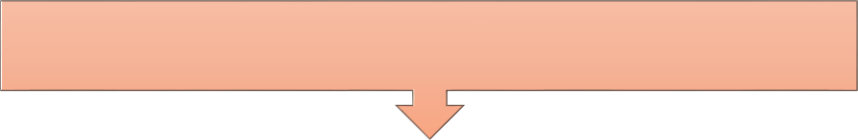

public static void Main(string[] args)

{

1. Set the input & imagine the output.
2. Define variable to receive the output

from a function.

1. Print the output.

// Set Input

string str = "Interview Happy";

// Set result received by the function

int characterCount = CountCharacters(str);

// Print result: Output: 15 Console.WriteLine(characterCount);

}



1. Write function logic and return (First comments and then code).
2. Test the code for success result.
3. Check edge cases and constraints.

// Function

public static int CountCharacters(string input)

{

// Edge case

if (input == null)

{

return 0; // Handle null input by returning 0

}

// Main Logic

return input.Length;

}

}

Q. How to iterate a string?



* To iterate a string, use a for loop(0 to string's length), and use str(i) method to access each character.

public class IterateString

{

public static void Main(string[] args)

{

string str = "Interview Happy";

// Use loop to iterate through each character of string for (int i = 0; i < str.Length; i++)

{

char ch = str[i]; Console.Write(ch + " ");

}

// Output: I n t e r v I e w H a p p y

}

}

Q. Write a function that returns the reverse of a string?

string

using System.Text;

public class ReverseString

{

public static void Main(string[] args)



Interview Happy

yppaH weivretnI

{

reverse

string

string inputStr = "Interview Happy"; // Set Input string reversedString = ReverseStringMethod(inputStr);

Console.WriteLine(reversedString); // Output: yppaH weivretnI

}



public static string ReverseStringMethod(string input)

* Tip: Handle the edge cases after successfully running the program.

{

if (input == null) // Edge case return null;

StringBuilder reversed = new StringBuilder(); // Empty string

* Tip: Set the initial values blank rings and replace them with result later.

// Iterate all elements in reverse order for (int i = input.Length - 1; i >= 0; i--)

{

reversed.Append(input[i]); // yppa...

* Tip: Knowing basic and important string functions are very important.

}

return reversed.ToString();

}

}

Q. Write a function that checks whether a given string is a palindrome or not?



level

level



R E V E R S E

* Tip: Break down the big problem into smaller problems and then solve them.

using System.Text;

public class PalindromeChecker

{

public static void Main(string[] args)

{

string testString = "level"; // Input

bool result = IsPalindrome(testString); // Result Console.WriteLine(result); // Output: true

}

public static bool IsPalindrome(string input)

{

if (input == null) // Edge case return false;

StringBuilder reversed = new StringBuilder(); // Empty string for (int i = input.Length - 1; i >= 0; i--)

{

reversed.Append(input[i]); // Reverse the string

}

return input.Equals(reversed.ToString());

}

}

# String Coding Problems Using Functions



Q. What are the must-know pre-requisites for solving basic coding problems?

Q. What is the common approach for solving coding problems?

Q. Write a function that counts the number of characters in a string?

Q. Write a function that returns the reverse of a string?

Q. Write a function that checks whether a given string is a palindrome or not?

Q. What are the important methods of String class?

Q. Write a function that returns the longest word in the sentence.

Q. Write a function that checks whether two strings are anagrams or not?

Q. Write a function to remove all whitespace characters from a string.

Q. Write a function that counts the number of vowels in a string?

Q. What are some more important methods of String class?

Q. What are the important methods of String class?



public class StringMethodsExample

{

public static void Main(string[] args)

{

string str = " Interview Happy ";

// 1. Get length of the string Console.WriteLine(str.Length); // Output: 21

// 2. Character at specific index

Console.WriteLine(str[7]); // Output: r

// 3. Get sub-string based on index

string substring = str.Substring(8, 4); //from 8 to 12 Console.WriteLine(substring); // Output: view

// 4. Get index of a characater int index = str.IndexOf('H');

Console.WriteLine(index); // Output: 13

// 5. Remove the white spaces from start and end string trimmedStr = str.Trim();

Console.WriteLine(trimmedStr); // Output: Interview Happy

Q. What are the important methods of String class?



// 6. Replace a part of old string with some new string string replacedStr = str.Replace("Happy", "Crack"); Console.WriteLine(replacedStr); // Output: Interview Crack

// 7. Split the string in parts based on delimeters string[] parts = trimmedStr.Split(' ');

foreach (string part in parts)

{

Console.WriteLine(part);

}

// Output: Interview

// Happy

// 8. Convert the string to character array char[] charArray = str.ToCharArray(); foreach (char c in charArray)

{

Console.Write(c);

}

Console.WriteLine(); // Output: Interview Happy

}

}

Q. Write a function that returns the longest word in the sentence.



public class LongestWordFinder

Interviews are the best

{

public static void Main(string[] args)

{

string testSentence = "Interviews are the best"; string longestWord = FindLongestWord(testSentence); Console.WriteLine(longestWord); // Output: Interviews

Interviews

|  |  |  |  |
| --- | --- | --- | --- |
| **Interviews** | **are** | **the** | **best** |

}

public static string FindLongestWord(string sentence)

{

if (string.IsNullOrEmpty(sentence)) return ""; // Edge case

string[] words = sentence.Split(' '); //break to array of words

string longestWord = ""; // set the empty word

* Tip: Knowing how to convert string to array and vice versa is important.

foreach (string word in words) // iterate all the words

{

if (word.Length > longestWord.Length) longestWord = word;

}

return longestWord;

}

}

Q. Write a function to remove all whitespace characters from a string.



* Tip: Use Meaningful Names for variables and functions.

public class RemoveWhitespace

{

public static void Main(string[] args)

{

string str = " Interview Happy ! ";

string result = RemoveWhitespaceMethod(str);

Console.WriteLine(result); // Output: InterviewHappy!

}

public static string RemoveWhitespaceMethod(string str)

{

return str.Replace(" ", "");

}

}

Q. Write a function that counts the number of vowels in a string?



I n t e r v i e w H a p p y

Count = 5

aeiouAEIOU

public class VowelCounter

{

public static void Main(string[] args)

{

string inputString = "Interview Happy"; // Input int numVowels = CountVowels(inputString); // Result Console.WriteLine(numVowels); // Output: 5

}

public static int CountVowels(string str)

{

string vowels = "aeiouAEIOU"; // Declare vowels string int vowelCount = 0; // Assume 0 vowels in the string

foreach (char ch in str)

{

// Check if character is present in vowels string or not

if (vowels.IndexOf(ch) != -1)

{

vowelCount++;

}

}

return vowelCount;

}

}

Q. Write a function that checks whether two strings are anagrams or not?



listen

to array

|  |  |  |  |  |  |
| --- | --- | --- | --- | --- | --- |
| **l** | **i** | **s** | **t** | **e** | **n** |

|  |  |  |  |  |  |
| --- | --- | --- | --- | --- | --- |
| **s** | **i** | **l** | **e** | **n** | **t** |

sort

=



silent



public class AnagramChecker

{

public static void Main(string[] args)

{

string s1 = "listen"; // Input 1 string s2 = "silent"; // Input 2

Console.WriteLine(AreAnagrams(s1, s2)); // Output: true

}

public static bool AreAnagrams(string str1, string str2)

{

// Convert both the strings to character arrays char[] charArray1 = str1.ToCharArray();

char[] charArray2 = str2.ToCharArray();

Array.Sort(charArray1); // Sort the string

Array.Sort(charArray2); // Sort the string

// Compare the sorted arrays character by character for (int i = 0; i < charArray1.Length; i++)

{

if (charArray1[i] != charArray2[i]) return false;

}

return true;

}

}

|  |  |  |  |  |  |
| --- | --- | --- | --- | --- | --- |
| **e** | **i** | **l** | **n** | **s** | **t** |

|  |  |  |  |  |  |
| --- | --- | --- | --- | --- | --- |
| **e** | **i** | **l** | **n** | **S** | **t** |



Anagrams =true

# Number Coding Problems



Q. Write a function to calculate the factorial of a number.

Q. What is the difference between ++i and i++?

Q. Write a function that checks whether a number is prime or not?

Q. How to swap two numbers in C#?

Q. Write a function to calculate the GCD for two numbers.

Q. Write a function to sum the digits of a number.

Q. Write a function to calculate the Fibonacci sequence up to a given number.

Q. Write a function to calculate the factorial of a number.



5!

1*2*3*4*5



120

public class Factorial

{

public static void Main(string[] args)

{

int number = 5; // Input

long factorial = CalculateFactorial(number); // Result Console.WriteLine(factorial); // Output: 120

}

public static long CalculateFactorial(int num)

{

if (num == 0) // Edge case

{

return 1;

}

long result = 1; // Set initial value for (int i = 1; i <= num; i++)

{

result *= i; // Multiply current number with result

}

return result;

}

}

* Tip: Edge cases are handled before the normal logic of the program, because for edge cases normal logic is not applicable.

Q. What is the difference between ++i and i++?



❖ ++i (Pre-increment): it increments i first and then uses the incremented value.

* i++ (Post-increment): it uses the current value of i first and then increments i afterward.

int i = 5;

int result = ++i; // result = 6, i = 6

int i = 5;

int result = i++; // result = 5, i = 6

Q. Write a function that checks whether a number is prime or not?



public class PrimeChecker



17

17 % (2 to 8) != 0

True (prime)

{

public static void Main(string[] args)

{

int num = 17; // Input Console.WriteLine(IsPrime(num)); // Output: true

}

public static bool IsPrime(int number)

{

// Edge case: Check if the number is less than or equal to 1 if (number <= 1)

return false;

// Iterate from 2 to half of the number for (int i = 2; i <= number / 2; i++)

{

// Check if number is divisible by current number if (number % i == 0)

* Tip: In most coding problems, first rule out all negative or invalid scenarios.

{

return false;

}

}

return true;

}

}

Q. How to swap two numbers in C#?



10

a b

10

public class SwapNumbers

{

public static void Main(string[] args)

{

int a = 5; int b = 10;

// Swap using a temporary variable int temp = a;

a = b;

b = temp;

Console.WriteLine("a = " + a + ", b = " + b);

// Output: a = 10, b = 5

}

}



5

temp

5

a

10

b

10

a

b

5

* Tip: swapping will be used in many other coding problems.

Q. Write a function to calculate the GCD for two numbers.



num1 num2

18

public class GCD

{

public static void Main(string[] args)

{

int num1 = 30, num2 = 18; // Multiple Inputs int result = FindGCD(num1, num2); // Result Console.WriteLine(result); // Output: 6

}

public static int FindGCD(int num1, int num2)

{

// Iterate from smaller number to 1

for (int i = num2; i >= 1; i--)

{

// Check if both numbers are divisible by current number if (num2 % i == 0 && num1 % i == 0)

{

return i; // That is the GCD

}

}

return 1;

}

}



30

2, 3, 6



GCD = 6

Q. Write a function to sum the digits of a number.



number

public class SumOfDigits

{

public static void Main(string[] args)

{

int number = 1234; // Input

int sum = SumOfDigitsMethod(number); // Result Console.WriteLine(sum); // Output: 10

}

public static int SumOfDigitsMethod(int num)

{

int sum = 0; // Assume initial sum is 0

// Continue dividing the number until it becomes 0 while (num != 0)

{

int remainder = num % 10; // Get reminder

sum += remainder; // Add reminder to existing sum num = num / 10; // Divide the number by 10 to

remove last digit

}

return sum;

}

}



1234

(1234 % 10) + (123 % 10) + (12 % 10) + (1 % 10)

4+3+2+1 = 10

Q. Write a function to calculate the Fibonacci sequence up to a given number.



number

public class Fibonacci

{

public static void Main(string[] args)

{

int n = 7; // Input

GenerateFibonacci(n); // Output: 0, 1, 1, 2, 3, 5, 8

}

public static void GenerateFibonacci(int n)

{

int a = 0, b = 1;

Console.Write(a + ", " + b); // Set initial two numbers

for (int i = 2; i < n; i++)

{

int next = a + b; // Add immediate previous two numbers

Console.Write(", " + next);

a = b; // reset a to b

b = next; // reset b to next

}

}

}

7



|  |  |  |  |  |  |  |
| --- | --- | --- | --- | --- | --- | --- |
| **0** | **1** | **0+1** | **1+1** | **1+2** | **2+3** | **3+5** |



|  |  |  |  |  |  |  |
| --- | --- | --- | --- | --- | --- | --- |
| **0** | **1** | **2** | **3** | **4** | **5** | **8** |

Fibonacci sequence

# Coding Algorithms



Q. Write a function to sort an array of numbers in ascending order(Bubble Sort).

Q. Write a function to search an element in any array(Binary Search)?

Q. Write a function to sort an array of numbers in ascending order(Bubble Sort).

* In bubble sort, compare and swap adjacent elements if they are not ordered. Repeat these steps to move the largest to the end until the array is sorted.

Outer for (i = 0 to 3)



Inner for

|  |  |  |  |
| --- | --- | --- | --- |
| **5** | **2** | **9** | **1** |

#### First Pass

Outer for (i = 1 to 3)

Inner for

#### Second Pass

Outer for (i = 2 to 3)

Inner for

|  |  |  |  |
| --- | --- | --- | --- |
| **2** | **5** | **1** | **9** |

#### Third Pass

(j = 0 to 3)



Inner for (j = 1 to 3)

Inner for

(j = 2 to 3)

Result

swap

no swap

|  |  |  |  |
| --- | --- | --- | --- |
| **2** | **5** | **9** | **1** |

|  |  |  |  |
| --- | --- | --- | --- |
| **2** | **5** | **9** | **1** |

swap

|  |  |  |  |
| --- | --- | --- | --- |
| **2** | **5** | **1** | **9** |

(j = 0 to 2)

Inner for (j = 1 to 2)

Result

no swap

swap

|  |  |  |  |
| --- | --- | --- | --- |
| **2** | **5** | **1** | **9** |

|  |  |  |  |
| --- | --- | --- | --- |
| **2** | **1** | **5** | **9** |

(j = 0 to 1)

swap

|  |  |  |  |
| --- | --- | --- | --- |
| **2** | **1** | **5** | **9** |

Result

|  |  |  |  |
| --- | --- | --- | --- |
| **1** | **2** | **5** | **9** |

Q. Write a function to sort an array of numbers in ascending order(Bubble Sort).



public class SortArray

{

public static void Main(string[] args)

{

int[] numbers = { 5, 2, 9, 1 }; // Input

// Array.Sort(numbers);

BubbleSortArray(numbers); Console.WriteLine($"[{string.Join(", ",

numbers)}]");

// Output: [1, 2, 5, 9]

}

public static void BubbleSortArray(int[] array)

{

int n = array.Length; bool swapped;

// outer for loop

for (int i = 0; i < n - 1; i++)

{

swapped = false;

// inner for loop

for (int j = 0; j < n - 1 - i; j++)

{

// Swap if current element is greater than next element

if (array[j] > array[j + 1])

{

int temp = array[j]; array[j] = array[j + 1]; array[j + 1] = temp; swapped = true;

}

}

if (!swapped) break; // Skip Sorting - Performance

}

}

}

Q. Write a function to search an element in any array(Binary Search)?

sorted

array

left = 0



mid = left + (right - left) / 2

**while loop**

left array

right array

left = mid(2) + 1 = 3 right = 4

mid = left + (right - left) / 2 = 3.5)

result

**Index(3)**

array[mid](10) == target(10)

array[mid] < target

array[mid] > target

~~array[mid](4) == target(10)~~

target

|  |  |  |  |  |
| --- | --- | --- | --- | --- |
| **2** | **3** | **4** | **10** | **20** |

Right = array.length - 1 = 4



|  |  |
| --- | --- |
| **2** | **3** |

|  |  |
| --- | --- |
| **10** | **20** |

Q. Write a function to search an element in any array(Binary Search)?



public class BinarySearch

{

public static void Main(string[] args)

{

int[] numbers = { 2, 3, 4, 10, 40 }; // Input int target = 10;

int result = BinarySearchMethod(numbers, target);

if (result == -1)

{

Console.WriteLine("Element not present");

}

else

{

Console.WriteLine("Element found at index " + result);

// Output: Element found at index 3

}

}

public static int BinarySearchMethod(int[] array, int target)

{

int left = 0;

int right = array.Length - 1;

// Continue loop unitl left is smaller than right while (left <= right)

{

int mid = left + (right - left) / 2; // Get mid index

// Check if target is present at mid if (array[mid] == target)

return mid; // Target found at index mid

// If target is greater, ignore the left half if (array[mid] < target)

{

left = mid + 1; // Set left as mid index + 1

}

else // If target is smaller, ignore the right half

{

right = mid - 1;

}

}

return -1; // Target not found in array

}

}

Q. Write a function to search an element in any array(Binary Search)?



* Binary search steps:



* Repeatedly divide the sorted array in half.

1.

* Compare the target to the middle element.

2.

* Narrow the search until the target element is found.

3.

All the best for your interviews Never ever give up

